**HCMC UNIVERSITY OF TECHNOLOGY AND EDUCATION**

**FACULTY OF INTERNATIONAL EDUCATION**



**PROJECT ON SOFTWARE ENGINEERING**

**DESIGNING AND DEVELOPING A DOCTOR APPOINTMENT SCHEDULING WEBSITE**

**Executed by:**

**NGUYỄN THANH NGUYÊN 20110387**

**CHÂU QUỐC THÁI 20110398**

**NGUYỄN VÕ ĐỨC ANH 20110353**

**Major**: **INFORMATION TECHNOLOGY**

**Supervisor**: **Assoc. Prof. PhD. HOÀNG VĂN DŨNG**

*Ho Chi Minh City, December 2023*

**HCMC UNIVERSITY OF TECHNOLOGY AND EDUCATION**

**FACULTY OF INTERNATIONAL EDUCATION**



**PROJECT ON SOFTWARE ENGINEERING**

**DESIGNING AND DEVELOPING A DOCTOR APPOINTMENT SCHEDULING WEBSITE**

**Executed by:**

**NGUYỄN THANH NGUYÊN 20110387**

**CHÂU QUỐC THÁI 20110398**

**NGUYỄN VÕ ĐỨC ANH 20110353**

**Major**: **INFORMATION TECHNOLOGY**

**Supervisor**: **Assoc. Prof. PhD. HOÀNG VĂN DŨNG**

*Ho Chi Minh City, December 2023*

|  |  |
| --- | --- |
|  | THE SOCIALIST REPUBLIC OF VIETNAM  **Independence – Freedom – Happiness**  -------- |

*Ho Chi Minh City, December, 2023*

**PROJECT ON SOFTWARE ENGINEERING ASSIGNMENT**

|  |  |
| --- | --- |
| Student name: _________________________ | Student ID: ___________________ |
| Student name: __________________________ | Student ID: ___________________ |
| Student name: __________________________ | Student ID: ___________________ |
| Major: ________________________________ | Class: ________________________ |
| Supervisor: ____________________________ | Phone number: _________________ |
| Date of assignment: _____________________ | Date of submission: _____________ |
| 1. Project title: _________________________________________________________ | |
| 2. Initial materials provided by supervisor: ___________________________________ | |
| 3. Content of the project: _________________________________________________ | |
| 4. Final product: ________________________________________________________ | |
| **CHAIR OF THE PROGRAM**  *(Sign with full name)* | **SUPERVISOR**  *(Sign with full name)* |

|  |  |
| --- | --- |
|  | THE SOCIALIST REPUBLIC OF VIETNAM  **Independence – Freedom– Happiness**  -------- |

**SUPERVISOR’S EVALUATION SHEET**

Student name: .................................................................Student ID: .................................

Student name: .................................................................Student ID: .................................

Student name: .................................................................Student ID: .................................

Major: .....................................................................................................................................

Project title: ............................................................................................................................

......................................................................................................................................……..

Supervisor: .............................................................................................................................

**EVALUATION**

1. Content of the project:

.................................................................................................................................................

.................................................................................................................................................

.................................................................................................................................................

1. Strengths:

.................................................................................................................................................

.................................................................................................................................................

.................................................................................................................................................

1. Weaknesses:

.................................................................................................................................................

.................................................................................................................................................

.................................................................................................................................................

1. Approval for oral defense? *(Approved or denied)*

.................................................................................................................................................

1. Overall evaluation: (Excellent, Good, Fair, Poor)

.......................................................................................................................................

6. Mark:……………….(*in words:* ..................................................................)

*Ho Chi Minh City, December, 2023*

**SUPERVISOR**

*(Sign with full name)*

|  |  |
| --- | --- |
|  | THE SOCIALIST REPUBLIC OF VIETNAM  **Independence – Freedom– Happiness**  -------- |

**EVALUATION SHEET OF**

**DEFENSE COMMITTEE MEMBER**

Student name: ..............................................................Student ID: ..........................

Student name: ..............................................................Student ID: ..........................

Student name: ..............................................................Student ID: ..........................

Major: ......................................................................................................................

Project title .................................................................................................................

Name of Defense Committee Member: .....................................................................................................................................

**EVALUATION**

1. Content and workload of the project

............................................................................................................................................................................................................................................................................................................................................................................................................................................................................................................................................................................................................................................................................................................................

2. Strengths:

........................................................................................................................................................................................................................................................................................

........................................................................................................................................................................................................................................................................................

3. Weaknesses:

......................................................................................................................................................................................................................................................................................

............................................................................................................................................

4. Overall evaluation: *(Excellent, Good, Fair, Poor)*

.........................................................................................................................…

5. Mark:……………….(*in words:* ..............................................................…)

*Ho Chi Minh City, December, 2023*

**COMMITTEE MEMBER**

*(Sign with full name)*

**TASK ASSIGNMENT TABLE**

|  |  |  |  |
| --- | --- | --- | --- |
| **Full name** | **Student ID** | **Task** | **Evaluation** |
| Nguyen Vo Duc Anh | 20110353 | - Code Front-end 100%  - Write report 33% | Good |
| Nguyen Thanh Nguyen | 20110387 | - Code Back-end 50%  - Write report 33% | Good |
| Chau Quoc Thai | 20110398 | - Code Back-end 50%  - Write report 33% | Good |

**DISCLAIMER**

We, the members of this research team, hereby solemnly affirm that this work is the result of our research efforts, with valuable guidance from our supervisor, Associate Professor Dr. Hoàng Văn Dũng. The content and outcomes presented in this project are truthful and have not been previously published in any other research work.

All data presented in tables and charts, serving the purpose of analysis, commentary, and evaluation, were collected diligently by the authors from various sources, as documented in the reference section.

In the event of any detected misconduct or fraudulent activities, we fully acknowledge and accept responsibility before the Council and stand ready to bear the consequences, both ethically and regarding the evaluation of our thesis.

Ho Chi Minh City, December, 2023

**ACKNOWLEDGEMENT**

To successfully complete this report, we would like to express our heartfelt gratitude to Assoc. Prof. PhD. Hoang Van Dung, who provided direct support throughout our report preparation process. We appreciate your valuable guidance, drawing from your practical experience, which steered us in the right direction according to the chosen report requirements. Your willingness to address our inquiries and provide timely feedback and suggestions helped us overcome weaknesses and complete the task excellently and within the set deadline.

We would also like to extend our sincere appreciation to our esteemed faculty members within Faculty of International Education and, specifically, the Information Technology Department for their dedication in imparting the necessary knowledge. This foundation allowed us to embark on this project and create the conditions for us to study and execute our research effectively. Additionally, we are thankful to our peers in the same cohort for sharing valuable information and insights that contributed to the enhancement of our project.

Undertaking this topic and report within a limited timeframe, with constrained technical knowledge and limited experience in software project implementation, presented various challenges. Therefore, while working on this project, there were inevitable shortcomings. We earnestly look forward to receiving valuable contributions and feedback from our esteemed faculty members to further enrich our knowledge and enable our group to excel in our graduation thesis.

Our team sincerely appreciates your support. In conclusion, we wish our respected faculty members continued good health and even greater success in their educational endeavors. Once again, our heartfelt thanks.

Ho Chi Minh City, December, 2023

**TABLE OF CONTENT**

**TABLE OF FIGURES 1**

**TABLE OF TABLES 5**

**PREFACE 6**

**CHAPTER I: INTRODUCTION 7**

1. Topic Overview 7

1.1. Topic name 7

1.2. The urgency of the subject 7

1.3 Scientific and practical significance 7

1.4. Research purposes 8

1.5. Research subjects 9

1.6. Research scope 10

1.7. Research Methods 11

2. Current Status Survey 12

2.1. Medpro (https://medpro.vn/) 13

2.2. YouMed (https://youmed.vn/) 15

2.3. Conclusion after survey 17

3. Theoretical Basis 18

3.1. ReactJS 18

3.2. NodeJS 19

3.3. MySQL 21

3.4. Sequelize 23

**CHAPTER II: SYSTEM FUNCTIONS 25**

1. List of functions 25

2. System functions 25

2.1. Functional design 25

2.2. Functional Specification 27

3. User role 29

3.1. For Guest 29

3.2. For Doctor 29

3.3. Admin 29

3.4. All Users 29

**CHAPTER III: SYSTEM ANALYSIS AND DESIGN 30**

1. General use case 30

2. Detailed specification of each use case 30

2.1. Use case Login 30

2.2. Use case View Doctor Information 33

2.3. Use case View Specialist Detail 35

2.4. Use case View Clinic Detail 37

2.5. Use case Book An Appointment 38

2.6. Use case Manage User 42

2.7. Use case Manage Doctor 45

2.8. Use case Manage Doctor Schedule 47

2.9. Use case Manage Clinic 50

2.10. Use case Manage Specialty 53

2.11. Use case Verify Booking Appointment 56

2.12. Use case Manage Doctor’s Patient 59

2.13. Use case Manage Patient History 63

3. Class Diagram 66

3.1. Table User 66

3.2. Table Booking 67

3.3. Table Schedule 67

3.4. Table Clinic 68

3.6. Table History 68

3.7. Table Markdown 69

3.8. Table Doctor Information 69

3.9. Table Allcode 69

4. Collaboration diagram 70

4.1. Login Function 70

4.2. User Management 70

4.3. Doctor Management 70

4.4. Booking Appointment 71

4.5. Specialty 72

4.6. Clinic 72

**CHAPTER IV: SYSTEM INSTALLATION AND SYSTEM INTERFACE 73**

1. System installation 73

2. System interface 74

2.1. For Guest 74

2.2. For Doctor 81

2.3. For Admin 84

**CHAPTER V: TEST PLAN 89**

1. Introduction 89

1.1. Purpose 89

1.2. Project overview 89

1.3. Methods 89

2. White-box testing 91

2.1. Function getAllCodeService 91

2.2. Function postBookAppointment 94

2.3. Function handleUserLogin 99

2.4. Function createNewUser 101

2.5. Function getAllDoctors 103

3. Black-box testing and bug report 105

**CHAPTER VI: CONCLUSION 124**

1. Result 124

2. Advantages and disadvantages of the system 124

2.1. Advantages of the system 124

2.2. Disadvantages of the system 124

3. Development 125

**REFERENCES 126**

# 

# TABLE OF FIGURES

Fig. 1. Survey of patients' long-term dissatisfaction in February 2023. 12

Fig. 2. Homepage Interface of the Medpro Website. 13

Fig. 3. Registration and Login Process into the System. 14

Fig. 4. Categories of Collaborating Hospitals. 14

Fig. 5. Some categories are not yet filled. 15

Fig. 6. YouMed Homepage. 15

Fig. 7. Image of Health News section. 16

Fig. 8. Image when using the search function. 16

Fig. 9. Image when using the search function. 17

Fig. 10. News page. 17

Fig. 11. Logo of ReactJS. 18

Fig. 12. Logo of NodeJS. 20

Fig. 13. Logo of MySQL. 21

Fig. 14. Use Case Diagram. 30

Fig. 15. Activity Diagram for Login. 32

Fig. 16. Sequence Diagram for Login. 33

Fig. 17. Activity Diagram for Viewing Doctor Information. 34

Fig. 18. Sequence Diagram for Viewing Doctor Information. 35

Fig. 19. Diagram for Viewing Specialist Detail. 36

Fig. 20. Sequence Diagram for Viewing Specialist Detail. 36

Fig. 21. Activity Diagram for Viewing Clinic Detail. 37

Fig. 22. Sequence Diagram for Viewing Clinic Detail. 38

Fig. 23. Activity Diagram for Booking Appointment. 40

Fig. 24. Sequence Diagram for Booking Appointment. 41

Fig. 25. Activity Diagram for User Management. 43

Fig. 26. Sequence Diagram for User Management. 44

Fig. 27. Activity Diagram for Doctor Management. 46

Fig. 28. Sequence Diagram for Doctor Management. 47

Fig. 29. Activity Diagram for Doctor Schedule Management. 49

Fig. 30. Sequence Diagram for Doctor Schedule Management. 50

Fig. 31. Clinic Management Specification. 52

Fig. 32. Sequence Diagram for Clinic Management. 53

Fig. 33. Activity Diagram for Specialty Management. 55

Fig. 34. Sequence Diagram for Speciality Management. 56

Fig. 35. Activity Diagram for Booking Appointment Verification. 58

Fig. 36. Sequence Diagram for Booking Appointment Verification. 59

Fig. 37. Activity Diagram for Doctor’s Patient Management. 61

Fig. 38. Sequence Diagram for Doctor’s Patient Management. 62

Fig. 39. Activity Diagram for Doctor’s Patient Management. 64

Fig. 40. Sequence Diagram for Doctor’s Patient Management. 65

Fig. 41. Class Diagram. 66

Fig. 42. Collaboration for Login Function. 70

Fig. 43. Collaboration for User Management. 70

Fig. 44. Collaboration for Doctor Management. 71

Fig. 45. Collaboration for Booking Appointment. 71

Fig. 46. Collaboration for Booking Appointment. 72

Fig. 47. Collaboration for Clinic. 72

Fig. 48. Google verification interface. 73

Fig. 49. Database of phpMyAdmin. 74

Fig. 50. Logo of the Care For You website. 75

Fig. 51. Header interface in Vietnamese language. 75

Fig. 52. Header interface in English language. 75

Fig. 53. Interface notifying the successful of the appointment booking process. 75

Fig. 54. Interface notifying the failure of the appointment booking process. 75

Fig. 55. Home page interface. 76

Fig. 56. Doctor detail page interface. 77

Fig. 57. Specialty detail page interface. 78

Fig. 58. Clinic detail page interface. 79

Fig. 59. Contact page interface. 80

Fig. 60. Patient appointment booking form interface in Vietnamese language. 80

Fig. 61. Patient appointment booking form interface in English language. 81

Fig. 62. Login page interface. 81

Fig. 63. Header interface in Vietnamese language. 81

Fig. 64. Header interface in English language. 81

Fig. 65. Drop down in Vietnamese language. 82

Fig. 66. Drop down in English language. 82

Fig. 67. Doctor plan management page interface in Vietnamese language. 82

Fig. 68. Doctor plan management page interface in English language. 83

Fig. 69. Interface of patient management page with doctor's appointment booked. 83

Fig. 70. Interface of patient management page with doctor's appointment booked. 83

Fig. 71. Interface of doctor's patient history management page. 84

Fig. 72. Interface of Form to send medical examination results to the patient. 84

Fig. 73. Login page interface. 85

Fig. 74. Header interface in Vietnamese language. 85

Fig. 75. Header interface in English language. 85

Fig. 76. User management page interface in Vietnamese language. 85

Fig. 77. User management page interface in English language. 86

Fig. 78. Doctor information editing page interface in Vietnamese language. 86

Fig. 79. Doctor information editing page interface in English language. 87

Fig. 80. Doctor plan management page interface in Vietnamese language. 87

Fig. 81. Doctor plan management page interface in English language. 87

Fig. 82. Clinic management page interface. 88

Fig. 83. Specialty management page interface. 88

Fig. 84. Function getAllCodeService. 92

Fig. 85. Control flow graph of Function getAllCodeService. 92

Fig. 86. General Data Flow Graph of Function getAllCodeService. 93

Fig. 87. Function postBookAppointment. 95

Fig. 88. Control flow graph of Function postBookAppointment. 95

Fig. 89. Data Flow Chart of Function postBookAppointment. 96

Fig. 90. Function handleUserLogin. 99

Fig. 91. Control flow graph of Function handleUserLogin. 99

Fig. 92. General data flow graph of Function handleUserLogin. 100

Fig. 93. Function createNewUser. 101

Fig. 94. Control flow graph of Function createNewUser. 102

Fig. 95. General Data Flow Graph. 103

Fig. 96. Function getAllDoctors. 103

Fig. 97. Control flow graph of Function getAllDoctors. 104

Fig. 98. General Data Flow Graph of Function getAllDoctors. 105

Fig. 99. Disabled Input data for email and password label. 107

Fig. 100. Function getArrDays. 110

Fig. 101. The process of saving the doctor's medical examination plan was successful. 110

Fig. 102. Schedule table data. 111

Fig. 103. Notification of successful saving of doctor information. 112

Fig. 104. Specialty detail page interface. 119

# TABLE OF TABLES

Tab. 1. Functional Specification. 27

Tab. 2. Login Specification. 30

Tab. 3. View Doctor Information Specification. 33

Tab. 4. View Specialist Detail Specification. 35

Tab. 5. View Clinic Detail Specification. 37

Tab. 6. Book An Appointment Specification. 38

Tab. 7. User Management Specification. 42

Tab. 8. Doctor Management Specification. 45

Tab. 9. Doctor Schedule Management Specification. 48

Tab. 10. Clinic Management Specification. 50

Tab. 11. Specialty Management Specification. 53

Tab. 12. Specialty Management Specification. 56

Tab. 13. Manage Doctor’s Patient Specification. 59

Tab. 14. Manage Patient History Specification. 63

Tab. 15. Class Diagram Specification. 66

Tab. 16. Black-box testing. 105

Tab. 17. Update Information for User can change email and password Bug Report. 106

Tab. 18. Create new schedule the data has been save duplicate Bug Report. 107

Tab. 19. Edit a Doctor Information Bug Report. 111

Tab. 20. Formative Message in homepage Bug Report. 113

Tab. 21. When Create Schedule Bug Report. 114

Tab. 22. When Edit User Infor Bug Report. 116

Tab. 23. When change the Province Specialty Bug Report. 117

Tab. 24. Cannot Load Image of Doctor in Specialty Bug Report. 119

Tab. 25. Cannot Load Image of Doctor in Specialty Bug Report. 120

Tab. 26. Notification of successful saving of doctor information. 122

# PREFACE

In the modern day, information technology is considered the forefront industry and a vital catalyst for the development of various economic, cultural, and social aspects of life. Particularly in recent times, we have witnessed the daily advancements in information technology. Nowadays, scheduling medical appointments is becoming increasingly convenient, with the ability to do so without the need to visit a healthcare facility in person, all thanks to the use of the internet.

This model has been widely adopted in developed countries, providing patients with a seamless and efficient way to book their medical appointments. However, in our country, the implementation of such online appointment scheduling systems still faces several challenges, especially around healthcare infrastructure and electronic healthcare records.

In the next few years, the adoption of online healthcare appointment scheduling is expected to grow in our country. We will witness the benefits of this technology, enabling patients to book appointments from the comfort of their homes, saving time and improving the overall healthcare experience.

With the intention of exploring this online healthcare appointment scheduling model, we conducted research, studied the subject, and decided to focus on the development and analysis of such a system as the subject of my academic research project to gain a deeper understanding of this model and its potential in our healthcare system.

# CHAPTER I: INTRODUCTION

## 1. Topic Overview

### 1.1. Topic name

Designing and developing a doctor appointment scheduling website.

### 1.2. The urgency of the subject

With the economy continually growing, the standard of living for people is on the rise, and individuals are increasingly concerned about their own health. However, as the population continues to increase, the situation in healthcare facilities becomes more and more pressing. The increasing number of patients coming for medical check-ups poses a challenge as the available medical facilities cannot expand at the same pace. Moreover, there are concerns about various issues such as fraud, solicitation, theft, and more that may occur.

Therefore, we have decided to establish an "online medical appointment booking website," which is a service or online system that allows users to schedule medical appointments at hospitals or healthcare facilities over the internet. This service typically offers users the convenience and flexibility to choose the time and doctor for their medical check-up. Users can access the hospital's or healthcare facility's website or mobile application, select the appointment time, check the availability of doctors, and easily make an appointment through the online interface.

The online medical appointment booking service can help reduce waiting times at medical clinics and provide convenience for patients. It can also assist in better managing the doctor's schedules and improving the efficiency of managing the healthcare system of a hospital or healthcare facility.

### 1.3 Scientific and practical significance

Building a medical appointment booking website not only brings practical benefits but also holds significant importance in the fields of science and healthcare, including:

- Healthcare Management Optimization: The medical appointment booking website enhances the management of appointment schedules at healthcare facilities. This creates favorable conditions for planning, optimizing resources, and improving patient service.

- Enhanced User Experience: Developing a website improves the user experience when accessing healthcare services. Patients can easily book appointments without the need to visit the healthcare facility in person, reducing wait times and increasing convenience.

- Research and Technological Advancements in Healthcare: Developing the medical appointment booking website promotes the development and application of technology in the healthcare sector. Research into user experience optimization, medical information security, and healthcare information system integration can contribute significantly to the medical field.

- Data Collection and Analysis: A medical appointment booking website can provide essential data about appointment patterns, user needs, and healthcare service usage trends. This information can be used for research and healthcare system improvement, predicting healthcare facility loads, and enhancing service quality.

- Support for Prediction and Prevention: Analyzing data from appointment bookings can offer valuable information for predicting disease trends, community healthcare needs, and, in turn, supporting disease prevention and community health management.

### 1.4. Research purposes

User Experience Optimization: An important goal of the research is to create the best possible user experience. This includes designing a user-friendly interface, a convenient and efficient booking process, as well as providing clear and detailed information about making medical appointments.

Enhancing Flexibility and Convenience: The purpose of building a medical appointment booking website is to enhance flexibility for patients in choosing appointment times and dates, allowing them to easily adjust their schedules based on personal needs and work commitments.

Doctor Schedule Management Optimization: The research also aims to improve the management of medical appointment schedules at healthcare facilities. By automating the booking process, the system can help optimize the use of doctors' time and medical resources.

Improving Healthcare Facility Efficiency: The research's goal is to enhance the operational efficiency of healthcare facilities by optimizing the appointment booking process, reducing wait times, and increasing access to healthcare services.

Enhancing Medical Information Security Standards: Another important goal is to ensure the security of patients' medical information during the appointment booking process and when using online services.

Creating a Database and Essential Information: Building a medical appointment booking website creates a valuable database, providing information about healthcare appointment needs, trends in healthcare service usage, and offering useful data for medical research and healthcare management.

### 1.5. Research subjects

Patients and End Users: These are the primary subjects of the research. The research needs to focus on understanding the needs, attitudes, and requirements of patients when using the medical appointment booking website. Analyzing usage patterns, investigating user experiences, and collecting feedback from them are essential for improving the interface and user experience.

Healthcare Staff: Doctors, nurses, and healthcare personnel are also essential subjects for research. Understanding their needs and work processes will help optimize how they use the website to manage medical appointment schedules and interact with patients.

Healthcare Management and System Management: To optimize schedule management and the operational efficiency of healthcare facilities, researching the deployment and management of the appointment booking system is crucial. This includes evaluating the impact of implementing the medical appointment booking website on the healthcare facility's work processes and performance.

### 1.6. Research scope

The scope of research when developing a medical appointment booking website may include the following aspects:

- User Diversity: The research needs to clearly define the potential users of the medical appointment booking website, including age, educational background, technological skills, and specific user groups (such as the elderly, people with disabilities, etc.).

- User Interface (UI) and User Experience (UX): The scope of research should focus on designing a user-friendly user interface (UI) and an engaging and convenient user experience (UX). This includes designing the booking steps, providing detailed and easily understandable information, and ensuring compatibility across different devices.

- Information Security: The research should concentrate on establishing a secure personal medical information system. This involves implementing data protection mechanisms, complying with healthcare data security regulations, and ensuring patient data privacy.

- Healthcare System Integration: The scope also includes interaction and integration with existing healthcare information systems, including appointment schedules, electronic health records, and payment systems. This ensures the seamless and efficient operation of the appointment booking website.

- Data Analysis and Schedule Management: The research can also focus on data analysis of appointment bookings, assessing the workload of healthcare facilities, predicting healthcare appointment needs, and improving schedule management to optimize patient service.

- Effectiveness Evaluation: Lastly, the scope of research may encompass evaluating the effectiveness of the medical appointment booking website after implementation, measuring enhancements in user experience, improved performance, and other benefits it brings to healthcare facilities.

**\* Database:**MySQL, Sequelize

* **Front-End:** ReactJS

**\* Back-End:** NodeJS

### 1.7. Research Methods

When researching the development of a medical appointment booking website, using appropriate research methods helps identify important factors and understand user needs, as well as how to enhance their experience.

Interviews and Surveys: Conduct interviews and surveys with potential and actual users to understand their needs, expectations, and challenges when using the medical appointment booking service. This provides valuable insights into improving the user experience.

Focus Groups: Organize focus group discussions to gather diverse opinions from users. These discussions help gain a deeper understanding of user expectations, preferences, and concerns.

User Testing: Create prototype versions of the website and have users test them. Collect feedback to improve the user interface, user experience, and convenience.

Market and Competitor Research: Evaluate similar or competing websites, assessing their strengths and weaknesses to improve the medical appointment booking website.

Data Analysis and Statistics: Use this method to analyze data from appointment bookings, evaluate differences in website usage among user groups, and improve the system based on these trends.

Workflow and Process Research: Research the workflows and management at healthcare facilities to understand how to effectively integrate the website into existing processes.

Combining these methods will provide valuable information for improving the medical appointment booking website, enhancing the user experience, and optimizing healthcare facility performance.

**2. Current Status Survey**

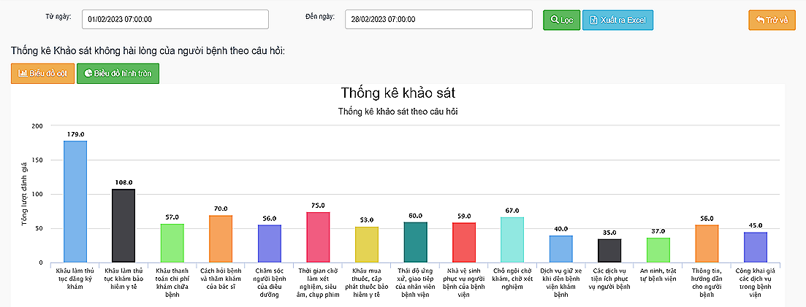

Fig. 1. Survey of patients' long-term dissatisfaction in February 2023.

According to information from the Ho Chi Minh City Department of Health, it announced the dissatisfaction of patients when going for examination at medical facilities and hospitals in February 2023, with feedback on the stage of registration and examination procedures. highest number of responses.

After searching for the keyword "Đặt lịch khám bệnh" on Google, I found 3 outstanding websites.

Evaluate websites based on the following criteria:

- Loading speed

- Display

- Feature

- Limit

### 2.1. Medpro (https://medpro.vn/)

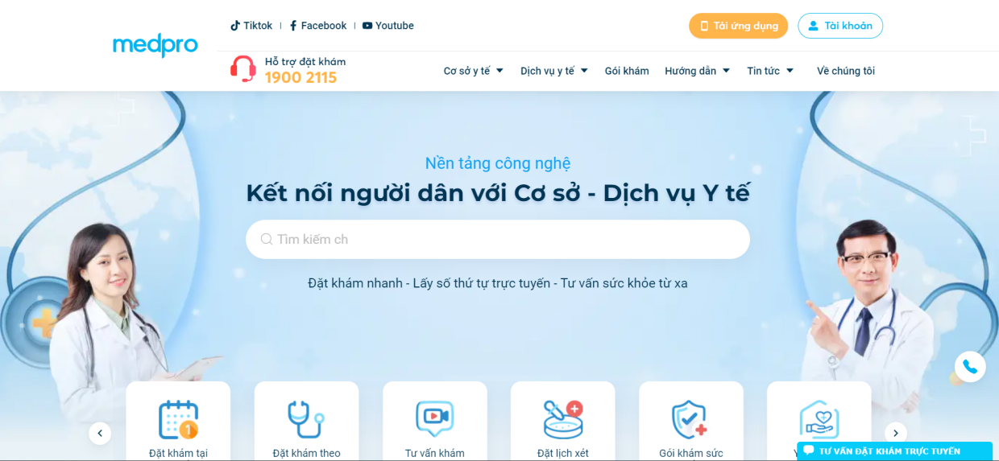

Fig. 2. Homepage Interface of the Medpro Website.

**Features:** Medpro allows patients and their family members to complete the online hospital registration process anytime, anywhere, without the need to physically visit the hospital. This is facilitated by four main criteria presented on the website: appointment scheduling and selection of examination dates and times, cashless payment of fees, appointment and re-examination scheduling management, and patient data management. Additionally, it provides both a mobile app and a website for easy use on smartphones and personal computers.

**Loading Speed:** Most icons, images, and lines of text load quickly, and page transitions are highly responsive.

**Functionality:** Medpro offers features that help patients easily search and select categories that match their preferences. It also provides various health checkup packages offered by partner hospitals on the website, optimizing the registration and payment processes, as well as post-payment steps. Moreover, it offers a wide range of hospitals, providing patients with multiple choices. Online consultation and a 24/7 hotline are available to support users.

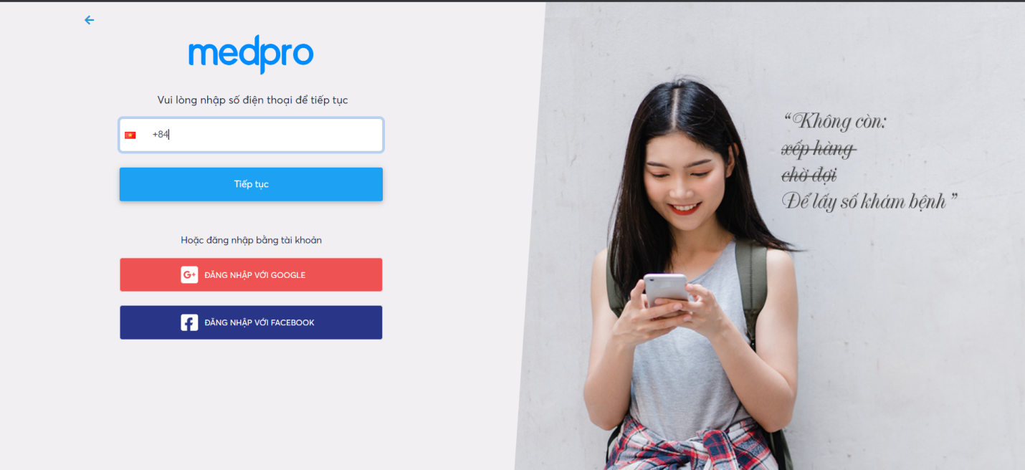

Fig. 3. Registration and Login Process into the System.

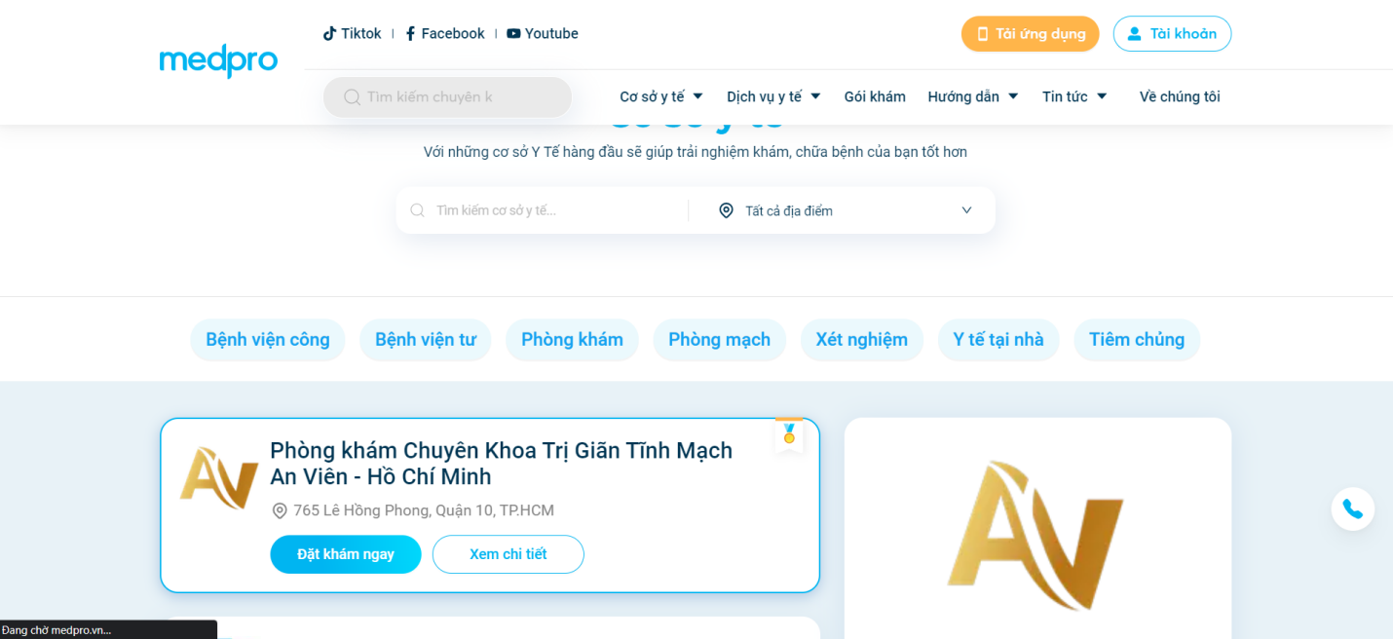

Fig. 4. Categories of Collaborating Hospitals.

**Limitations:** Some categories still lack data, and furthermore, the website is primarily in the Vietnamese language, which may pose usability challenges for non-Vietnamese users.

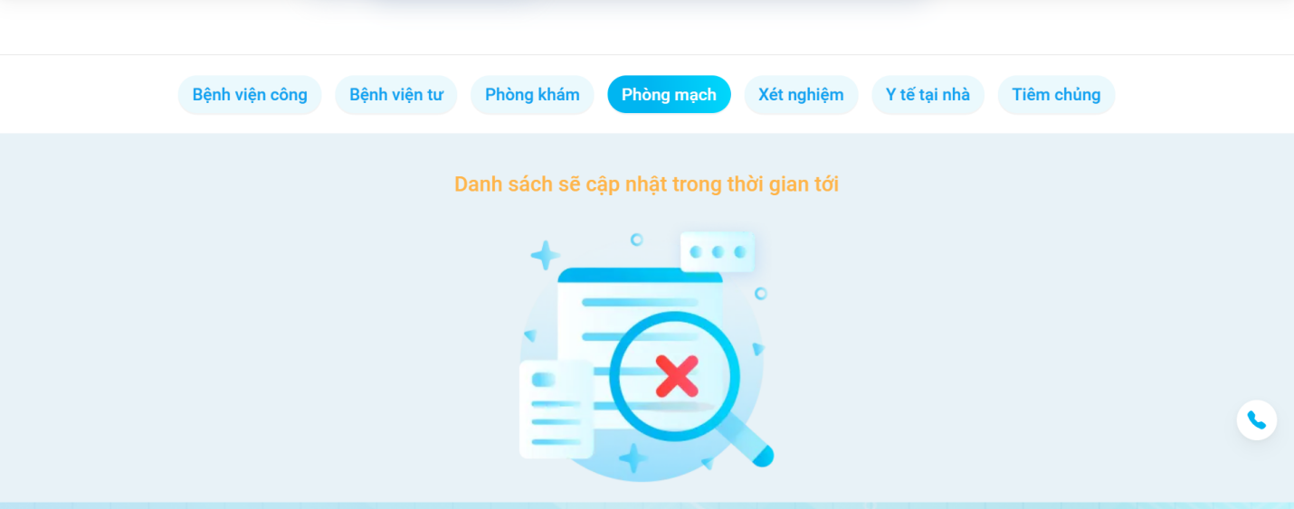

Fig. 5. Some categories are not yet filled.

**2.2. YouMed (https://youmed.vn/)** 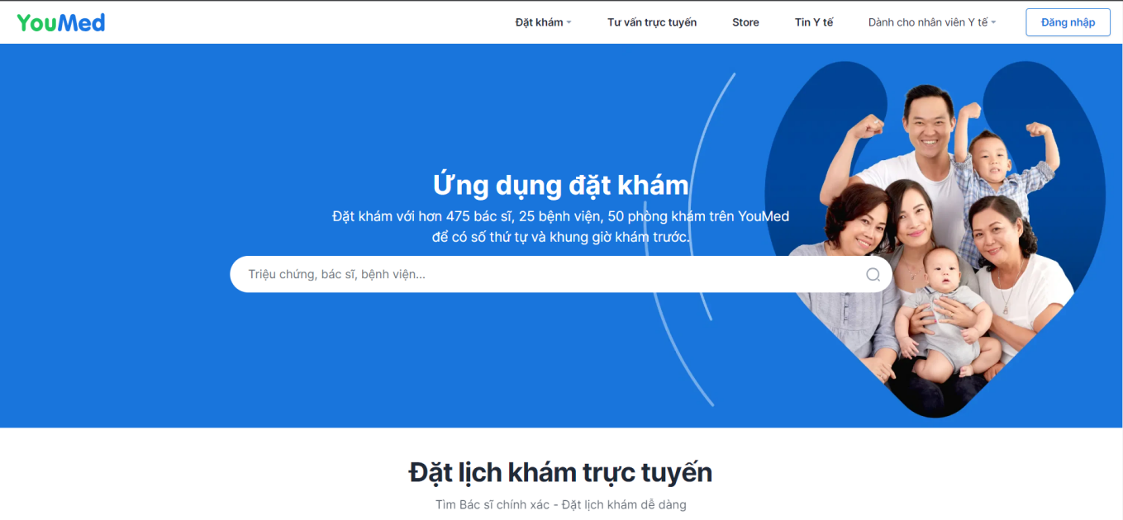

Fig. 6. YouMed Homepage.

**Features:** YouMed offers the ability to schedule appointments with over 475 doctors, 25 hospitals, and 50 clinics through YouMed. Users can use YouMed to obtain appointment slots and times in advance. The platform has been developed for both the website and a mobile app, providing users with a wide range of choices. Additionally, the website focuses on sharing health knowledge to create a reliable and easily understandable source of health information for all types of readers.

**Page Loading Speed:** Some APIs and images have relatively slow loading speeds, such as medical articles taking more than 10 seconds to load.

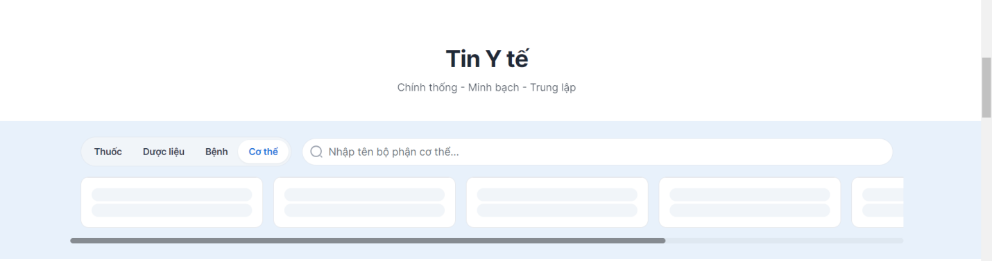

Fig. 7. Image of Health News section.

**Functionality**: YouMed offers a comprehensive set of features for appointment scheduling, with divisions into various medical departments and different examination services. Additionally, data security is a significant concern for YouMed.

**Limitations:** In terms of limitations, as previously mentioned, some images and information load relatively slowly. When using the search tool, the UI header experiences issues, and similar errors can be found on some other pages. Furthermore, like the Medpro company, the website is predominantly in the Vietnamese language, making it somewhat challenging for non-Vietnamese patients to access and use.

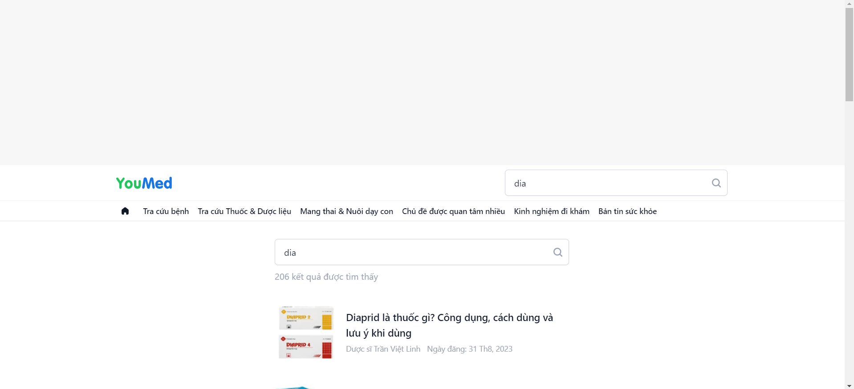

Fig. 8. Image when using the search function.



Fig. 9. Image when using the search function.

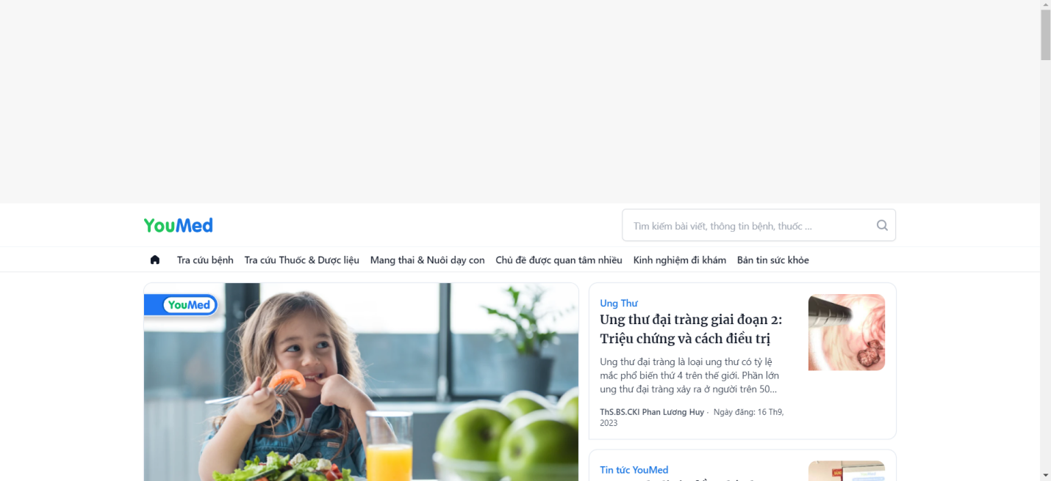

Fig. 10. News page.

**2.3. Conclusion after survey**

Through the process of surveying and analyzing data, databases, online payment procedures, and appointment scheduling processes, these surveys provide us with a general overview of the online medical appointment booking model. Subsequently, we can build a website with the necessary features without encountering the limitations of existing websites.

## 3. Theoretical Basis

### 3.1. ReactJS



Fig. 11. Logo of ReactJS.

ReactJS is a freely available open-source JavaScript library for creating user interfaces through components. It is developed by Meta (formerly Facebook) and a collaborative community consisting of individual developers and various companies.

React is versatile and can be employed to build various types of applications, including single-page applications, mobile apps, and server-rendered applications using frameworks like Next.js. React primarily focuses on user interface design and rendering components within the Document Object Model (DOM). In many cases, ReactJS applications integrate with additional libraries for tasks such as routing and other client-side functionalities.

Virtual DOM: This technology reduces the need to re-render the entire DOM whenever changes occur, which improves application speed. ReactJS makes use of a Virtual DOM, a JavaScript object that has all the properties and attributes needed to build a true DOM. To optimize the re-rendering of the real DOM when data changes, it computes the differences between the virtual DOM object and the real tree. One-way data binding, another feature of ReactJS, makes data flow easier by using props to transfer data from a parent component to a child component. This one-way data flow facilitates easier control and debugging of errors.

ReactJS is well-suited for building large applications where data frequently changes, and these changes often correspond to interface modifications. For instance, on Facebook, your news feed continuously displays various status updates with changing like counts, shares, and comments. ReactJS is highly beneficial for handling such dynamic data.

JSX: JSX is a syntax extension that allows you to write HTML-like code within JavaScript. JSX offers several advantages:

- Faster: When JSX is compiled into JavaScript, it undergoes optimization that makes it run substantially faster than if the same code were written in JavaScript directly.

- Safer: JSX is statically typed, like JavaScript, meaning it is compiled before it is executed, much like C++ or Java. This preliminary compilation aids in the early detection of faults.

- Easier: Because JSX expands on JavaScript, it is simple for JavaScript developers to use.

Components: ReactJS is built around components rather than templates, as seen in some other frameworks. In ReactJS, you create web applications using small components that can be reused in different contexts. Components can be nested, containing other components. Each component in ReactJS has its state, which can change, and ReactJS updates the component based on state changes. Virtually everything in ReactJS is a component, simplifying code maintenance in large projects.

* Props and State:

- Props: These allow components to communicate with one another. When a component takes "props" as input, it returns properties that specify how the child component will render. Props are unchangeable.

- State: Represents the application's state. When the state changes, the component re-renders to update the interface.

ReactJS's combination of these features makes it a powerful tool for building dynamic and interactive user interfaces.

**3.2. NodeJS**



Fig. 12. Logo of NodeJS.

Node.js is an open-source server environment that is compatible with multiple operating systems, including Windows, Linux, Unix, and macOS. JavaScript code can be executed outside of a web browser with Node.js, a back-end JavaScript runtime environment that is powered by the V8 JavaScript engine.

NodeJS is an open-source platform built on the Chrome JavaScript runtime for developing fast and scalable applications. It utilizes event-driven, non-blocking I/O to create lightweight and efficient applications, particularly suited for real-time data processing on distributed devices.

NodeJS operates with a single thread and could work asynchronously. Unlike servers written in PHP, where each incoming request creates a new thread for processing, a NodeJS server handles all actions within a single thread. This design approach in NodeJS offers several advantages for websites:

- Asynchronous: All NodeJS APIs are non-blocking, relying on the NodeJS server's background to wait for data to return. Moving the server to the next API call after making a request and NodeJS's event-driven mechanism enable the server to respond to API calls in real-time.

- Fast Execution: NodeJS is built on the V8 JavaScript Engine platform, resulting in speedy program execution.

- Single Thread with High Scalability: NodeJS uses a single-threaded model with an event loop, which enables servers to respond without interruption and makes them highly scalable.

- No Buffering: NodeJS doesn't buffer any data, and applications primarily produce data output.

- Licensed: NodeJS is licensed under the MIT License.

Operation: NodeJS utilizes non-blocking, event-driven I/O for real-time tasks, allowing rapid processing. NodeJS's rapid scalability and the ability to handle many concurrent connections with high throughput are significant benefits. In contrast to traditional web applications where each request creates a new processing thread, consuming system RAM inefficiently, NodeJS uses a single-threaded approach combined with non-blocking I/O to execute requests, supporting tens of thousands of concurrent connections.

Express is a web application framework for NodeJS that offers powerful web features. Express makes it easy to develop fast NodeJS-based web applications. It supports various HTTP methods and middleware, creating a robust and user-friendly API. Key features of the Express framework include:

- Ability to set up middleware to handle HTTP requests.

- Define routing that can be used with different actions based on HTTP methods and URLs.

- Render HTML pages based on passed-in parameters to templates.

### 3.3. MySQL



Fig. 13. Logo of MySQL.

MySQL is an open-source Relational Database Management System (RDBMS) operating as a client-server model. In the realm of RDBMS, MySQL has been integrated with Apache and PHP.

Officially released since the 1990s, MySQL currently manages data through databases, with each database capable of containing multiple relational tables with data. Furthermore, MySQL follows the same access methodology and utilizes similar SQL language. So, what is the history and development process of MySQL?

We will delve into this in detail in the following section.

* Some basic commands on MySQL:

- Create a database: CREATE DATABASE test;

- Create a table: CREATE TABLE students (id INT AUTO_INCREMENT PRIMARY KEY, name VARCHAR(255), gender VARCHAR(10));

- Insert data: INSERT INTO students (name, gender) VALUES ('thanh', 'male');

- Update data: UPDATE students SET name = 'thanh update' WHERE id = 1;

- Delete data: DELETE FROM students WHERE id = 1;

- Find all records: SELECT * FROM students;

- Find specific records: SELECT * FROM students WHERE name = 'thanh';

* Advantages of MySQL:

- Quick and Efficient: MySQL offers rapid performance by introducing standards and cost-effective measures, enhancing execution speed.

- Robust and Scalable: MySQL efficiently manages large datasets and, notably, can scale up as required.

- Feature-Rich: What are the advantages of MySQL? MySQL supports a wide range of SQL functionalities, both indirectly and directly, meeting the expectations of a relational database management system.

- High Security: MySQL is well-suited for applications accessing databases over the internet, featuring robust security measures, including advanced levels of protection.

* Disadvantages of MySQL:

- Limited Capacity: As the number of records in your database grows, data retrieval can become increasingly challenging. To address this, various measures must be employed to improve data access speed, such as implementing MySQL caching or distributing the database across multiple servers.

- Reliability Concerns: What are the drawbacks of MySQL? The specific functionality handling within MySQL (e.g., auditing, transactions, reference materials) can make it less reliable than some other relational database management systems.

- Constraints: What is MySQL? By design, MySQL does not intend to offer a complete solution and comes with limitations related to features that certain applications may require. So, what are the key distinctions between MySQL Server and MySQL?

**3.4. Sequelize**

Sequelize, a Node.js-based Object Relational Mapper, simplifies interactions with various databases such as MySQL, MariaDB, SQLite, PostgreSQL, and others. Its role as an Object Relational Mapper involves managing database records through the representation of data as objects. Notably, Sequelize boasts a robust migration mechanism capable of seamlessly updating existing database schemas to new iterations. In essence, Sequelize offers extensive support for database synchronization, eager loading, associations, transactions, and migrations, thereby streamlining development processes and enhancing security by mitigating the risk of SQL injections.

* To successfully use Sequelize, ensure the following:

- A development environment configured with Node.js. If the setup hasn't been completed, refer to the relevant tutorial for the operating system: "How to Install Node.js and Create a Local Development Environment."

- MySQL installed in the working environment. Follow the steps outlined in the tutorial "How to Install MySQL" for the specific environment. Additionally, ensure the creation of a user as instructed.

- A working knowledge of JavaScript and MySQL queries. If necessary, skills can be enhanced by referring to the "How to Code in JavaScript" series and the tutorial titled "An Introduction to Queries in MySQL."

- A fundamental understanding of relational database concepts. If not already done, familiarize yourself with the basics through the tutorial "Understanding Relational Databases."

* Some basic commands on Sequelize:

- Create a new model: npx sequelize-cli model:generate --name User --attributes firstName:string,lastName:string,email:string

- Run migrations to create tables in the database: npx sequelize-cli db:migrate

- Create a new record in the table:

const User = require('./models').User;

User.create({

firstName: 'Chau',

lastName: 'Thai',

email: 'john.doe@example.com'

}).then(user => {

console.log('User created:', user);

});

- Query data from table:

User.findAll().then(users => {

console.log('All users:', users);

});

- Query data with conditions:

User.findOne({ where: { firstName: 'John' } }).then(user => {

console.log('Found user:', user);

});

- Delete a record:

User.destroy({ where: { firstName: 'John' } }).then(() => {

console.log('User deleted');

});

**CHAPTER II: SYSTEM FUNCTIONS**

**1. List of functions**

**\* For Guest:**

1. View specialist detail
2. View information of doctors
3. View information of clinics
4. Booking an appointment
5. Appointment confirmation via email

**\* For Doctor:**

1. Login for Doctor
2. Scheduled time management
3. Patient scheduling management
4. Send information of the medical examination process to the patient
5. Patient History management

**\* For Admin:**

1. Login for Admin
2. User management
3. Doctor management
4. Clinic Management
5. Specialty Management

**\* All Actor:**

1. Contact
2. Switch language VN/EN

**2. System functions**

**2.1. Functional design**

**\* For Guest:**

1. View Specialist Detail: Guests can view comprehensive profiles of specialists including qualifications and expertise.
2. View Information of Doctors: Provides access to doctors' professional information and background.
3. View Information of Clinics: Allows the inspection of various health facility features, services, and infrastructures.
4. Booking an Appointment: Enables guests to view the availability of doctors and book appointments.
5. Appointment confirmation via email: Send confirmation emails with appointment details.

**\* For Doctor:**

1. Login for Doctor: Secure login process for doctor to access the system.
2. Scheduled time management: Doctor can oversee and organize the appointment schedules.
3. Patient scheduling management: Doctor can manage their scheduled patients.
4. Send information of the medical examination process to the patient: Doctor can send information about the medical examination process such as examination results, invoices, prescriptions, etc. to the patient.
5. Patient History Management: Doctors can manage a history of patients who have completed medical appointments with the doctor.

**\* For Admin:**

1. Login for Admin: Secure login process for admin to access the system.
2. User Management: Provides the ability to manage user accounts and their permissions.
3. Doctor Management: Admin can add, remove, or edit doctor profiles and their schedules.
4. Clinic Management: Enables the admin to manage the various aspects of the health facility including services offered, facility hours, and maintenance.
5. Specialty Management: Admin can add, remove, or edit information of specialties.

**\* For All Actors:**

16. Contact: A feature that provides information on how to get in touch with the health facility or support staff.

17. Switch Language VN/EN: Allows users to change the language of the website between Vietnamese and English.

**2.2. Functional Specification**

Tab. 1. Functional Specification.

|  |  |  |
| --- | --- | --- |
| **No.** | **Function Name** | **Description** |
| 1 | View Specialist Detail | Guests view comprehensive profiles of specialists including qualifications and expertise. |
| 2 | View Information of Doctors | * Provides access to doctors' professional information and background. |
| 3 | View Information of Clinics | It allows clients the inspection of various health facility features, services, and infrastructures. |
| 4 | Booking an Appointment | * Guests can view the availability of doctors and book appointments. |
| 5 | Appointment confirmation via email | Guests can read through feedback and ratings given by other users. |
| 6 | Login for Doctor | * Secure login process for doctor to access the system. * Doctors will receive notifications such as: * Please input your Email, Password * Yours’s Email isn't existed in your system. Please try other emails! * User not found! * Wrong password! * Login success! |
| 7 | Scheduled time management | Doctors oversee and organize the appointment schedules. |
| 8 | Patient scheduling management | Doctors manage their scheduled patients. |
| 9 | Send information of the medical examination process to the patient | Doctors send information about the medical examination process such as examination results, invoices, prescriptions, etc. to the patient. |
| 10 | Patient History Management | Doctors manage a history of patients who have completed medical appointments with the doctor. |
| 11 | Login for Admin | Secure login process for admin to access the system.   * Admin will receive notifications such as: * Please input your Email, Password * Your Email isn't existed in your system. Please try other emails! * User not found! * Wrong password!   Login success! |
| 12 | User Management | It provides the ability to manage user information, accounts, and their permissions. |
| 13 | Doctor Management | Admin can add, remove, or edit doctor profiles and their schedules. |
| 14 | Clinic Management | It enables the admin to manage the various. |
| 15 | Specialty Management | Admin can add, remove, or edit information of specialties. |
| 16 | Contact | A feature that provides information on how to get in touch with the health facility or support staff. |
| 17 | Switch Language VN/EN | It allows users to change the language of the website between Vietnamese and English. |

## 3. User role

### 3.1. For Guest

- Guests can access detailed information about healthcare specialists, including their qualifications and areas of expertise.

- Guests can view profiles of individual doctors, including their experience, patient reviews, and availability.

- Guests can explore information about different clinics, including their location, facilities, and services.

- Guests can schedule medical appointments with their chosen doctors.

- Guests can read comments and reviews left by other users about doctors and clinics.

- Guests receive confirmation emails for their booked appointments.

### 3.2. For Doctor

- Doctors can log in to the system using their credentials.

- Doctors can manage their scheduled working hours.

- Doctors can view and manage their appointments with patients.

- Doctors can provide relevant information to patients regarding the medical examination process.

**3.3. Admin**

- Admins can log in to the system using their credentials.

- Admins can manage information related to doctors, including profiles and availability.

- Admins can manage information related to clinics, including location and services.

- Admins can manage medical specialties available on the platform.

**3.4. All Users**

- All users can use the contact feature to get in touch with the platform.

- All users can switch between Vietnamese and English languages on the website for their convenience.

# CHAPTER III: SYSTEM ANALYSIS AND DESIGN

## 1. General use case

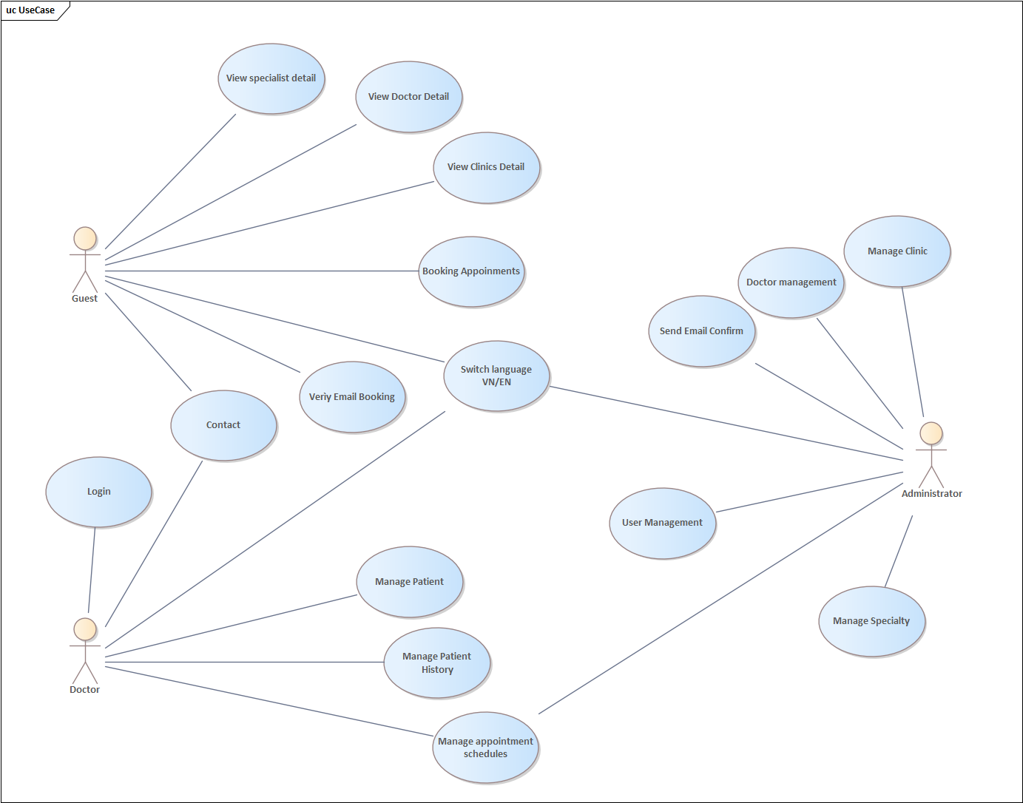

Fig. 14. Use Case Diagram.

## 2. Detailed specification of each use case

### 2.1. Use case Login

Tab. 2. Login Specification.

|  |  |  |  |
| --- | --- | --- | --- |
| **Use case ID** | UC01 | | |
| **Use case name** | Login | | |
| **Description** | Actor logs into the system | | |
| **Actor(s)** | Doctor, Admin | | |
| **Priority** | Must have | | |
| **Pre-Condition(s)** | This agent already has a registered, verified, and approved account | | |
| **Basic Flow** |  |  | **Action** |
| 1 | User | Select login function |
| 2 | System | Display login interface |
| 3 | User | Enter Account name + Pass (……) |
| 4 | User | Requires login |
| 5 | System | Check all information has been entered |
| 6 | System | Check Email and Password |
| 7 | System | Display functions corresponding to Account |
| **Alternative Flow** | 5a | System | “Missing Require Parameter” message |
| 5a1 | System | Return to Step 3 |
| 6a | System | Your email does not exist |
| 6a1 | System | Return to Step 3 |
| 6b | System | Wrong Password |
| 6b1 | System | Return to Step 3 |
| **Post-Condition(s)** | The agent can log into the system | | |

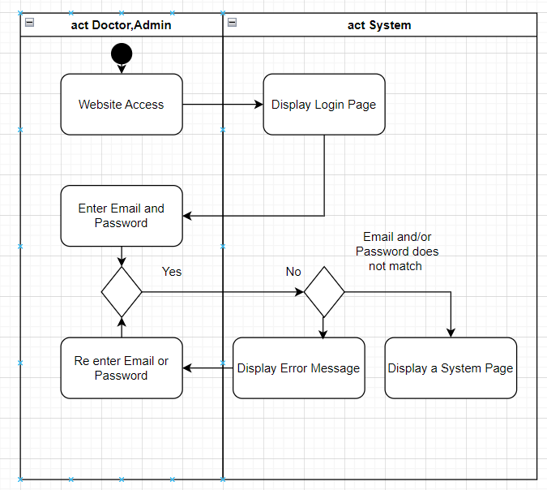

Fig. 15. Activity Diagram for Login.

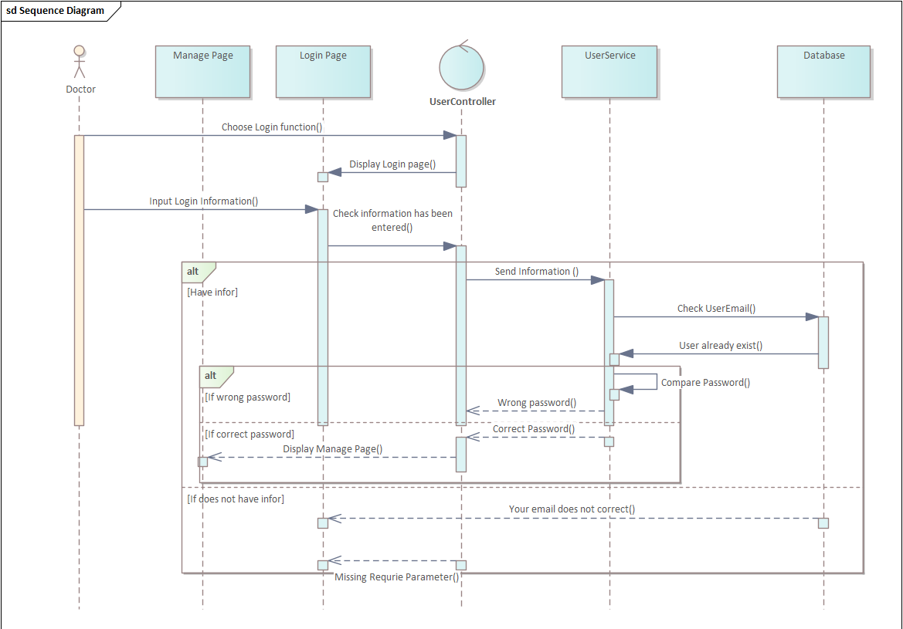

Fig. 16. Sequence Diagram for Login.

### 2.2. Use case View Doctor Information

Tab. 3. View Doctor Information Specification.

|  |  |  |  |
| --- | --- | --- | --- |
| **Use case ID** | UC02 | | |
| **Use case name** | View Doctor Information | | |
| **Description** | Display the list name of doctor when you choose the specialist | | |
| **Actor(s)** | Guest | | |
| **Priority** | Must have | | |
| **Pre-Condition(s)** | Choose the Specialist button | | |
| **Basic Flow** |  |  | **Action** |
| 1 | Guest | Choose one of Specialist |
| 2 | System | Display information of doctor |
| **Exception Flow** | 2a | System | “Does not have doctor in this time “ |
| **Post-Condition(s)** | Display Doctor information | | |

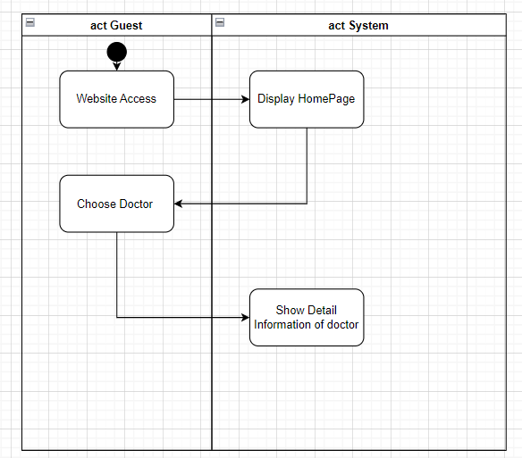

Fig. 17. Activity Diagram for Viewing Doctor Information.

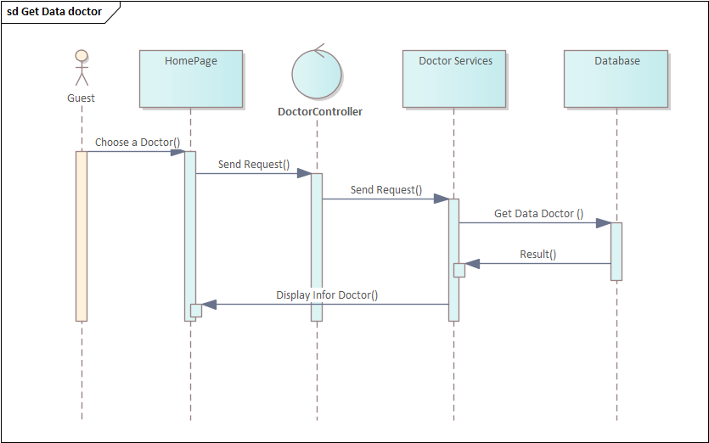

Fig. 18. Sequence Diagram for Viewing Doctor Information.

### 2.3. Use case View Specialist Detail

Tab. 4. View Specialist Detail Specification.

|  |  |  |  |
| --- | --- | --- | --- |
| **Use case ID** | UC03 | | |
| **Use case name** | View Specialist detail | | |
| **Description** | Display the list of Specialist | | |
| **Actor(s)** | Guest | | |
| **Priority** | Must have | | |
| **Pre-Condition(s)** |  | | |
| **Basic Flow** |  |  | **Action** |
| 1 | Guest | Choose the Specialist |
| 2 | System | Display information of Specialist |
| **Alternative Flow** |  |  |  |
| **Exception Flow** |  |  |  |
| **Post-Condition(s)** | Display Specialist Detail | | |

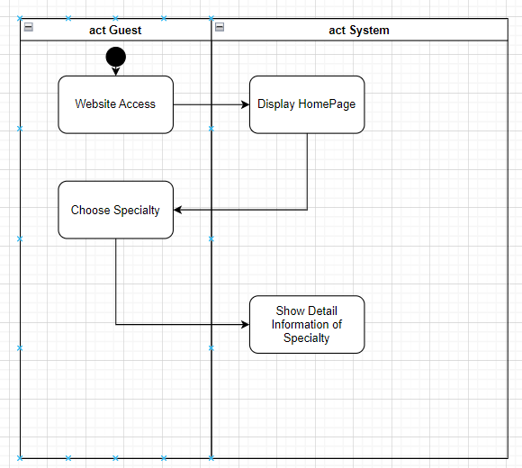

Fig. 19. Diagram for Viewing Specialist Detail.

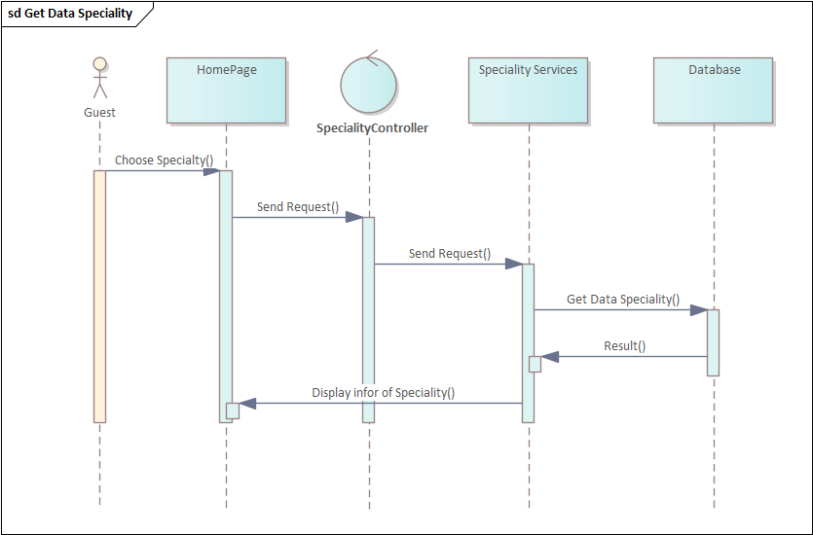

Fig. 20. Sequence Diagram for Viewing Specialist Detail.

### 2.4. Use case View Clinic Detail

Tab. 5. View Clinic Detail Specification.

|  |  |  |  |
| --- | --- | --- | --- |
| **Use case ID** | UC04 | | |
| **Use case name** | View Clinic | | |
| **Description** | Display the Blog | | |
| **Actor(s)** | Guest, Doctor | | |
| **Priority** | Must have | | |
| **Pre-Condition(s)** |  | | |
| **Basic Flow** |  |  | **Action** |
| 1 | Guest | Choose Clinic |
| 2 | System | Display Clinic Information |
| **Alternative Flow** |  |  |  |
| **Exception Flow** |  |  |  |
| **Post-Condition(s)** | Display Blog | | |

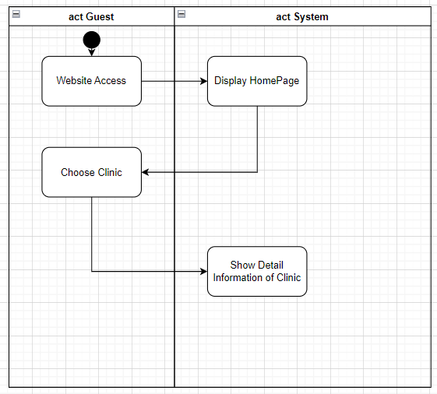

Fig. 21. Activity Diagram for Viewing Clinic Detail.

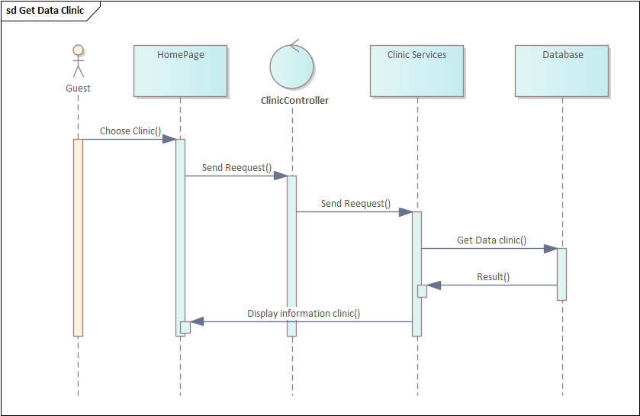

Fig. 22. Sequence Diagram for Viewing Clinic Detail.

### 2.5. Use case Book an Appointment

Tab. 6. Book An Appointment Specification.

|  |  |  |  |
| --- | --- | --- | --- |
| **Use case ID** | UC05 | | |
| **Use case name** | Book An Appointment | | |
| **Description** | Help the patient book schedule to see doctor | | |
| **Actor(s)** | Patient | | |
| **Priority** | Must have | | |
| **Pre-Condition(s)** |  | | |
| **Basic Flow** |  |  | **Action** |
| 1 | Patient | Choose Doctor in Homepage |
| 2 | System | Display Detail Doctor Page |
| 3 | Patient | Select Date and Time |
| 4 | System | Display Form to get information of patient |
| 5 | Patient | Enter Information (FullName, PhoneNumber, Email, Address, Reason for medical examination, ...) and click confirm |
| 6 | System | Check information |
| 7 | System | Send Email for Patients |
| 8 | System | Display Booking Schedule Succeed |
| **Alternative Flow** | 1a | Patient | Choose Specialty in Homepage |
| 1a2 | System | Display Specialty |
| 1a3 | Patient | Choose a Doctor, Time, Date |
| 1b | Patient | Choose Clinic in Homepage |
| 1b2 | System | Display Clinic |
| 1b3 | Patient | Choose a Doctor, Time, Date |
| **Exception Flow** | 8a | System | Display Booking Schedule Fail |
| **Post-Condition(s)** | Booking Schedule Succeed | | |

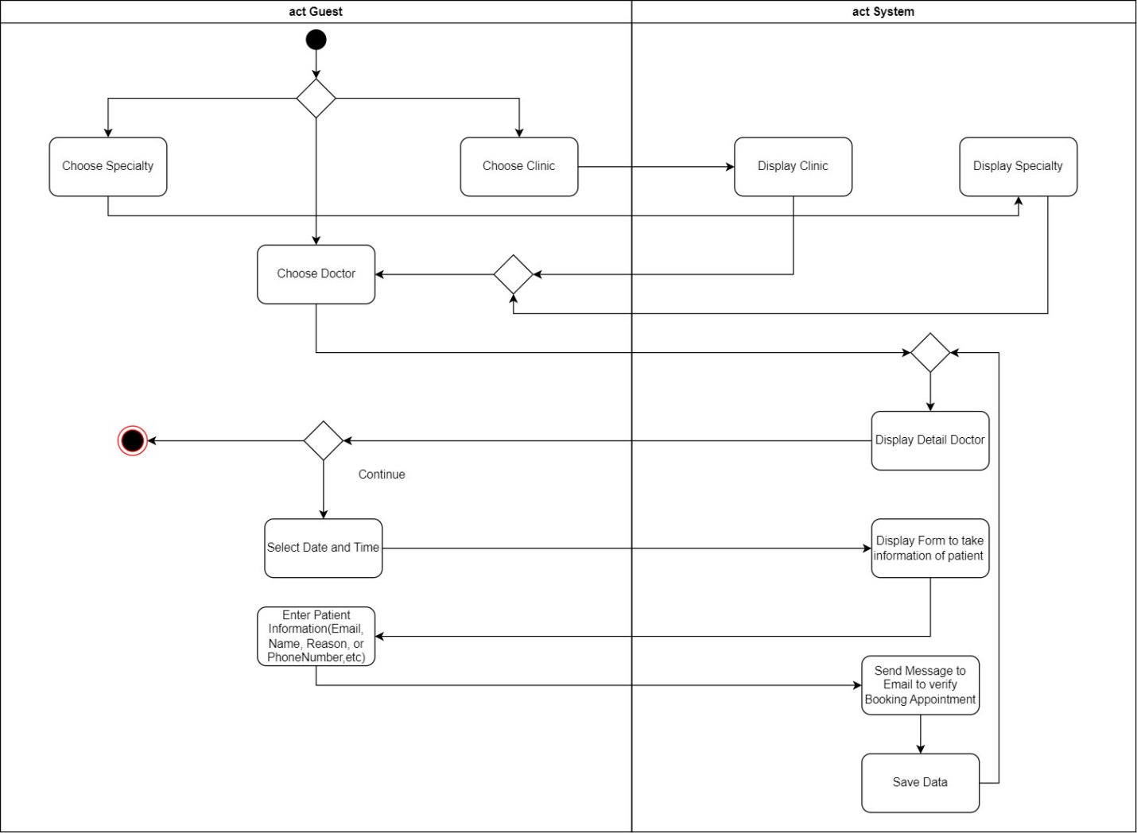

Fig. 23. Activity Diagram for Booking Appointment.

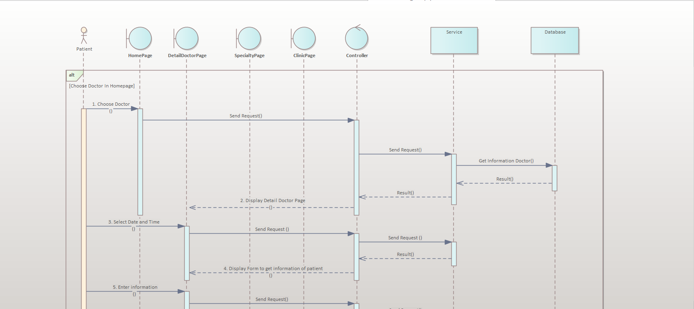

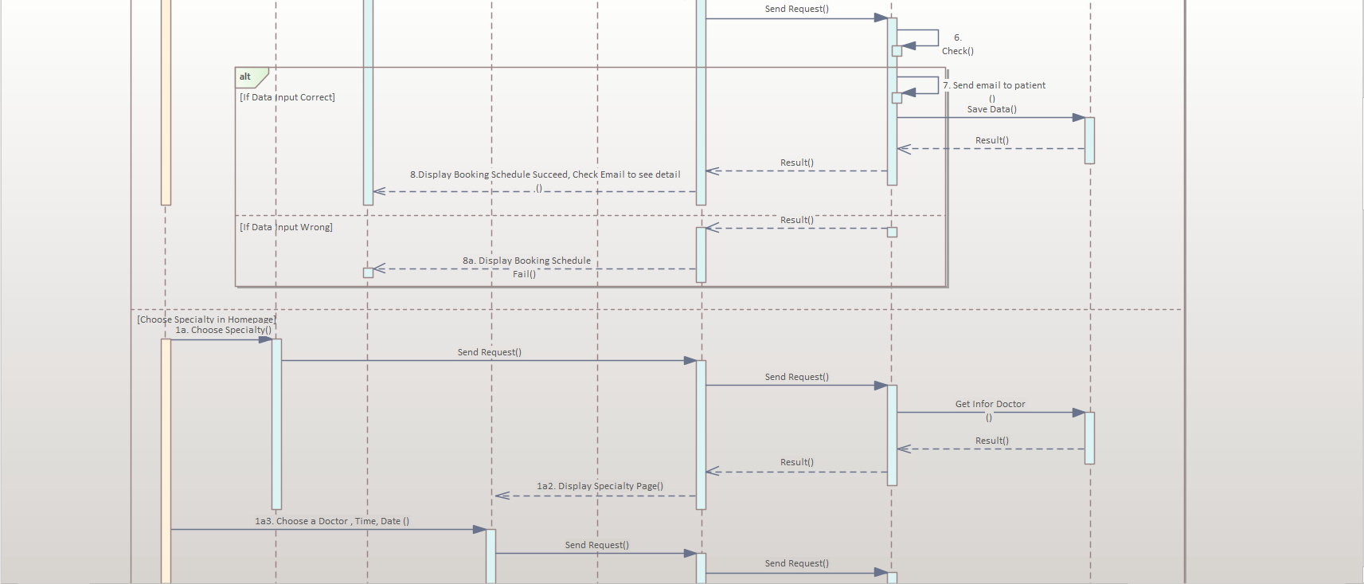

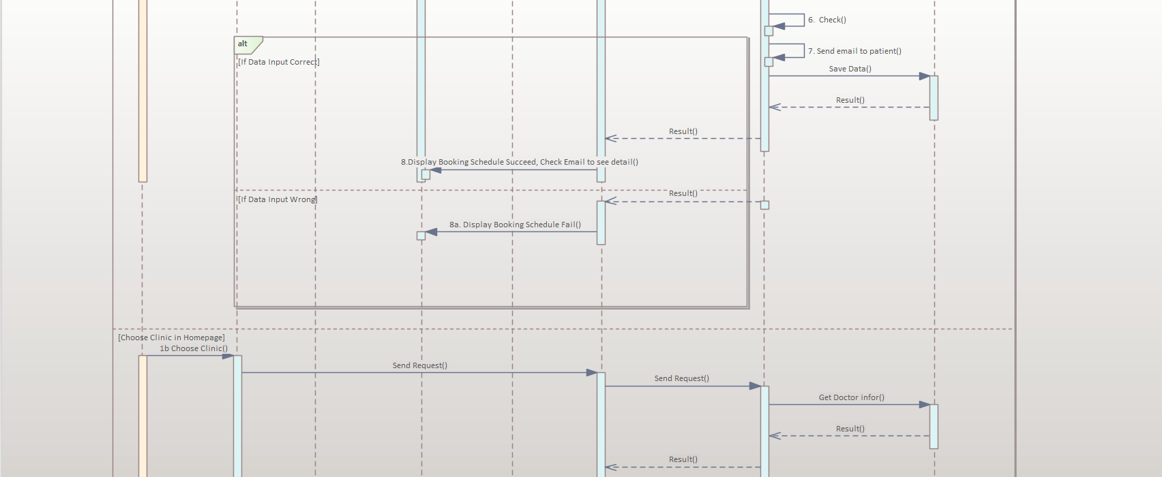

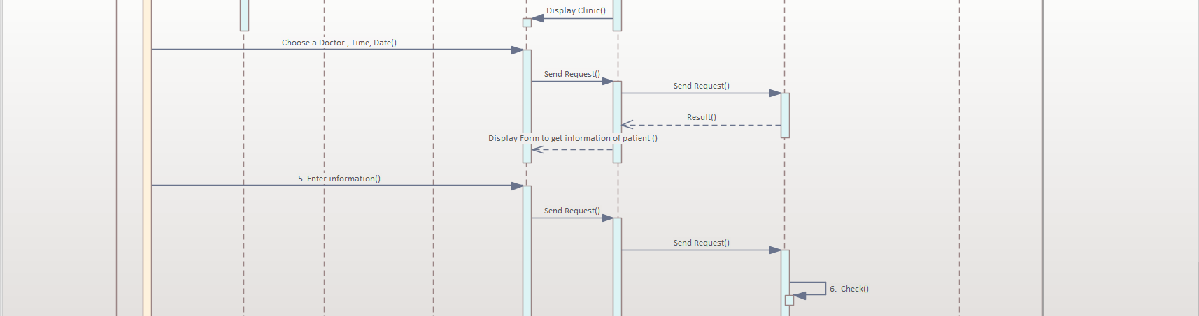

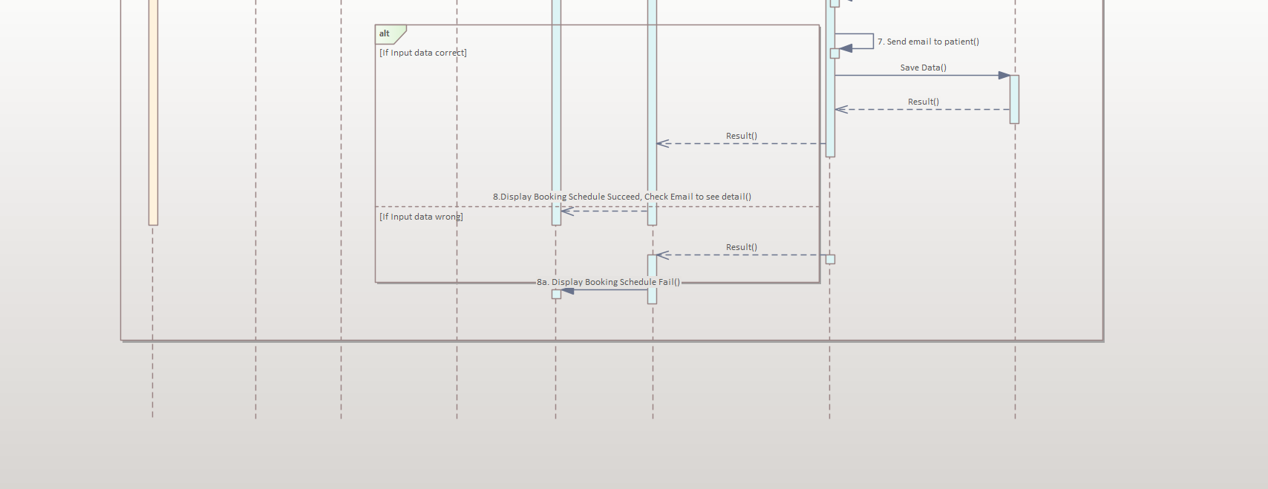

Fig. 24. Sequence Diagram for Booking Appointment.

**2.6. Use case Manage User**

Tab. 7. User Management Specification.

|  |  |  |  |
| --- | --- | --- | --- |
| **Use case ID** | UC06 | | |
| **Use case name** | Manage User | | |
| **Description** | Help the manager manage user | | |
| **Actor(s)** | Admin | | |
| **Priority** | Must have | | |
| **Pre-Condition(s)** | Requires user to be admin | | |
| **Basic Flow** |  |  | **Action** |
| 1 | Admin | Select "User Management" |
| 2 | System | Display User Management Interface |
| 3 | Admin | Select Function |
| 4 | System | Check Information |
| 5 | Admin | Click Save Button |
| 5 | System | Display “Success” on the screen |
| **Alternative Flow** | 3a | Admin | Input Information of new user |
| 3a1 | Admin | Select Create new user button |
| 3b | Admin | Select “Delete Button” |
| 3c | Admin | Select “Edit Product” |
| 3c2 | Admin | Choose Product you want to edit |
| 3c3 | Admin | Enter new information |
| **Exception Flow** | 5a | System | "Product does not exist" message |
| **Post-Condition(s)** | Create Update Delete user | | |

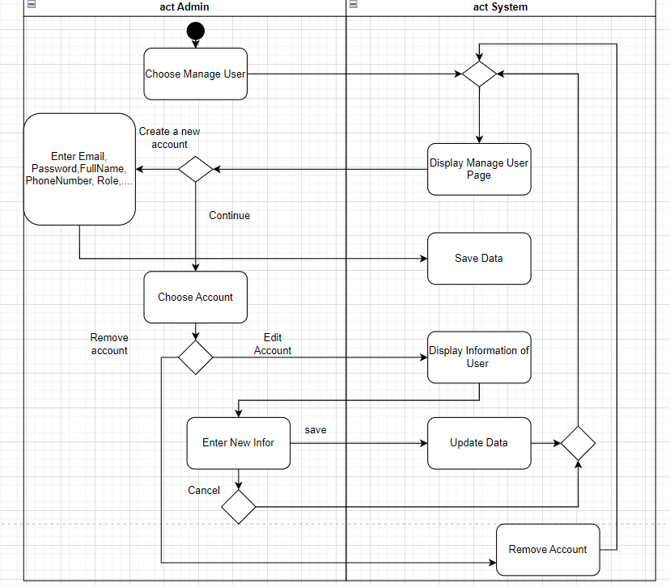

Fig. 25. Activity Diagram for User Management.

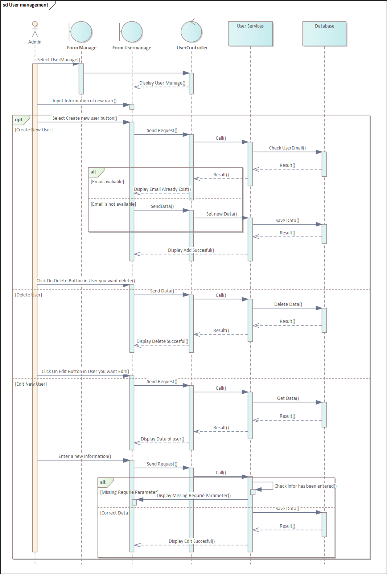

Fig. 26. Sequence Diagram for User Management.

**2.7. Use case Manage Doctor**

Tab. 8. Doctor Management Specification.

|  |  |  |  |
| --- | --- | --- | --- |
| **Use case ID** | UC07 | | |
| **Use case name** | Manage Doctor | | |
| **Description** | Help to create more information for doctor | | |
| **Actor(s)** | Admin | | |
| **Priority** | Must have | | |
| **Pre-Condition(s)** | Requires user to be admin | | |
| **Basic Flow** |  |  | **Action** |
| 1 | Admin | Select "Doctor Management" |
| 2 | System | Display Doctor Management Interface |
| 3 | Admin | Select Doctor |
| 4 | System | Check Data Doctor |
| 5 | System | Display Infor Doctor |
| 6 | Admin | Input Data |
| 7 | Admin | Click on Save button |
| 8 | System | Check Information |
| 9 | System | Display “Save information doctor success” on the screen |
| **Exception Flow** | 9a | System | Display “Save information doctor error” on the screen |
| **Post-Condition(s)** | Create and update more information for doctor | | |



Fig. 27. Activity Diagram for Doctor Management.

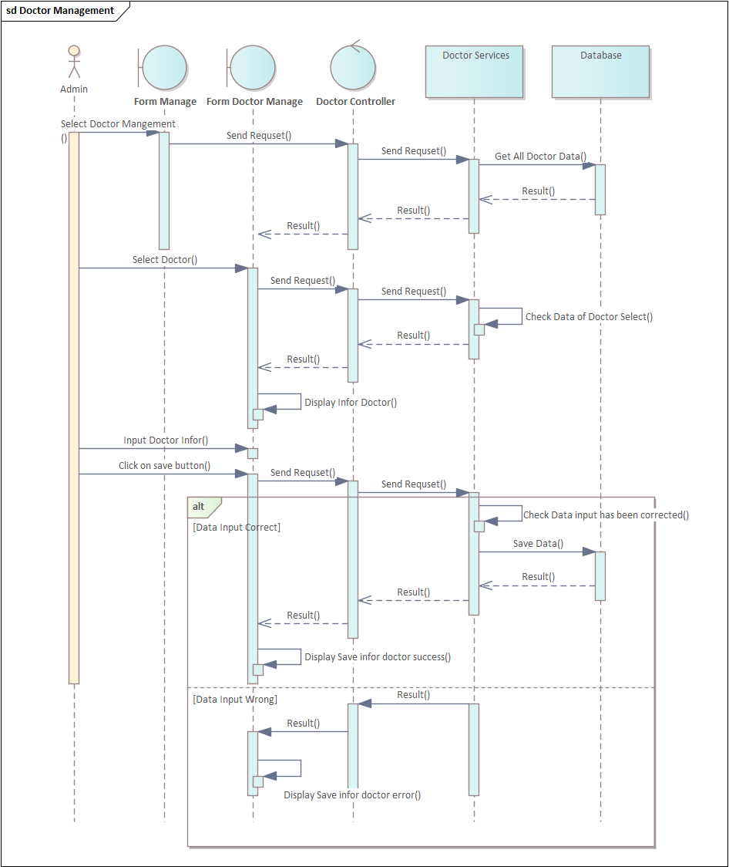

Fig. 28. Sequence Diagram for Doctor Management.

### 2.8. Use case Manage Doctor Schedule

Tab. 9. Doctor Schedule Management Specification.

|  |  |  |  |
| --- | --- | --- | --- |
| **Use case ID** | UC08 | | |
| **Use case name** | Manage Doctor Schedule | | |
| **Description** | Help to create doctor Schedule | | |
| **Actor(s)** | Admin, Doctor | | |
| **Priority** | Must have | | |
| **Pre-Condition(s)** | Requires user to be admin or Doctor | | |
| **Basic Flow** |  |  | **Action** |
| 1 | Doctor | Select "Manage Doctor Schedule" |
| 2 | System | Display Manage Doctor Schedule interface |
| 3 | Doctor | Select Doctor |
| 4 | System | Check Data Doctor |
| 5 | Doctor | Choose Date |
| 6 | Doctor | Choose Time and Click save button |
| 7 | System | Check Information |
| 8 | System | Display “Save information doctor successfully” on the screen |
| **Exception Flow** | 8a | System | Display “Save information doctor error” on the screen |
| **Post-Condition(s)** | Create and Update Schedule | | |

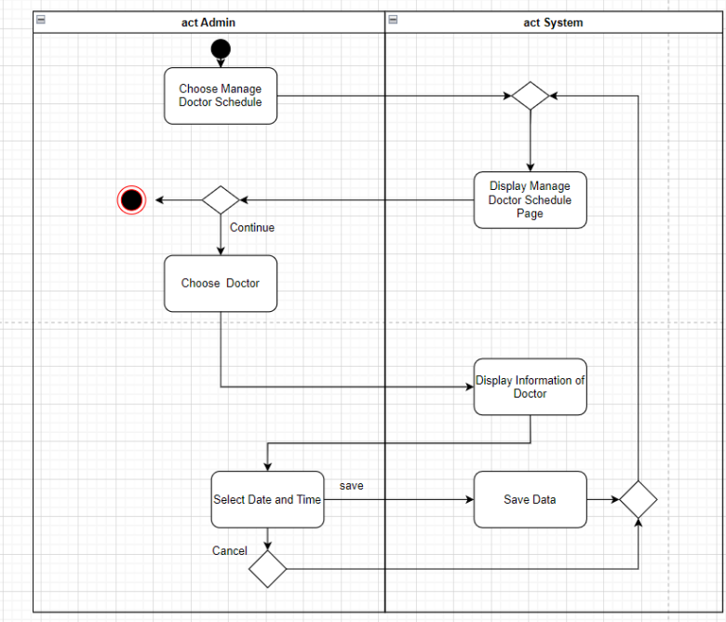

Fig. 29. Activity Diagram for Doctor Schedule Management.

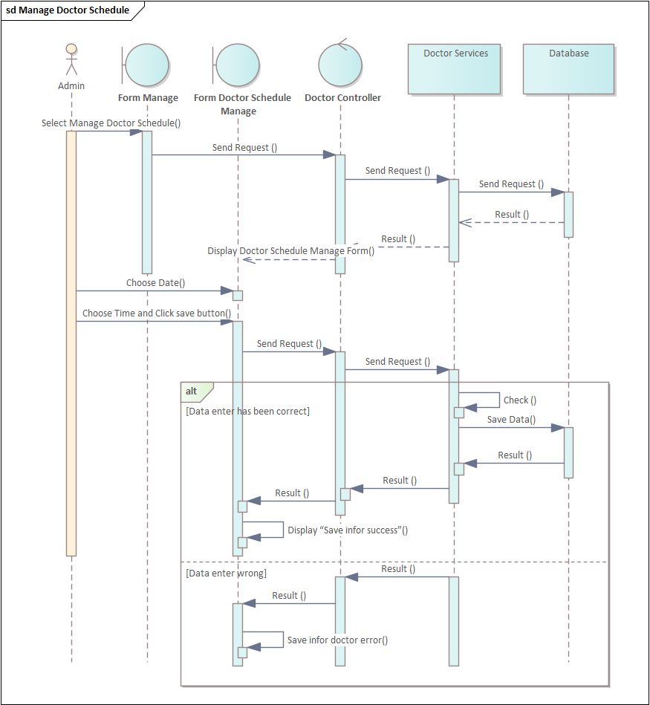

Fig. 30. Sequence Diagram for Doctor Schedule Management.

**2.9. Use case Manage Clinic**

Tab. 10. Clinic Management Specification.

|  |  |  |  |
| --- | --- | --- | --- |
| **Use case ID** | UC09 | | |
| **Use case name** | Manage Clinic | | |
| **Description** | Help to create clinic information | | |
| **Actor(s)** | Admin | | |
| **Priority** | Must have | | |
| **Pre-Condition(s)** | Requires user to be admin | | |
| **Basic Flow** |  |  | **Action** |
| 1 | Admin | Select "Manage Clinic" |
| 2 | System | Display Manage Clinic interface |
| 3 | Admin | Input Data (Name + Image + Address + Description) |
| 4 | Admin | Click save button |
| 5 | System | Check Information |
| 6 | System | Display “Save information doctor success” on the screen |
| **Exception Flow** | 6a | System | Display “Save information doctor error” on the screen |
| **Post-Condition(s)** | Create a new Clinics | | |

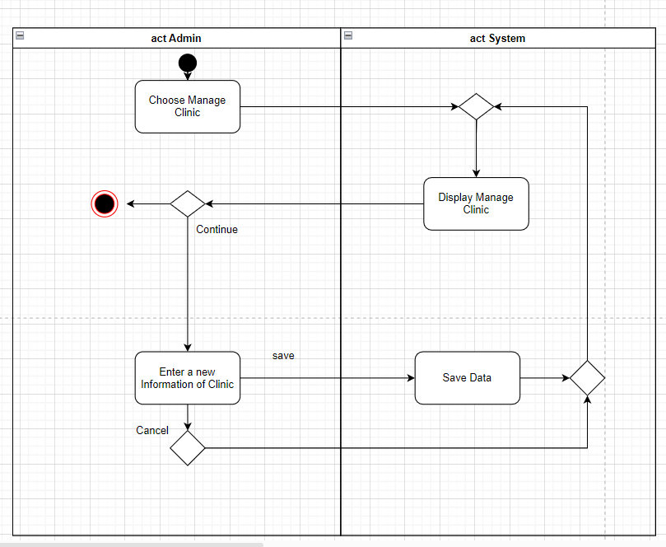

Fig. 31. Clinic Management Specification.

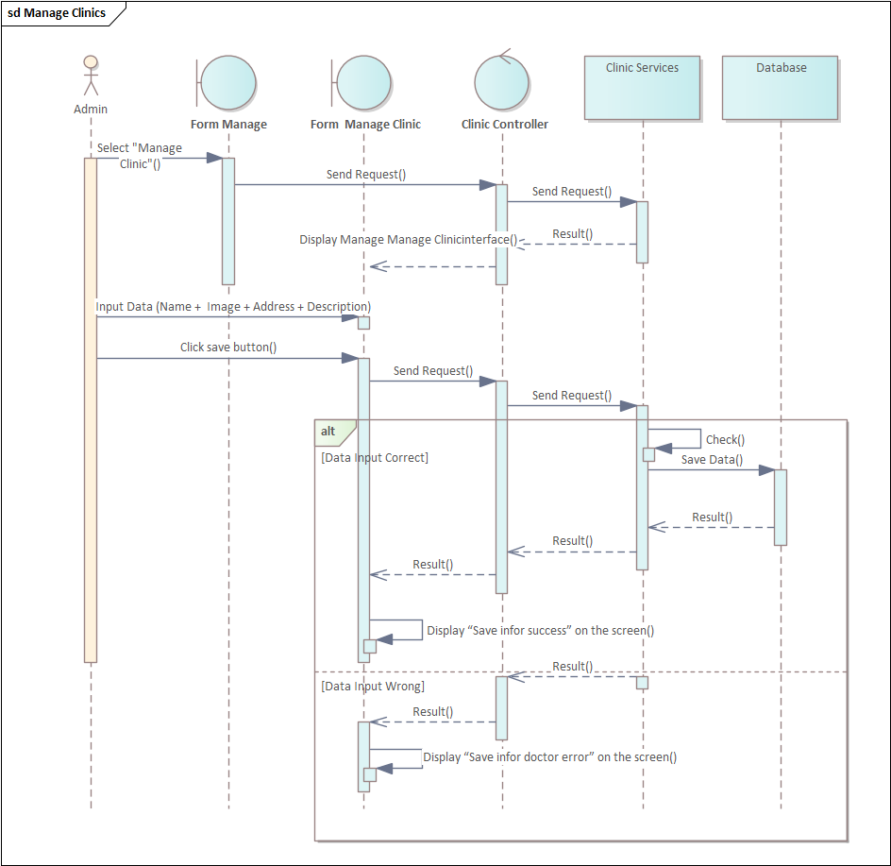

Fig. 32. Sequence Diagram for Clinic Management.

**2.10. Use case Manage Specialty**

Tab. 11. Specialty Management Specification.

|  |  |  |  |
| --- | --- | --- | --- |
| **Use case ID** | UC10 | | |
| **Use case name** | Manage Specialty | | |
| **Description** | Help to create Specialty information | | |
| **Actor(s)** | Admin | | |
| **Priority** | Must have | | |
| **Pre-Condition(s)** | Requires user to be admin | | |
| **Basic Flow** |  |  | **Action** |
| 1 | Admin | Select "Manage Clinic" |
| 2 | System | Display Manage Specialty interface |
| 3 | Admin | Input Data (Name + Image + Description) |
| 4 | Admin | Click save button |
| 5 | System | Check Information |
| 6 | System | Display “Save information clinic success” on the screen |
| **Exception Flow** | 6a | System | Display “Save information clinic error” on the screen |
| **Post-Condition(s)** | Create a new Specialty | | |

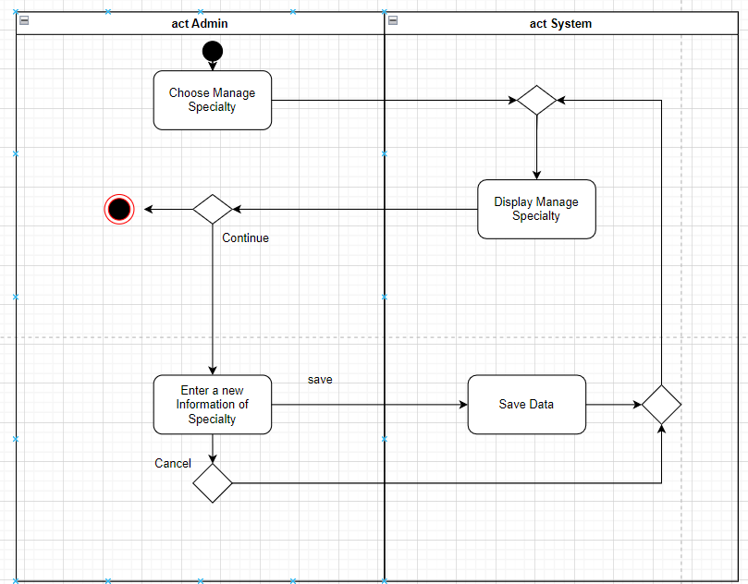

Fig. 33. Activity Diagram for Specialty Management.

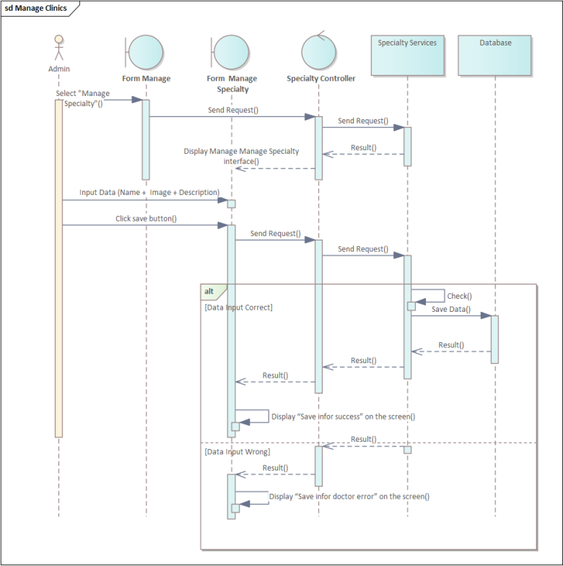

Fig. 34. Sequence Diagram for Specialty Management.

**2.11. Use case Verify Booking Appointment**

Tab. 12. Specialty Management Specification.

|  |  |  |  |
| --- | --- | --- | --- |
| **Use case ID** | UC11 | | |
| **Use case name** | Verify Booking Appointment | | |
| **Description** | Help patient to confirm appointment schedule | | |
| **Actor(s)** | Guest | | |
| **Priority** | Must have | | |
| **Pre-Condition(s)** | Patient has been scheduled on the system | | |
| **Basic Flow** |  |  | **Action** |
| 1 | Guest | Schedule on the system |
| 2 | System | Send message to email address patient |
| 3 | Guest | Check email and click to the link in the email to confirm appointment schedule |
| 4 | Admin | Check already confirm |
| 5 | System | Display “Appointment confirm successfully” |
| **Exception Flow** | 6a | System | Display “Appointment schedule does not exist or has been confirmed” |
| **Post-Condition(s)** | Verify booking appointment | | |

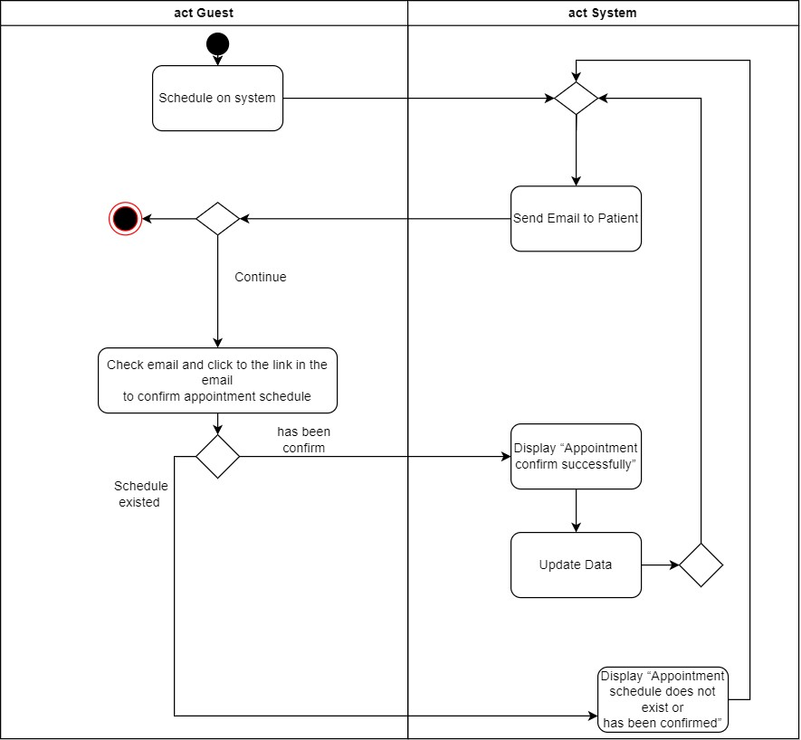

Fig. 35. Activity Diagram for Booking Appointment Verification.

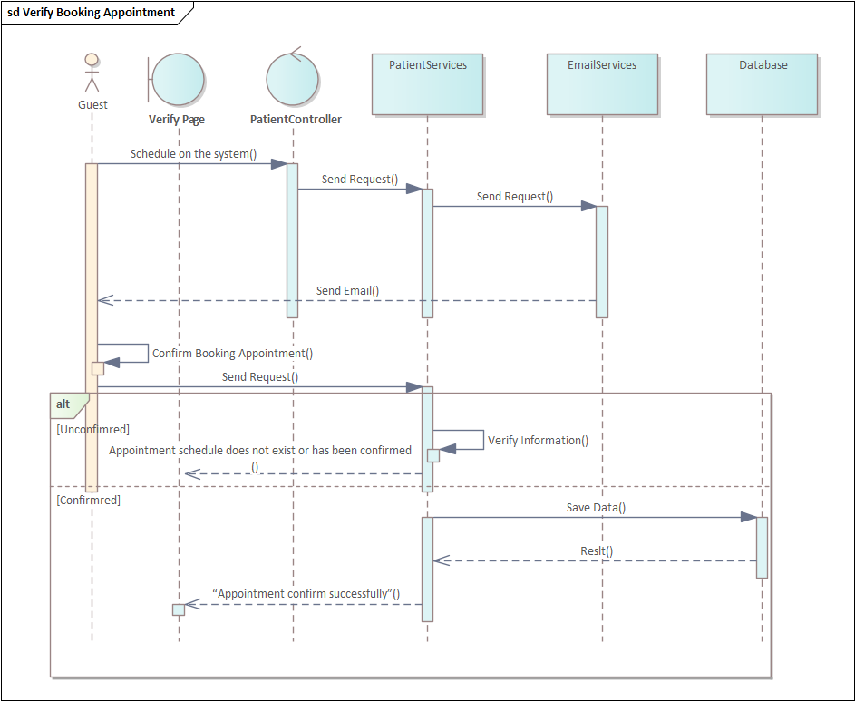

Fig. 36. Sequence Diagram for Booking Appointment Verification.

**2.12. Use case Manage Doctor’s Patient**

Tab. 13. Manage Doctor’s Patient Specification.

|  |  |  |  |
| --- | --- | --- | --- |
| **Use case ID** | UC12 | | |
| **Use case name** | Manage Doctor’s Patient | | |
| **Description** | Help doctor to see information of patient and send email to patient | | |
| **Actor(s)** | Doctor | | |
| **Priority** | Must have | | |
| **Pre-Condition(s)** | Require user to be doctor | | |
| **Basic Flow** |  |  | **Action** |
| 1 | Doctor | Select Manage Doctor’s Patient |
| 2 | System | Display Manage Doctor’s Patient Page |
| 3 | Doctor | Choose Date |
| 4 | System | Display information of patient on date |
| 5 | Doctor | Click on confirm button |
| 6 | System | Display form for doctor to send information or send Attachments for patient |
|  | 7 | Doctor | Input Information or Attachments |
|  | 8 | System | Send Information to email of patient |
|  | 9 | System | Display sends information success |
| **Exception Flow** | 9a | System | Display “Send information does not success” |
| **Post-Condition(s)** | Manage Doctor’s Patient | | |

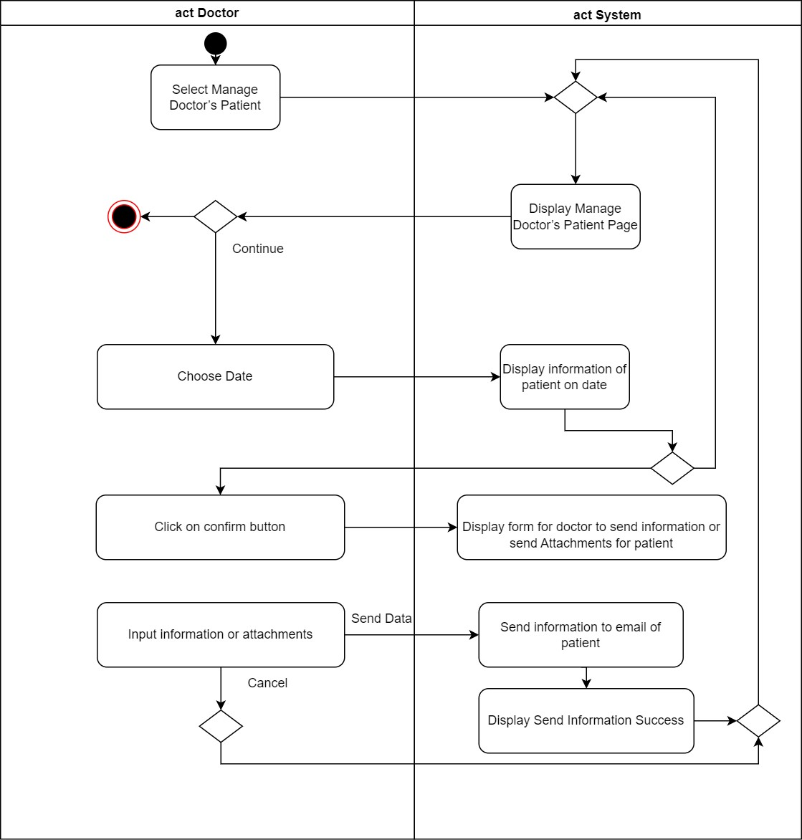

Fig. 37. Activity Diagram for Doctor’s Patient Management.

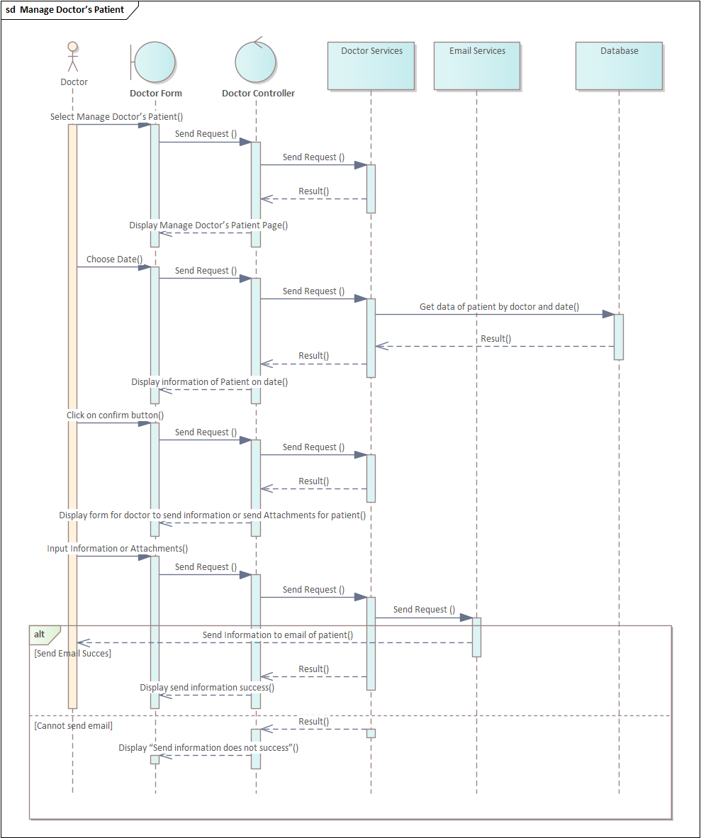

Fig. 38. Sequence Diagram for Doctor’s Patient Management.

**2.13. Use case Manage Patient History**

Tab. 14. Manage Patient History Specification.

|  |  |  |  |
| --- | --- | --- | --- |
| **Use case ID** | UC13 | | |
| **Use case name** | Manage Patient History | | |
| **Description** | See patient Information history | | |
| **Actor(s)** | Guest | | |
| **Priority** | Must have | | |
| **Pre-Condition(s)** | Require user be a doctor and have patient yet | | |
| **Basic Flow** |  |  | **Action** |
| 1 | Guest | Select Manage History Patient |
| 2 | System | Display Manage History Patient |
| 3 | Guest | Select Date |
| 4 | System | Display information of Describe disease information by date |
| **Alternative Flow** | 4a | Guest | Select “View Detail” Button |
|  | 4a1 | System | Display detailed description of patient |
|  | 4b | Guest | Select image |
|  | 4b1 | System | Display full screen image |
| **Post-Condition(s)** | See patient Information history | | |

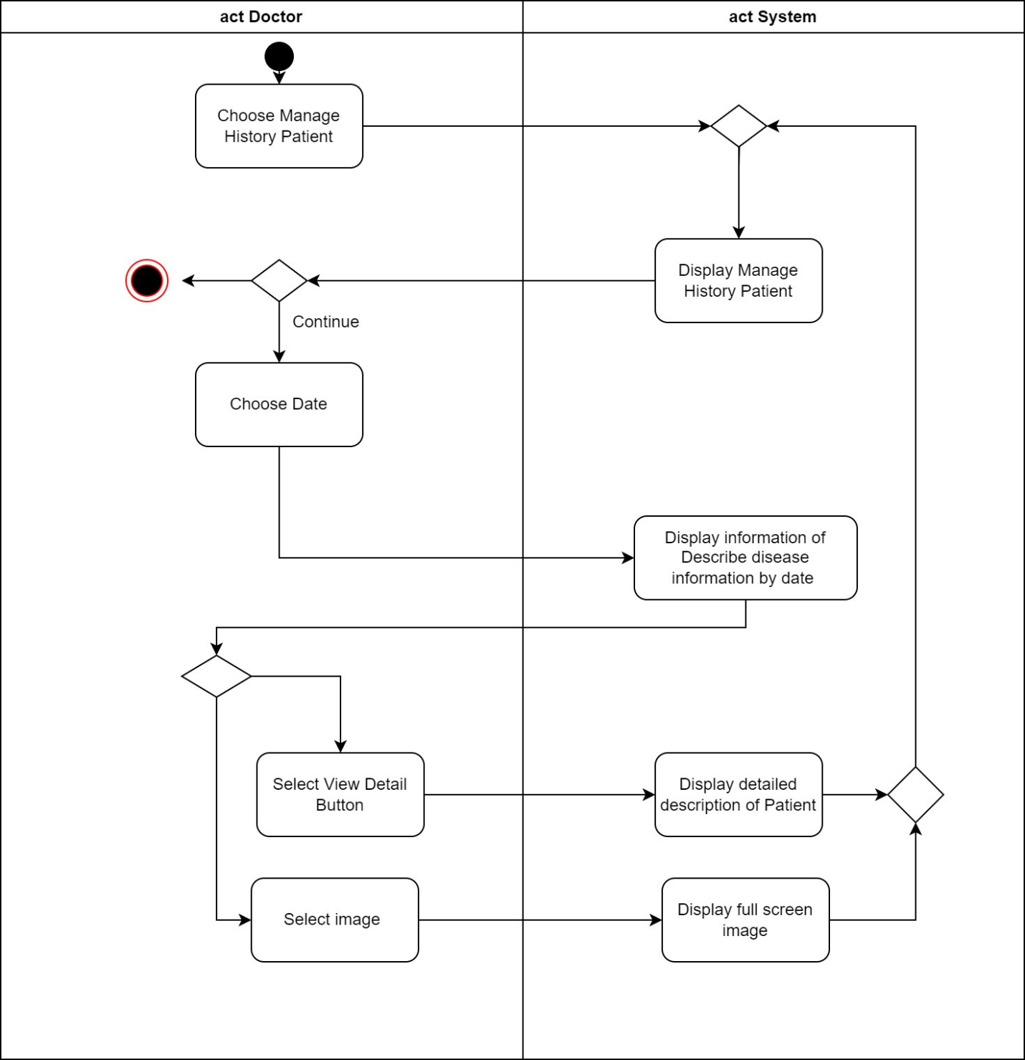

Fig. 39. Activity Diagram for Doctor’s Patient Management.

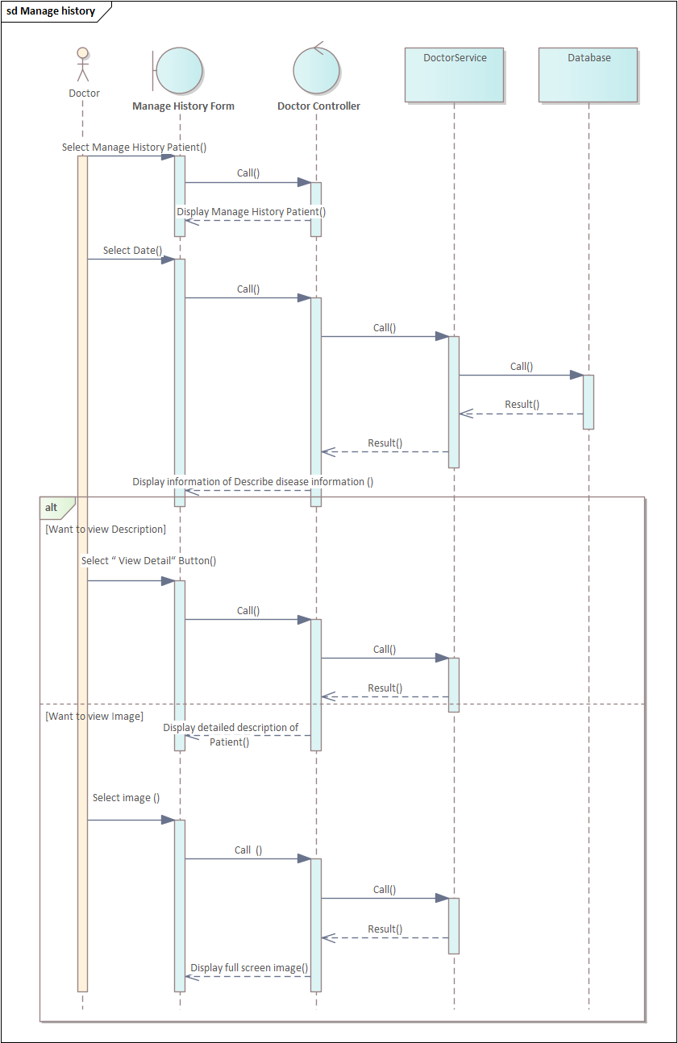

Fig. 40. Sequence Diagram for Doctor’s Patient Management.

## 3. Class Diagram

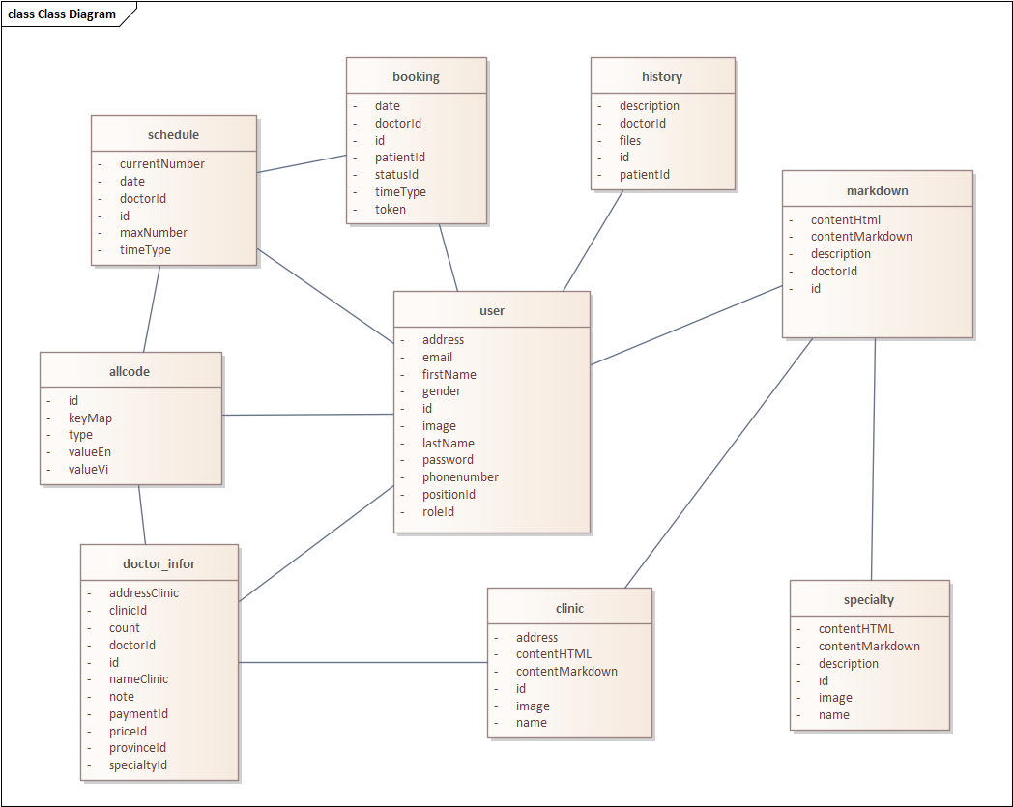

Fig. 41. Class Diagram.

**Class Diagram Specification**

Tab. 15. Class Diagram Specification.

### 3.1. Table User

|  |  |  |  |
| --- | --- | --- | --- |
| **No.** | **Attribute** | **Data type** | **Meaning** |
| 1 | email | String | Email to log in |
| 2 | password | String | Password to login |
| 3 | firstName | Boolean | User's last name |
| 4 | lastName | String | User's first name |
| 5 | address | String | Address of user |
| 6 | gender | String | Gender of user |
| 7 | roleId | Number | Decentralization |
| 8 | phonenumber | Number | Phone number of user |
| 9 | positionId | Number | Doctor's degree (master, doctor, …) |
| 10 | image | String | Avatar of user |

**3.2. Table Booking**

|  |  |  |  |
| --- | --- | --- | --- |
| **No.** | **Attribute** | **Data type** | **Meaning** |
| 1 | statusId | String | Id of status appointment |
| 2 | dortorId | String | Id of doctor appointment |
| 3 | patientId | String | Id of patient appointment |
| 4 | date | Date | Date of appointment |
| 5 | timeType | Date | Time frame for scheduling medical examination (Ex: 13:00 - 14:00) |

**3.3. Table Schedule**

|  |  |  |  |
| --- | --- | --- | --- |
| **No.** | **Attribute** | **Data type** | **Meaning** |
| 1 | currentNumber | String | Current number of patients booked in 1 time frame by 1 doctor |
| 2 | maxNumber | String | Maximum number of patients booked in 1 time frame by 1 doctor |
| 3 | date | Date | Date of appointment |
| 4 | timeType | Date | Time frame for scheduling medical examination (Ex: 13:00 - 14:00) |
| 5 | dortorId | String | Id of doctor appointment |

**3.4. Table Clinic**

|  |  |  |  |
| --- | --- | --- | --- |
| **No.** | **Attribute** | **Data type** | **Meaning** |
| 1 | address | String | Address of clinic |
| 2 | name | String | Name of clinic |
| 3 | descriptionMarkdown | String | Description of clinic when admin input |
| 4 | descriptionHTML | String | Description of clinic when displayed on the client's screen |
| 5 | image | String | The image of a clinic |

**3.5. Table Specialty**

|  |  |  |  |
| --- | --- | --- | --- |
| **No.** | **Attribute** | **Data type** | **Meaning** |
| 1 | image | String | Description of specialty |
| 2 | name | String | Name of specialty |
| 3 | descriptionMarkdown | String | Description of specialty when admin input |
| 4 | descriptionHTML | String | Description of specialty when displayed on the client's screen |

**3.6. Table History**

|  |  |  |  |
| --- | --- | --- | --- |
| **No.** | **Attribute** | **Data type** | **Meaning** |
| 1 | patientId | String | Patient id of the appointment |
| 2 | doctorId | String | Doctor id of the appointment |
| 3 | description | String | Description of the appointment |
| 4 | files | String | The link of the image related to the appointment |

**3.7. Table Markdown**

|  |  |  |  |
| --- | --- | --- | --- |
| **No.** | **Attribute** | **Data type** | **Meaning** |
| 1 | doctorId | String | Doctor id of Markdown |
| 2 | contentHTML | String | Information of doctor when displayed on the client's screen |
| 3 | contentMarkdown | String | Information of doctor when admin input |
| 4 | description | String | Brief description of the doctor that the user should be aware of |

**3.8. Table Doctor Information**

|  |  |  |  |
| --- | --- | --- | --- |
| **No.** | **Attribute** | **Data type** | **Meaning** |
| 1 | doctorId | String | Id of a doctor |
| 2 | priceId | String | Id of a price segment |
| 3 | provinceId | String | Id of a province |
| 4 | paymentId | String | Id of the payment type |
| 5 | addressClinic | String | Address of the clinic |
| 6 | nameClinic | String | Name of the clinic |
| 7 | note | String | Notes on doctor's information |
| 8 | count | String | The number of patients examined by doctor |

**3.9. Table Allcode**

|  |  |  |  |
| --- | --- | --- | --- |
| **No.** | **Attribute** | **Data type** | **Meaning** |
| 1 | key | String | Type of code data |
| 2 | type | String | Key of code data (Ex: role, status, timeType, …) |
| 3 | value | String | Value of code data |
| 4 | valueEn | String | Value of code data in English |
| 5 | valueVi | String | Value of code data in Vietnam |

**4. Collaboration diagram**

**4.1. Login Function**

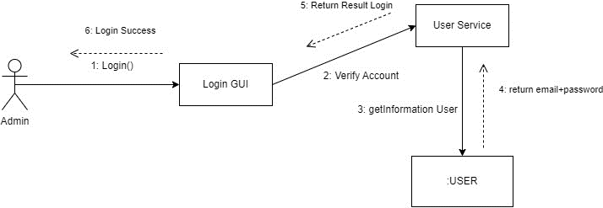

Fig. 42. Collaboration for Login Function.

**4.2. User Management**



Fig. 43. Collaboration for User Management.

**4.3. Doctor Management**

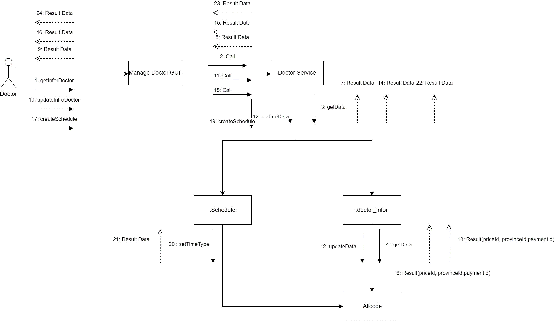

Fig. 44. Collaboration for Doctor Management.

**4.4. Booking Appointment**

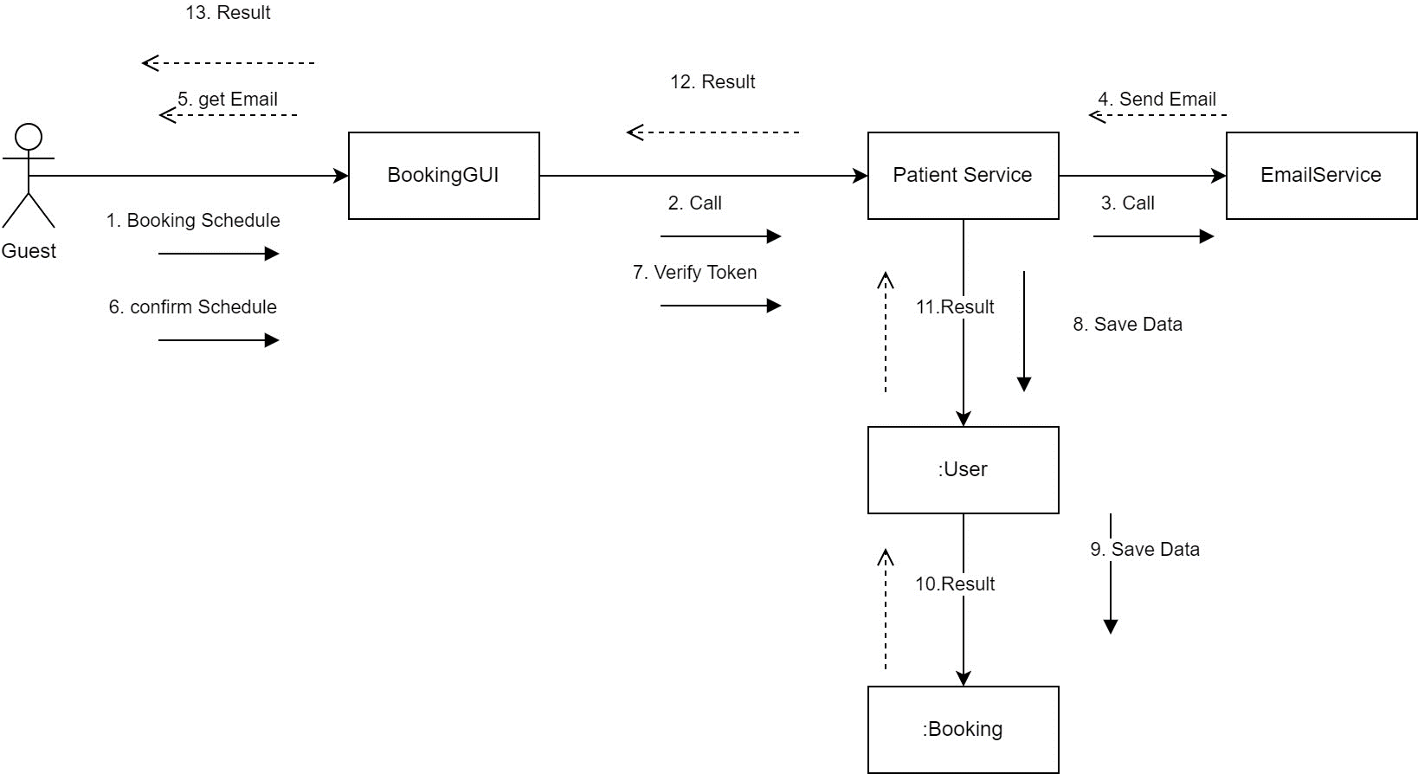

Fig. 45. Collaboration for Booking Appointment.

**4.5. Specialty**

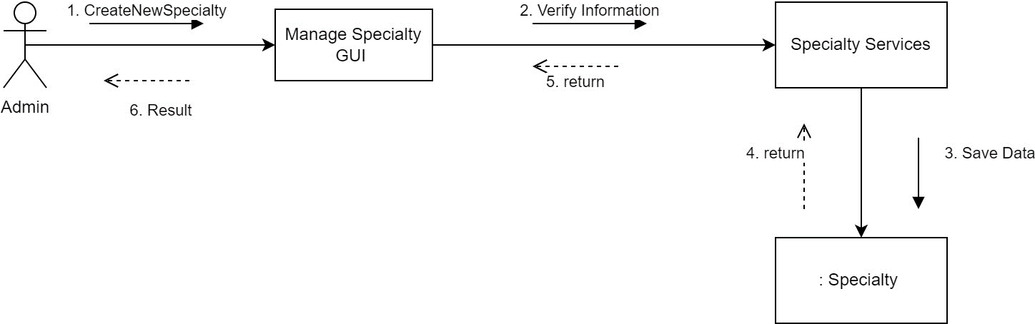

Fig. 46. Collaboration for Booking Appointment.

**4.6. Clinic**

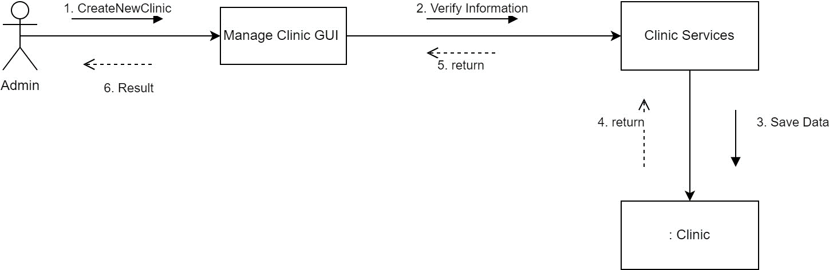

Fig. 47. Collaboration for Clinic.

**CHAPTER IV: SYSTEM INSTALLATION AND SYSTEM INTERFACE**

**1. System installation**

* Step 1: Download the entire code of this website.

* Step 2: run npm install in each folder frontend and back end

$npm install

* Step 3: Set up .env file use the “.env.example” file in folder backend to fix and add configuration

PORT=8668

NODE_ENV=development

URL_REACT=http://localhost:3000

MAX_NUMBER_SCHEDULE =10

EMAIL_APP_PASSWORD =

EMAIL_APP =

Note: EMAIL_APP = the email we use to send email confirm by nodemailer library

EMAIL_APP_PASSWORD = Come to setting of google account in the security Part go to the 2FA – Two factor authentication turn on this and go to app password inside this part to get email app password.

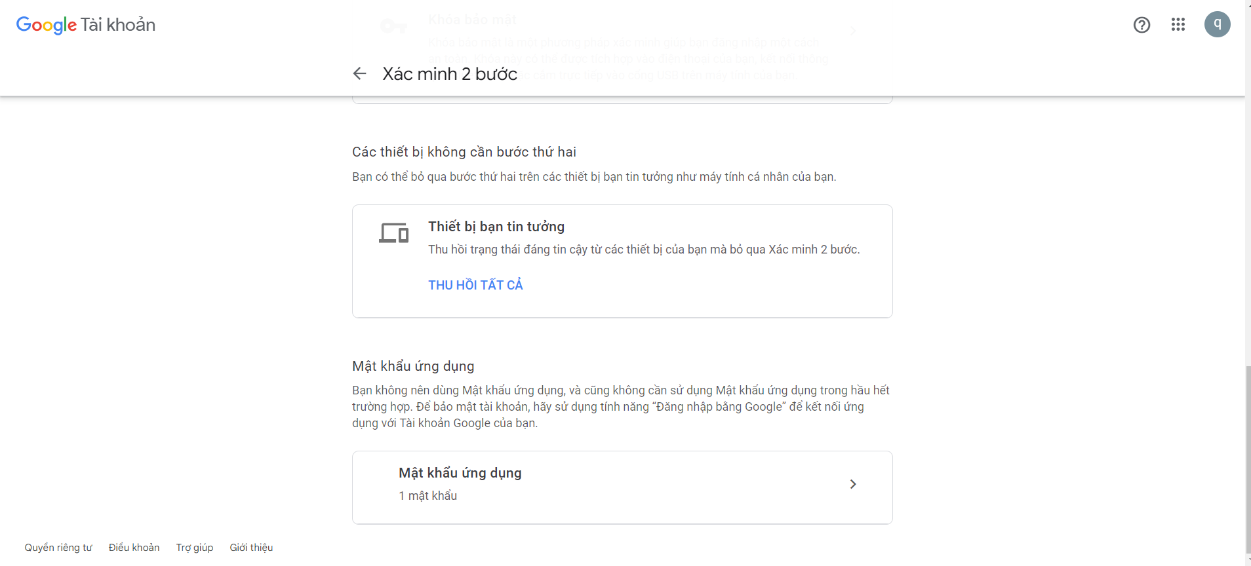

Fig. 48. Google verification interface.

* Step 4: Database: Use XAMPP to control MySQL Open site admin click on new database.

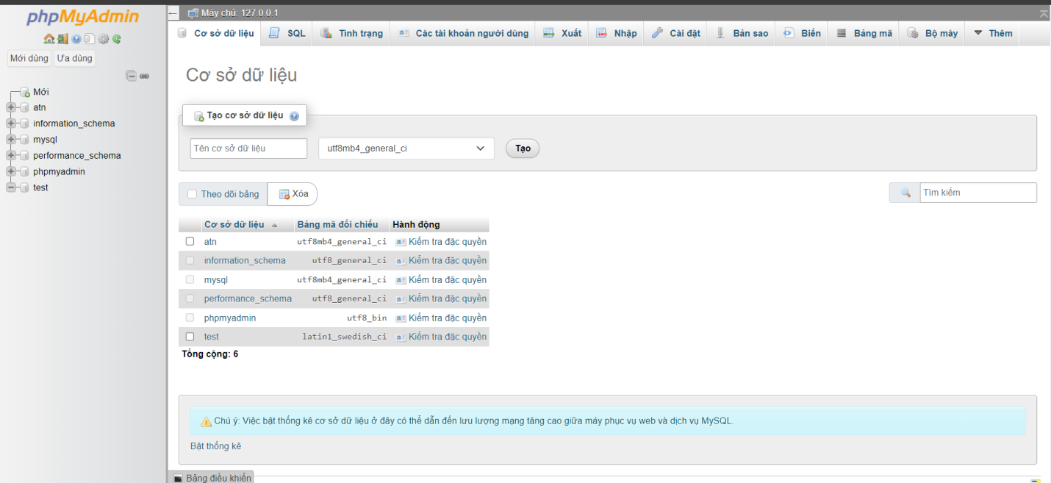

Fig. 49. Database of phpMyAdmin.

Input name of Database ‘atn’ and create

After that come to the backend terminal run the text: npx sequelize-cli db:migrate

Import data from this to database

<https://drive.google.com/file/d/1xOzDD3HPmuDHm9bzCUAQDQjoKjx-iCfT/view?usp=sharing>

* Step 5: run npm start in each folder (backend and frontend): $npm start

The account to test function:

ADMIN: Email: [test@gmail.com](mailto:test@gmail.com)

Password: 123

Doctor: Email: [linh@gmail.com](mailto:linh@gmail.com)

Password: 123

**2. System interface**

**2.1. For Guest**

**2.1.1. Common interfaces**



Fig. 50. Logo of the Care For You website.

* The header contains the Logo, page navigation bar, support button and English-Vietnamese language switch button.



Fig. 51. Header interface in Vietnamese language.



Fig. 52. Header interface in English language.

* The notification interface every time the user performs a certain process successfully or fails will be a toast displaying information for the user about that process.

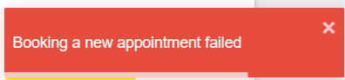

Fig. 53. Interface notifying the successful of the appointment booking process.

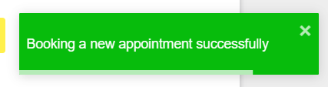

Fig. 54. Interface notifying the failure of the appointment booking process.

**2.1.2. Home page interface**

The Home page lists featured medical specialties, facilities, and featured doctors who can schedule appointments on the website.

When the user clicks on the next or previous button, it will scroll to or about specialties, clinics, or doctors.

When the user clicks on a specific specialty, clinic, or doctor, it will display the detailed information page of that specialty, clinic, or doctor.

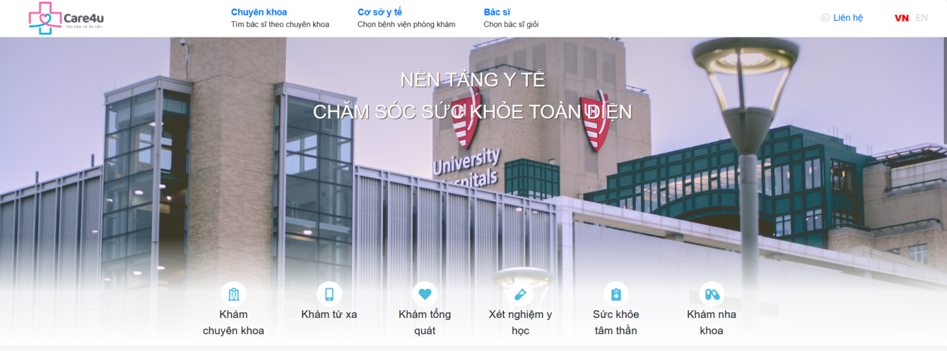



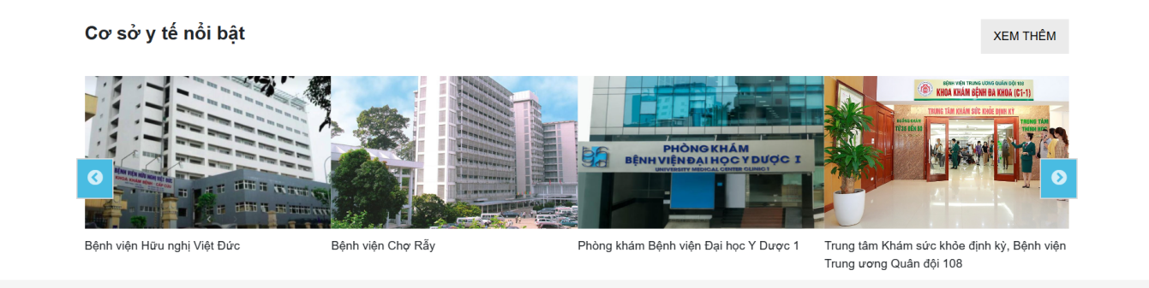

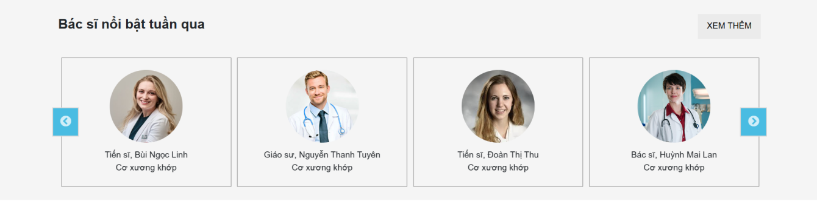

Fig. 55. Home page interface.

**2.1.3. Doctor detail page interface**

The interface of the doctor's details page includes information about the doctor's medical examination schedule, clinic, clinic address and doctor's examination price.

At this interface, there is also outstanding information about the doctor such as: Work history, Training process, Scientific examination, and treatment, etc.

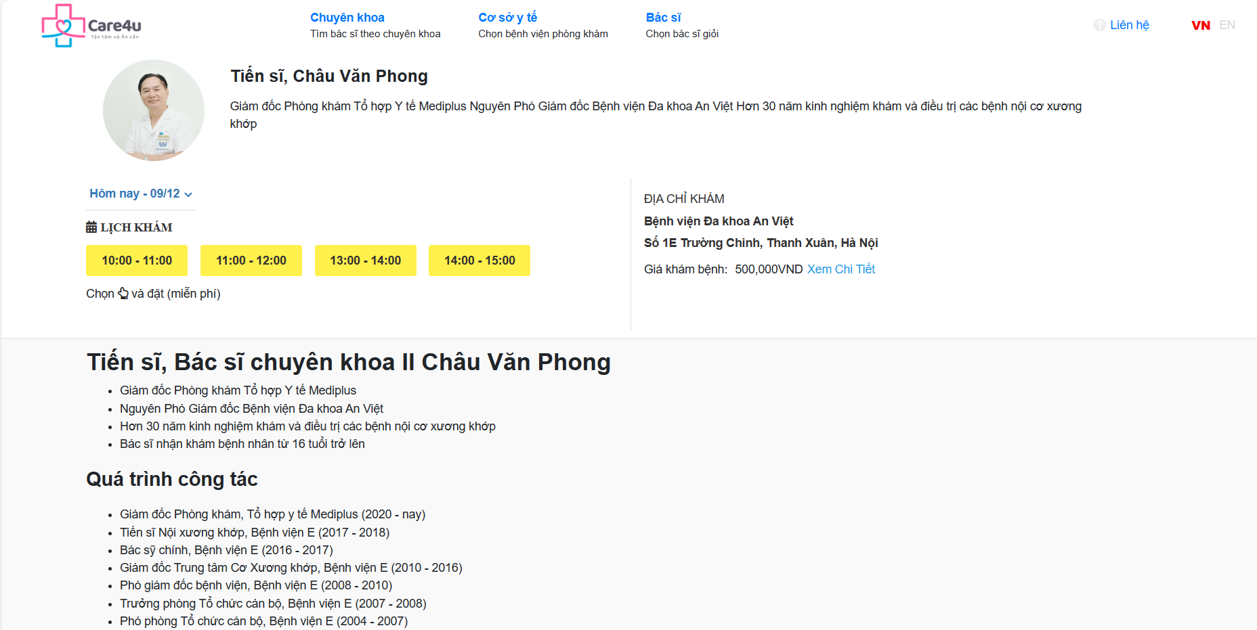

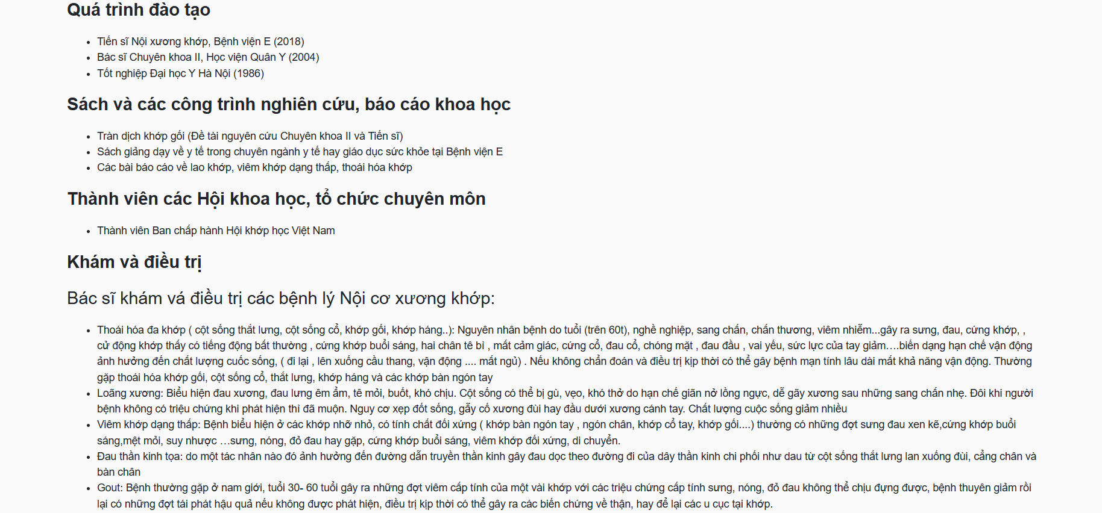

Fig. 56. Doctor detail page interface.

**2.1.4. Specialty detail page interface**

The specialty detail page interface includes information about the specialty and the doctors in that department.

In this interface, in the doctor section there is also a doctor's examination schedule that customers can book, information about the clinic address, and the doctor's examination price.

Guests can click "see more" in the doctor's section to get more information about that doctor.

Guests can also click to schedule an appointment at the doctor's time frames available on the screen.

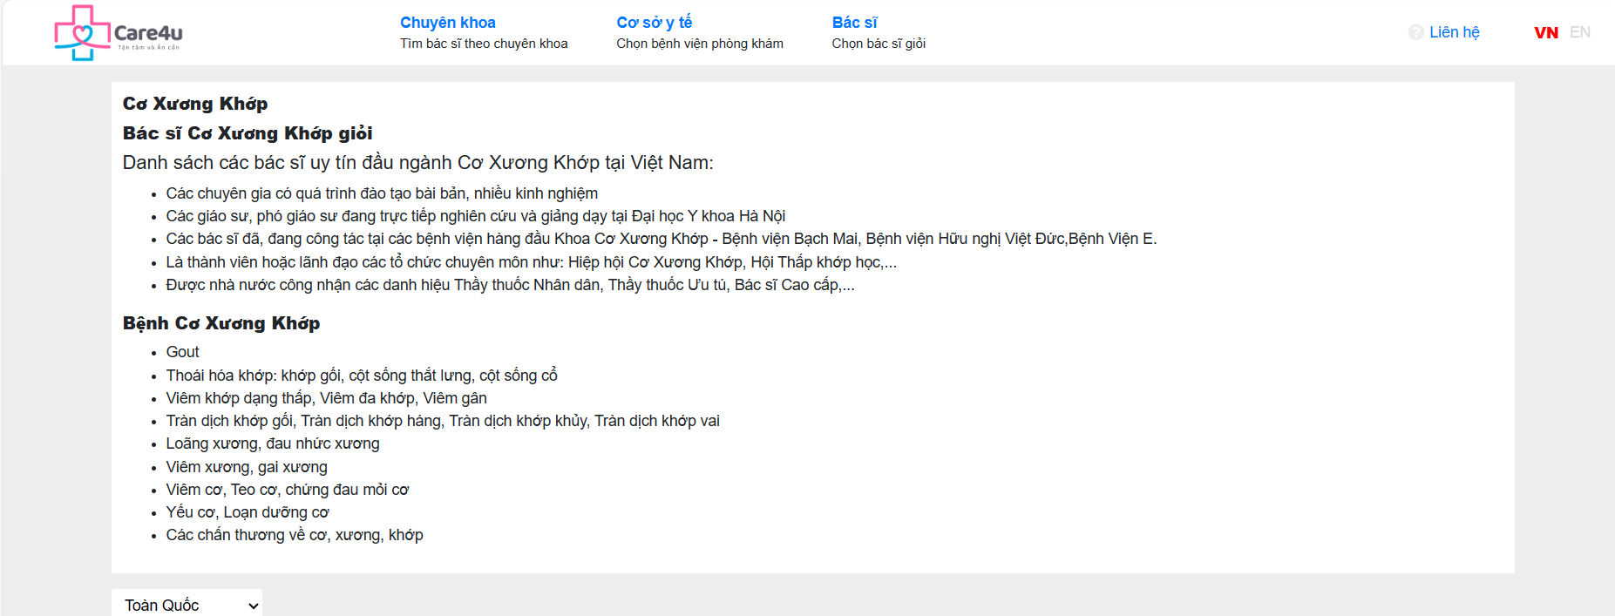

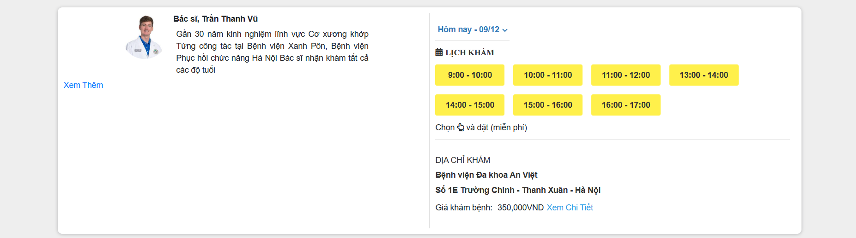

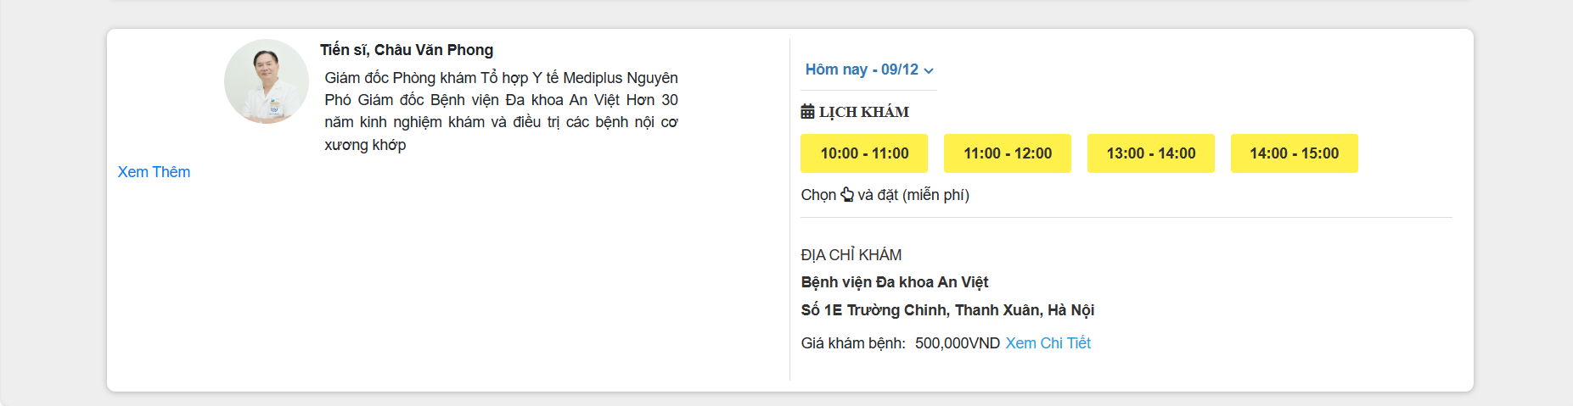

Fig. 57. Specialty detail page interface.

**2.1.5. Clinic detail page interface**

The clinic detail page interface includes information about the clinic and doctors at that clinic.

In this interface, in the doctor section there is also a doctor's examination schedule that Guests can book, information about the clinic address, and the doctor's examination price. Guests can also click to schedule an appointment at the doctor's time frames available on the screen.

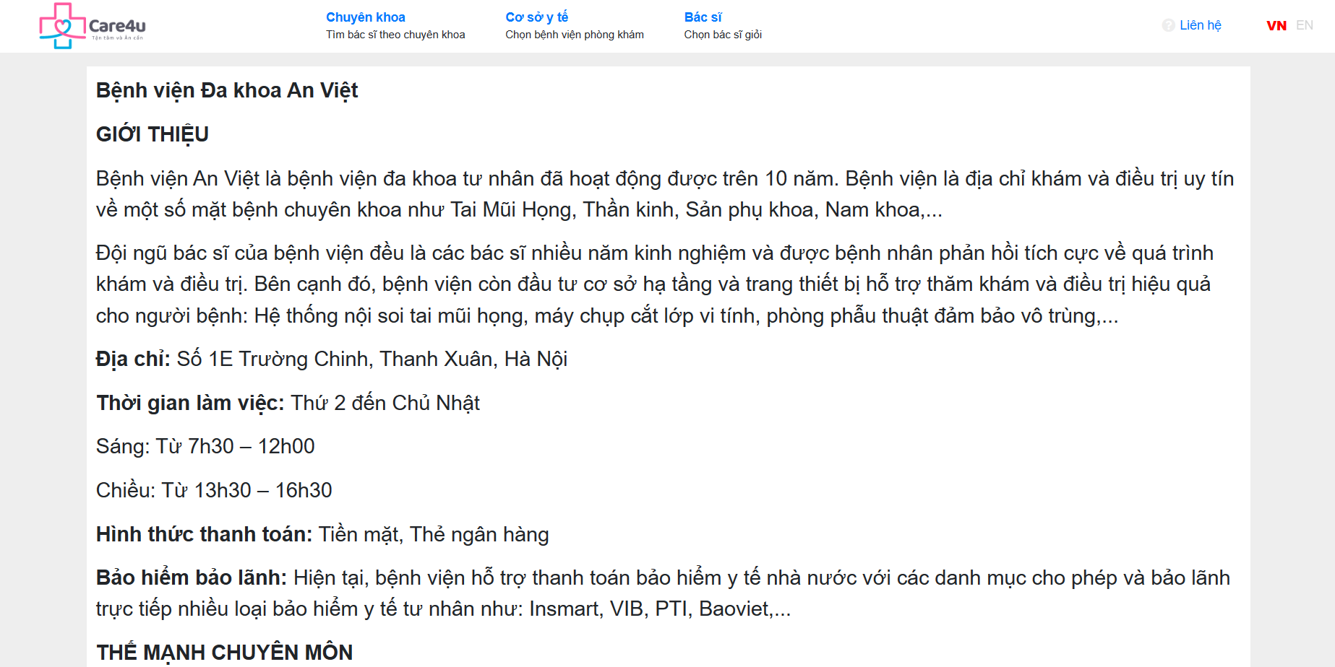

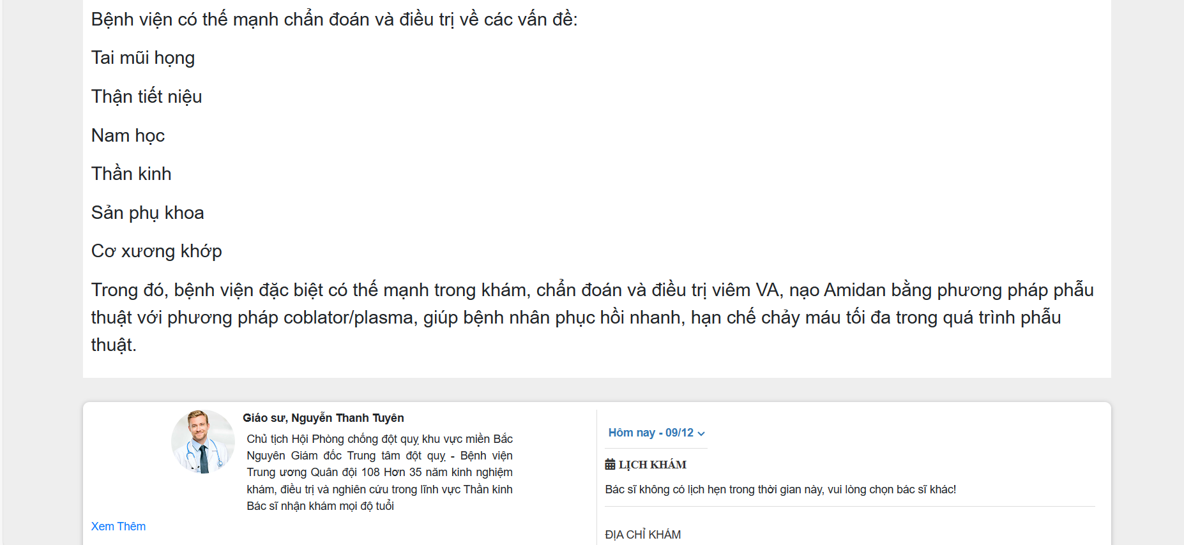

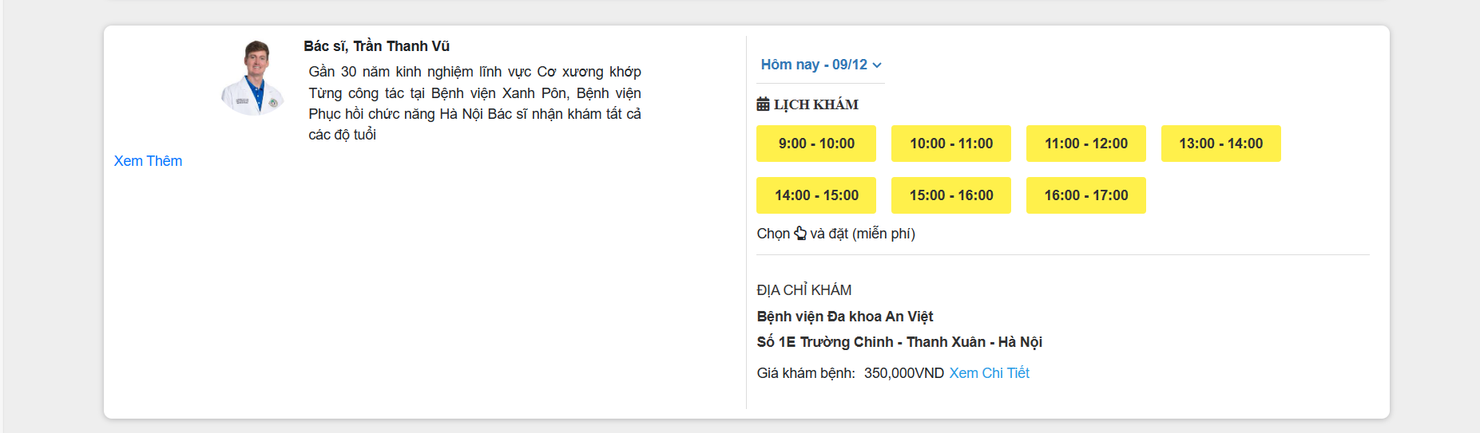

Fig. 58. Clinic detail page interface.

**2.1.6. Contact page interface**

The contact page interface includes information so users can contact the admin or support staff when needed.

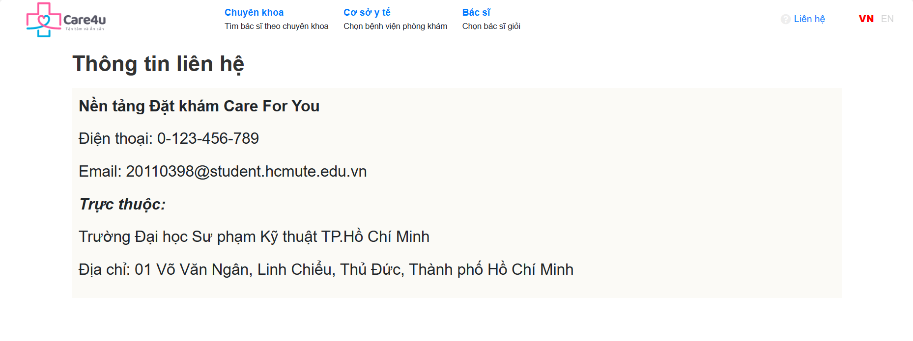

Fig. 59. Contact page interface.

**2.1.7. Patient appointment booking form interface**

The patient appointment booking form interface includes text boxes for users to enter information such as: full name, phone number, email, etc.

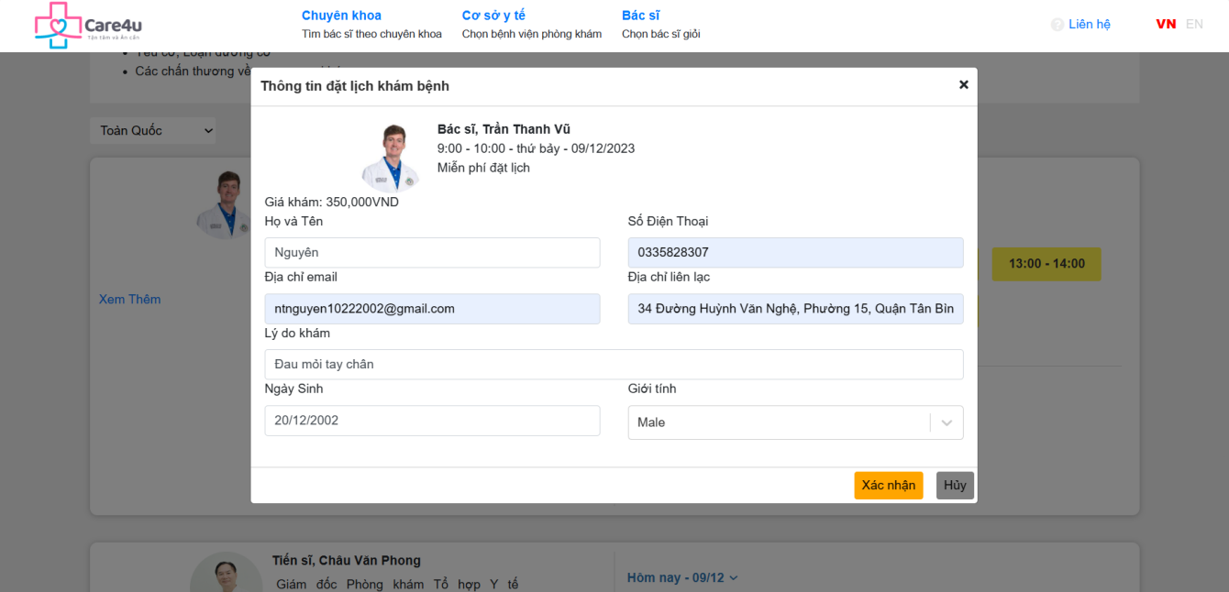

Fig. 60. Patient appointment booking form interface in Vietnamese language.

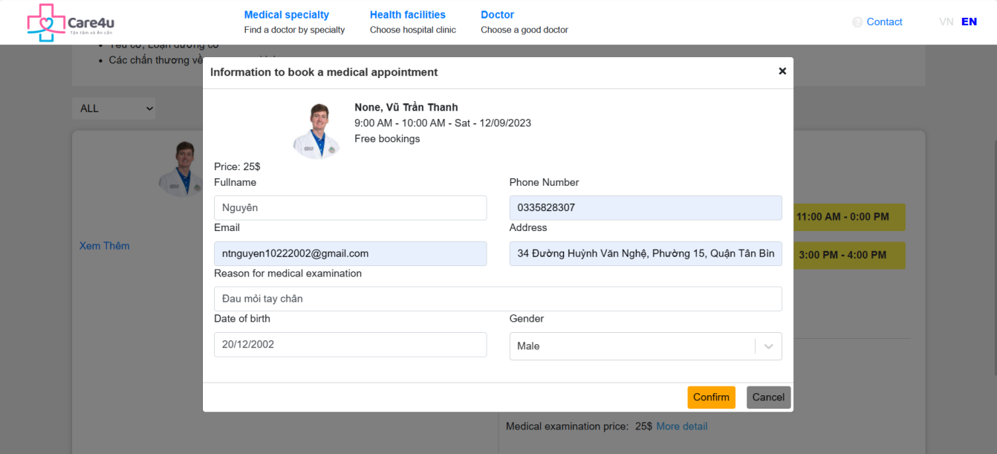

Fig. 61. Patient appointment booking form interface in English language.

**2.2. For Doctor**

* Login page interface

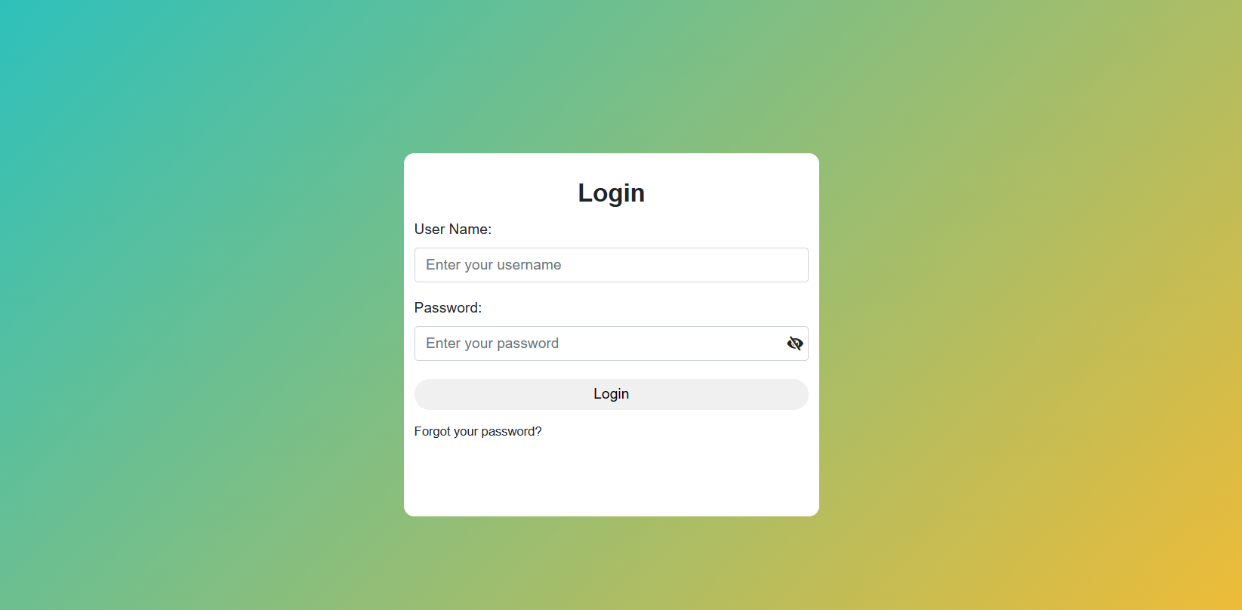

Fig. 62. Login page interface.

* Header interface



Fig. 63. Header interface in Vietnamese language.



Fig. 64. Header interface in English language.

* Drop down when select user

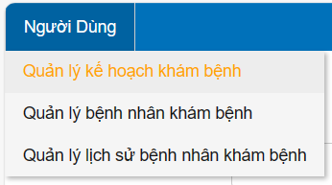

Fig. 65. Drop down in Vietnamese language.

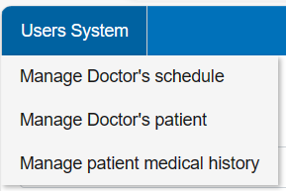

Fig. 66. Drop down in English language.

* Doctor plan management page interface

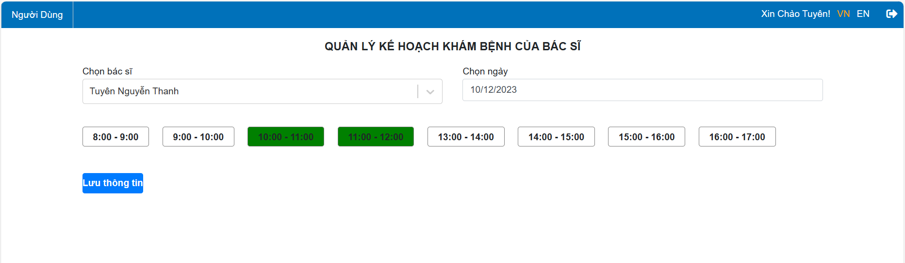

Fig. 67. Doctor plan management page interface in Vietnamese language.

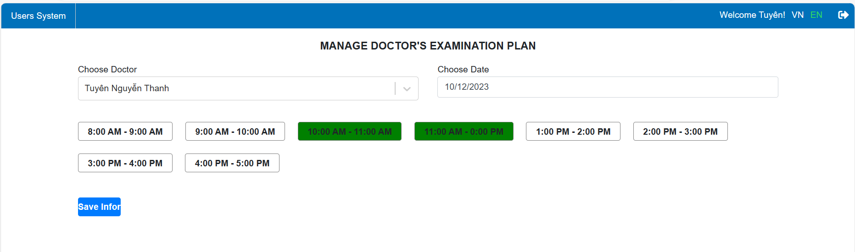

Fig. 68. Doctor plan management page interface in English language.

* Interface of patient management page with doctor's appointment booked

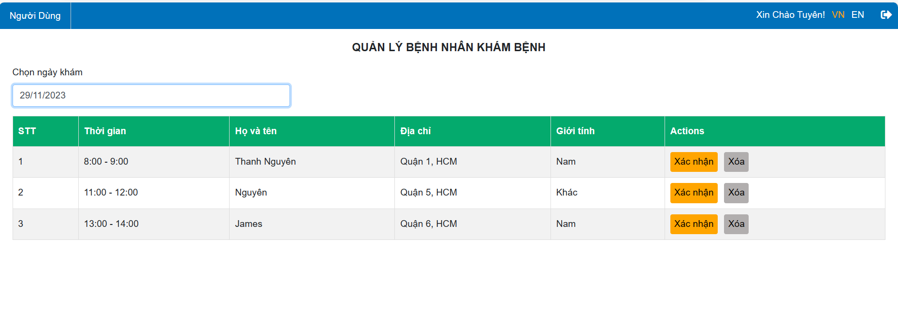

Fig. 69. Interface of patient management page with doctor's appointment booked.

* Interface of patient management page with doctor's appointment booked

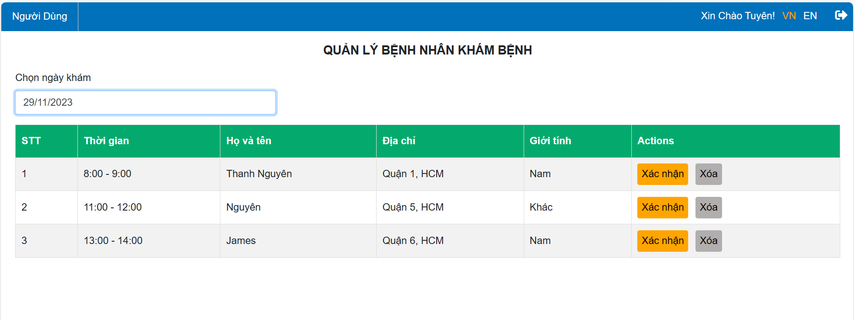

Fig. 70. Interface of patient management page with doctor's appointment booked.

* Patient history management page interface has completed an appointment with a doctor

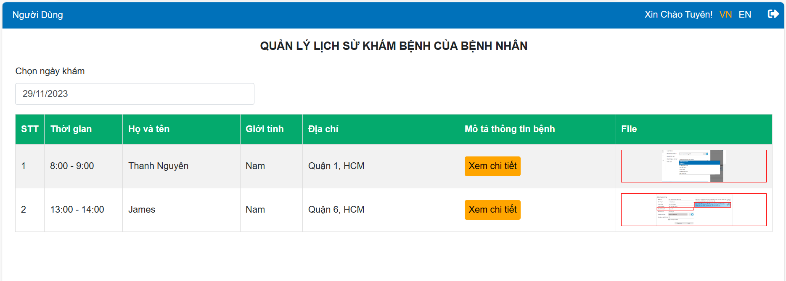

Fig. 71. Interface of doctor's patient history management page.

* Form interface to send medical examination results to the patient

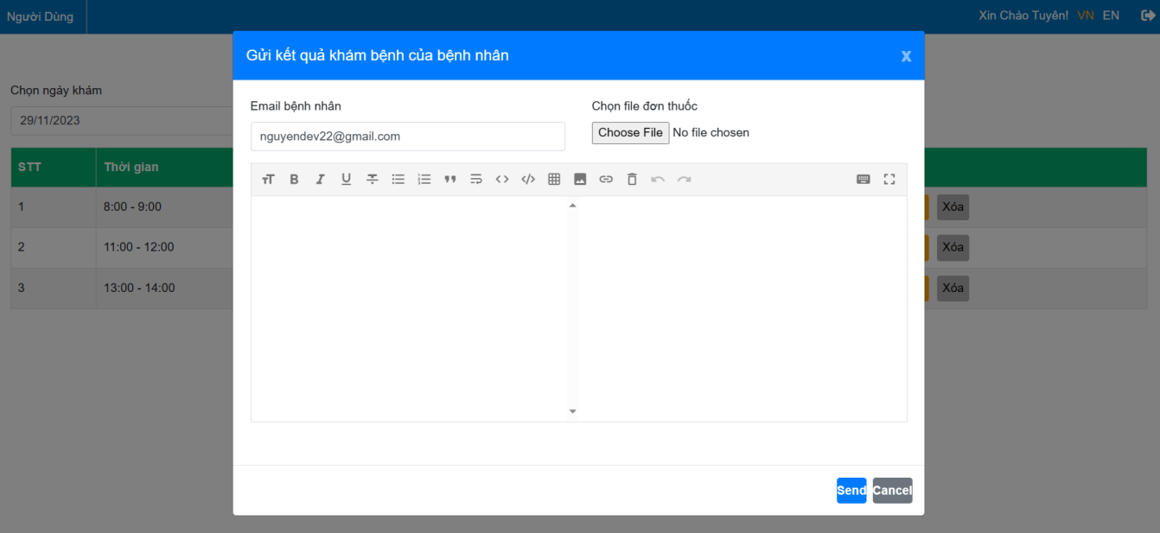

Fig. 72. Interface of Form to send medical examination results to the patient.

**2.3. For Admin**

* Login page interface



Fig. 73. Login page interface.

* Header interface



Fig. 74. Header interface in Vietnamese language.



Fig. 75. Header interface in English language.

* User management page interface

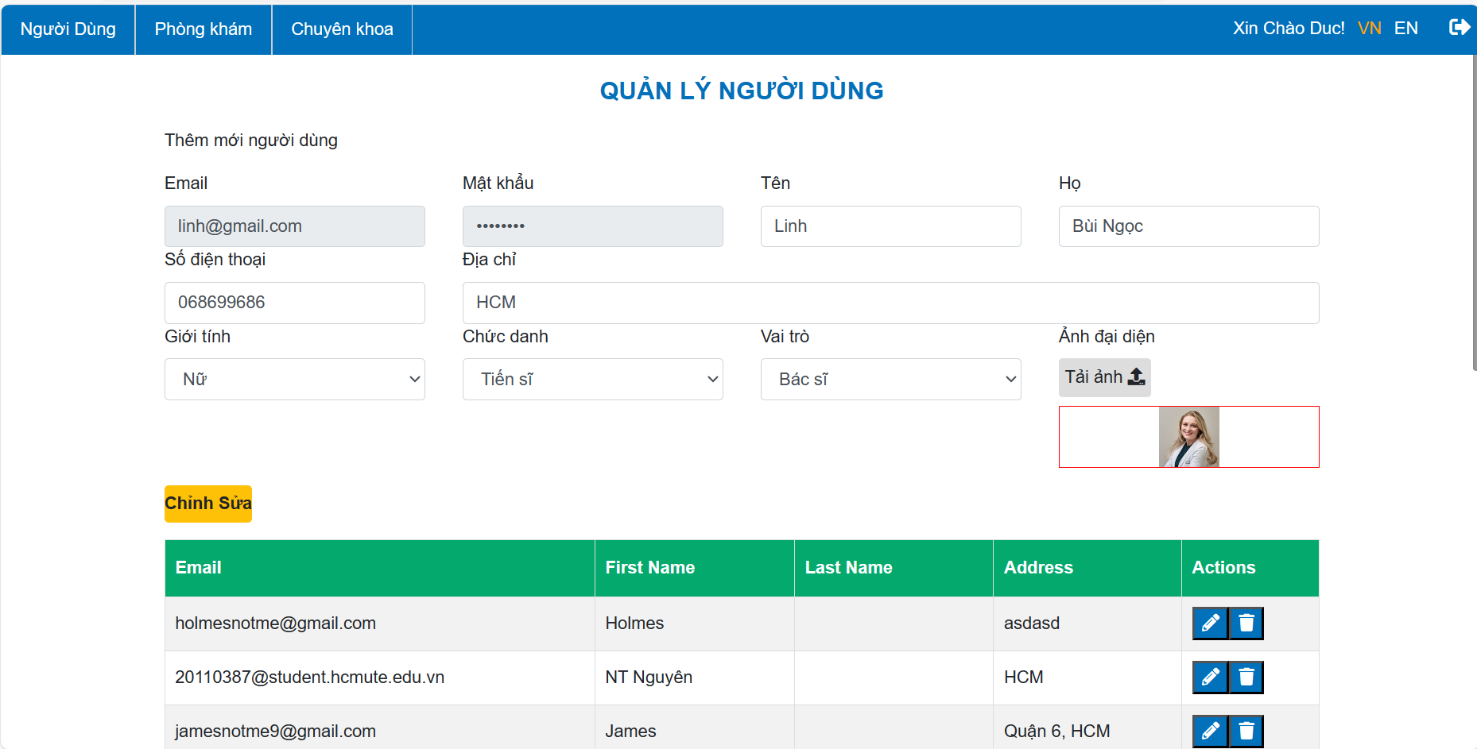

Fig. 76. User management page interface in Vietnamese language.

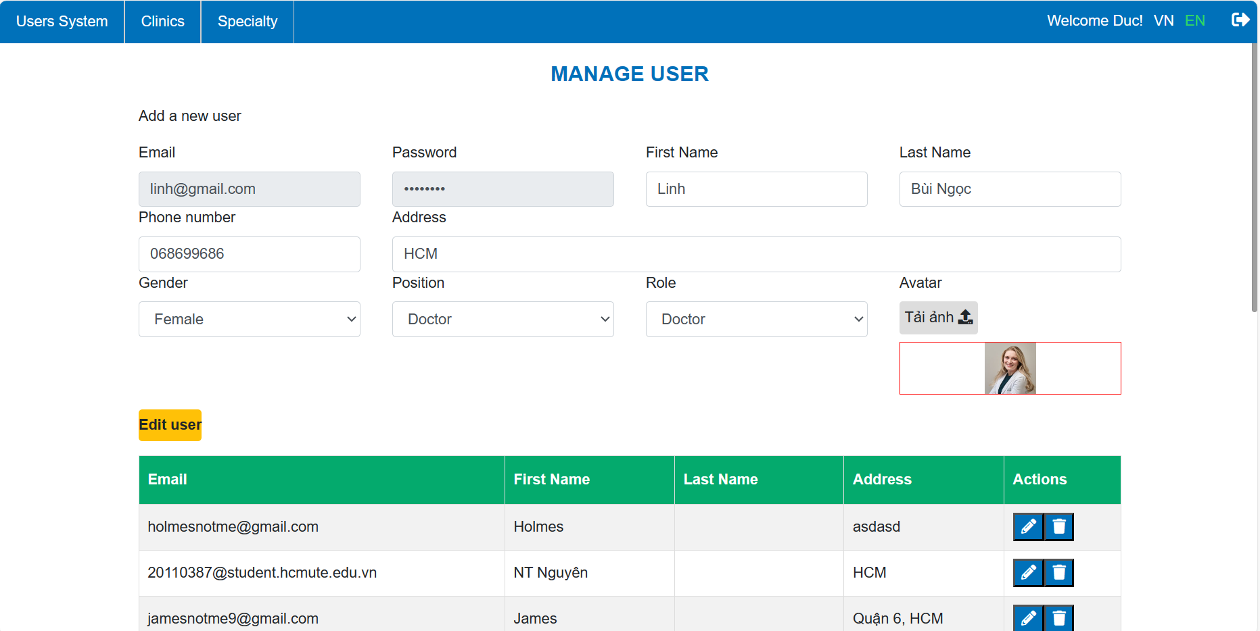

Fig. 77. User management page interface in English language.

* Doctor information editing page interface

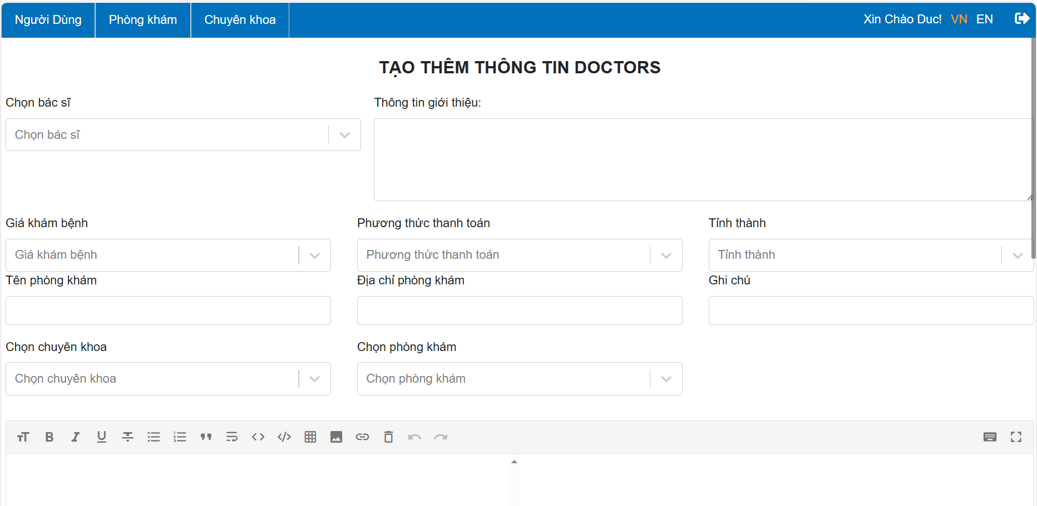

Fig. 78. Doctor information editing page interface in Vietnamese language.

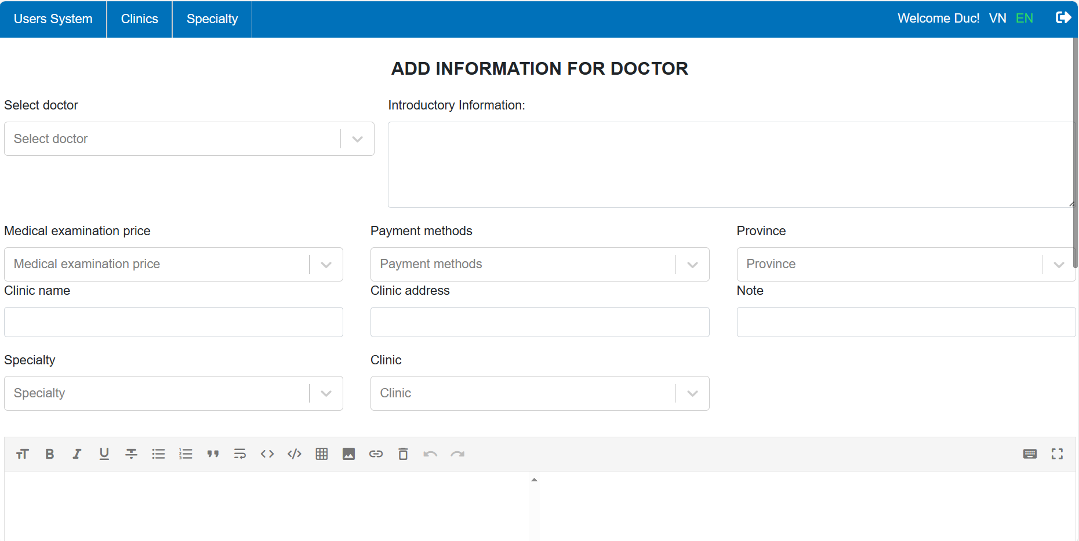

Fig. 79. Doctor information editing page interface in English language.

* Doctor plan management page interface

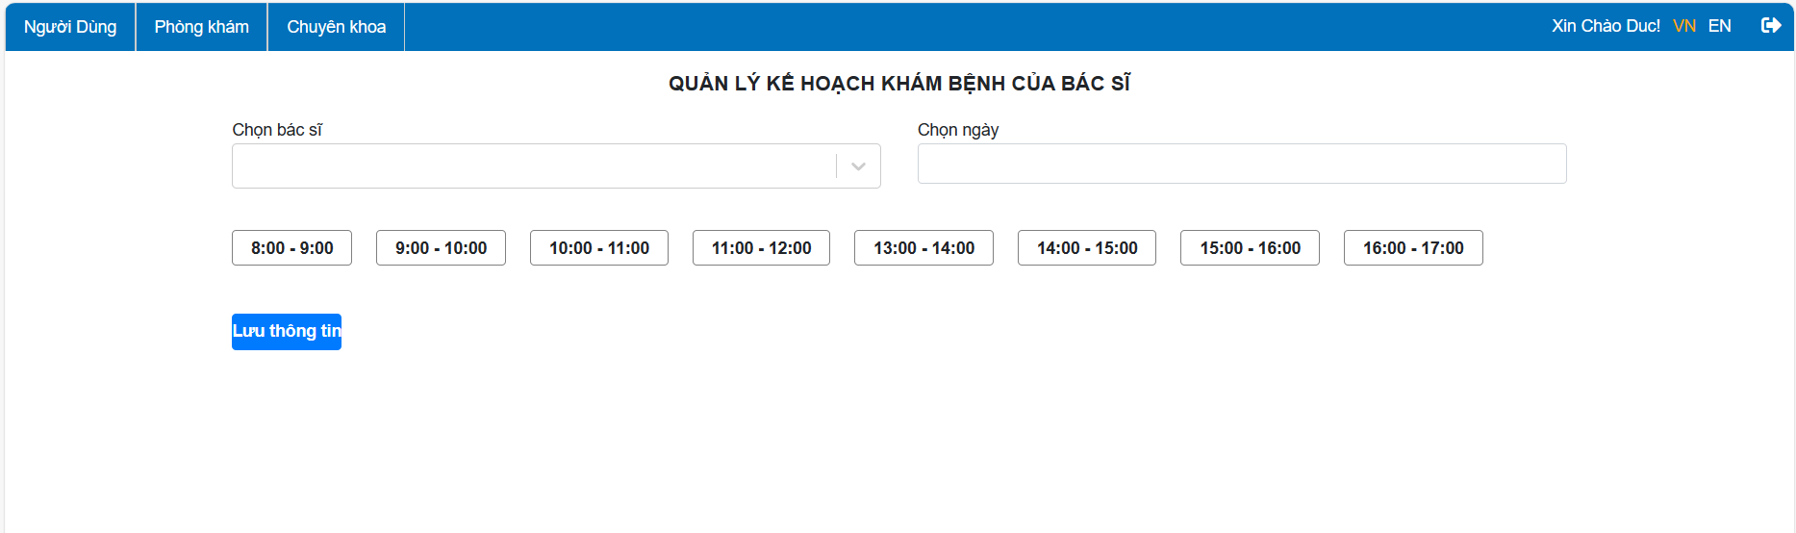

Fig. 80. Doctor plan management page interface in Vietnamese language.

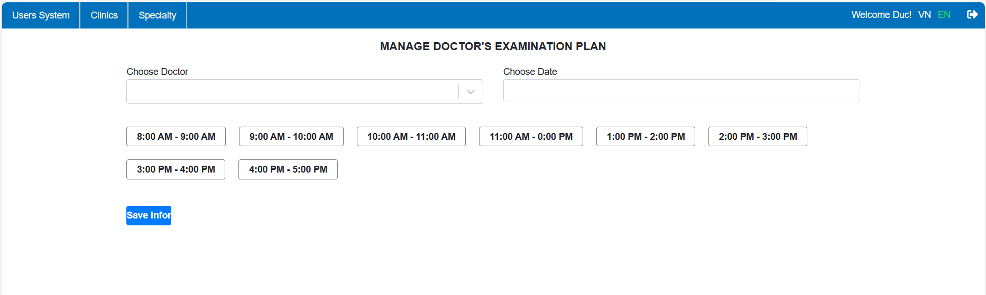

Fig. 81. Doctor plan management page interface in English language.

* Clinic management page interface

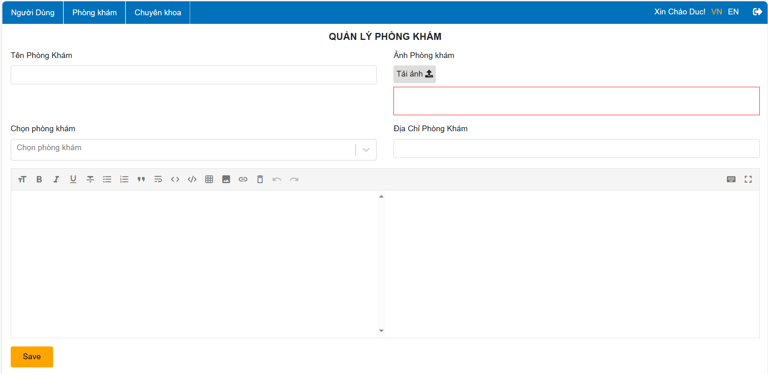

Fig. 82. Clinic management page interface.

* Specialty management page interface

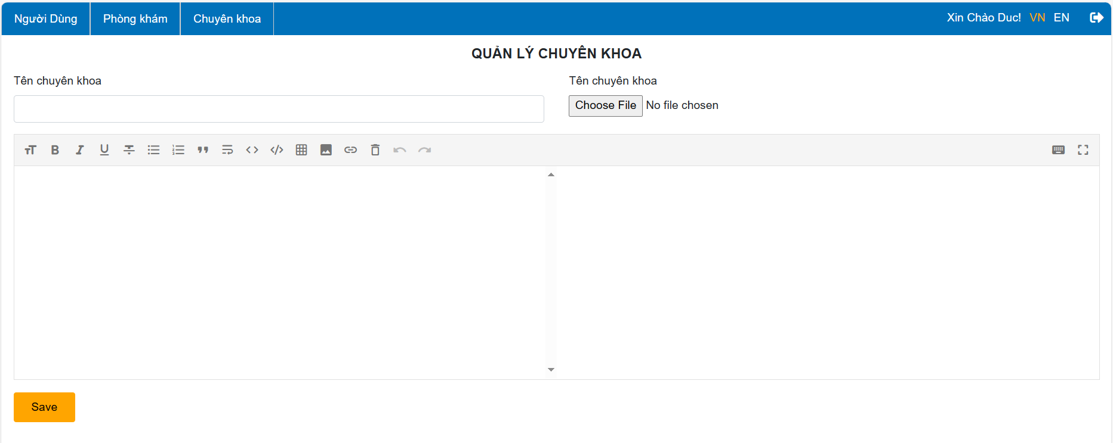

Fig. 83. Specialty management page interface.

**CHAPTER V: TEST PLAN**

**1. Introduction**

**1.1. Purpose**

This test plan aims for testing approach and overall, of the Scheduling Medical appointment for healthcare clinics Website. This document includes:

Test Strategy: This outlines the principles that will guide the testing process, encompassing project parameters such as start/end dates, objectives, and assumptions. It includes details on establishing a valid test, specifying entry/exit criteria, creating test cases, defining tasks, scheduling, and implementing a data strategy.

Execution Strategy: This articulates how the actual testing will take place, outlining the process for identifying and reporting defects, as well as the procedures for fixing and implementing solutions.

Test Management: This addresses the logistical aspects of the testing phase, covering communication protocols, escalation procedures, risk assessment and mitigation strategies, and the composition of the testing team.

**1.2. Project overview**

Scheduling Medical appointment for healthcare clinics Website is made to help the patient can shorten their waiting time for illness as well as make it easier for them to book medical appointments online. In addition, it can also make it easier for clinics and medical facilities to reach patients. They understand better about medical facilities so they can choose the most suitable place for treatment.

**1.3. Methods**

There are three frequently employed software testing approaches, namely:

- White box testing: Involves testing with a sample code structure, enabling users to test the running project by having access to its source code at any given time.

- Black box testing: Focuses on testing the functionality of a specific system or software based on its system requirements.

- Gray box testing: Encompasses a combination of black box and white box testing methods.

**1.4. Techniques**

* Unit testing

Unit testing is a software testing method where individual units or components of a software application are tested in isolation. The primary goal of unit testing is to validate that each unit of the software performs as designed. A "unit" in this context refers to the smallest testable part of a software, typically a function, method, or procedure.

During unit testing, the developer tests each unit of code independently to ensure that it behaves as expected. It helps identify and fix bugs at an early stage of development, making it an integral part of the software development process. Unit testing is often automated, allowing developers to run tests frequently and efficiently as they make changes to the code.

Key characteristics of unit testing include:

1. Isolation: Units are tested in isolation from the rest of the application to ensure that the focus is solely on the unit's functionality.

2. Automation: Unit tests are often automated, making it easier to run them frequently and integrate them into the development workflow.

3. Repeatability: Unit tests should produce the same results each time they are run, providing consistency and reliability.

4. Independence: Unit tests should be independent of each other, allowing them to be executed individually or in any order.

Unit testing helps improve the quality of the code, facilitates easier maintenance, and provides a level of documentation for how the units of code are expected to function.

* Regression testing

When alterations are made to the software product, there's a possibility that the modification might impact other sections of the program. This test is responsible for verifying that rectifying errors does not introduce new ones. The objective of this test is to confirm that a change, such as fixing a bug, does not result in the emergence of additional errors.

* Integration testing: Is a form of software testing that focuses on examining the connections between components based on the software's design. Its goal is to identify defects in interfaces and communication between modules. This testing method involves grouping software components that have been individually tested, ensuring that the synthesized elements align with the architectural design, and validating that the software functions cohesively as a system.

* System testing: On the other hand, evaluates a fully integrated system to ensure that it delivers the expected outcomes. This testing phase confirms that the system has undergone thorough integration with external systems or any third-party systems outlined in the system requirements.

* Acceptance testing: Represents a stage in the software testing process where the system is assessed for acceptability. This examination aims to evaluate the system's adherence to business requirements and determine if the deliverables are satisfactory for the end-user. The primary objective is to secure approval from the customer for the finalized product.

* Comprises two distinct test categories:

- Alpha testing – This entails an authentic or simulated functional performance evaluation conducted by either a potential user/customer or an independent testing team at the software production site.

- Beta Testing – Following alpha testing, beta testing occurs. Beta versions of the software, designated as beta versions, are made available to a restricted number of external users beyond the software's production team for further evaluation.

**2. White-box testing**

**2.1. Function getAllCodeService**

getAllCodeService is the function to get all Data to translate for the role the position timeType, …

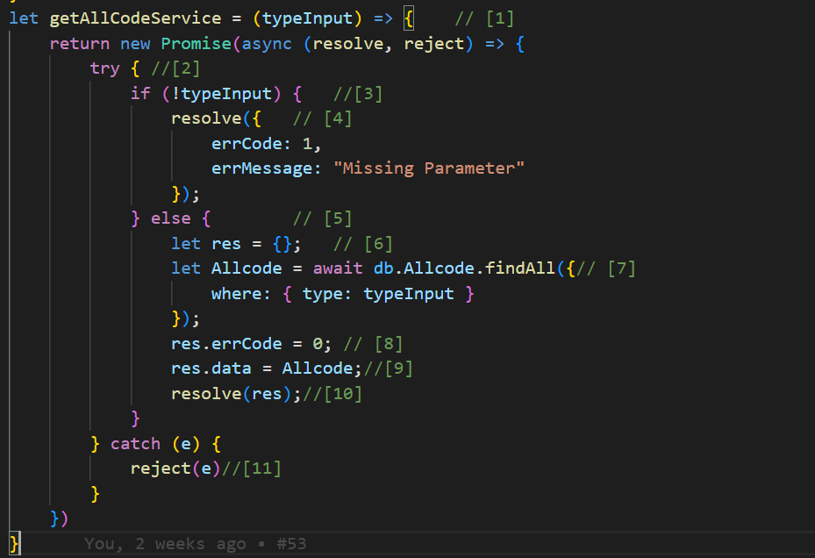

Fig. 84. Function getAllCodeService.

***Control flow graph:***

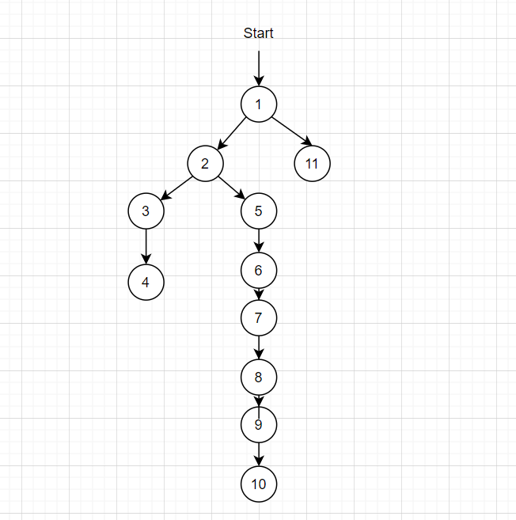

Fig. 85. Control flow graph of Function getAllCodeService.

***Cyclomatic complexity:***

V(G) = P +1= 2+1 = 3

So, there are at least 3 test cases that can cover 100% of branches

1. 1 -> 11
2. 1 -> 2 -> 3 -> 4
3. 1 -> 2 -> 5 -> 6-> ...-> 10

***Test cases for each path:***

Script 1: *1 -> 11*

Can’t connect to database server

=> Expected result: Error from server

Script 2: *1 -> 2 -> 3-> 4*

Don’t Input the Data or Missing Parameter

=> Expected result: Missing Parameter

Script 3: 1->2->...-> 10

Get all the data of “Allcode” table and transfer to the website

=> Expected result: Load data from “Allcode” table to server

***General Data Flow Graph:***

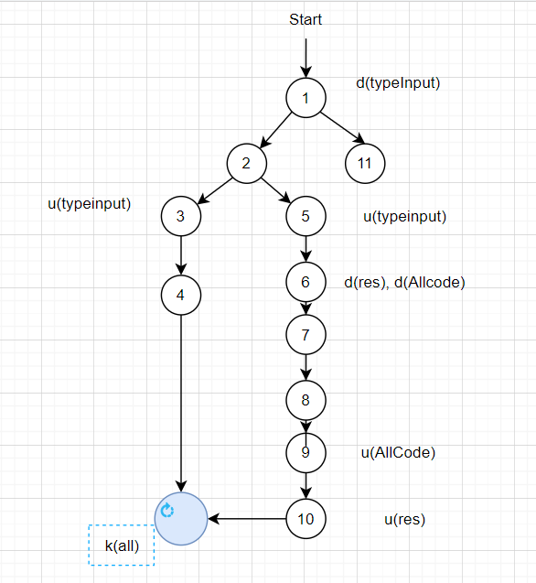

Fig. 86. General Data Flow Graph of Function getAllCodeService.

Testing lifecycle for variable typeInput:

Script 1: ~dk

Script 2: ~duk

Script 3: ~duk

Testing lifecycle for variable res

Script 1: ~dk

Script 2: ~dk

Script 3: ~duk

Testing for lifecycle for variable allCode

Script 1: ~dk

Script 2: ~dk

Script 3: ~duk

**2.2. Function postBookAppointment**

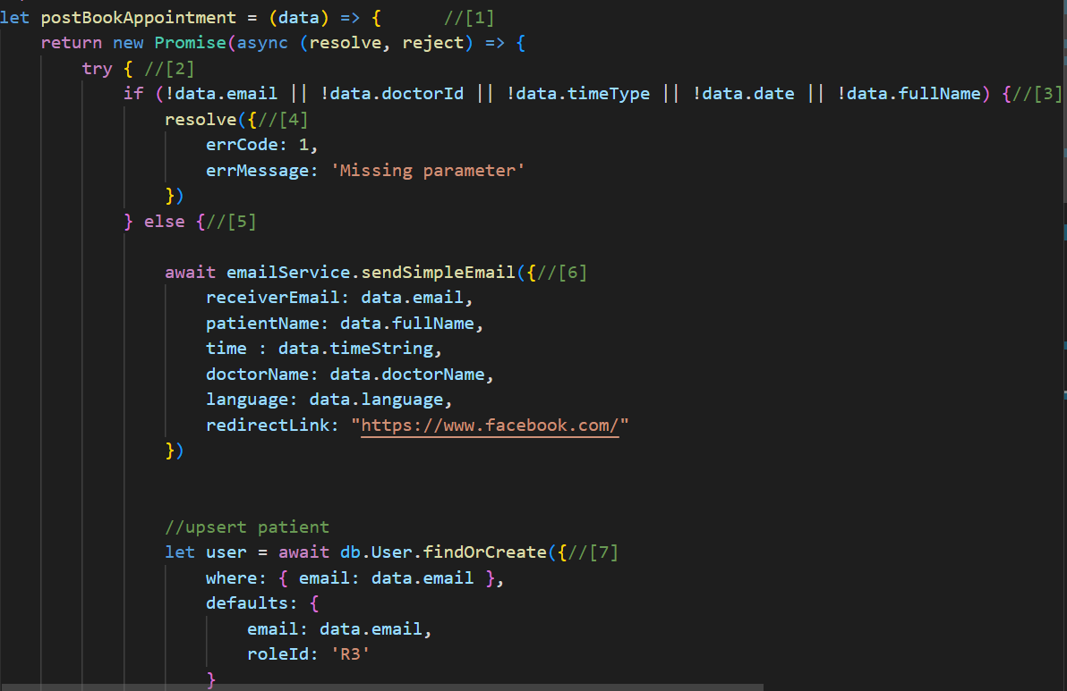

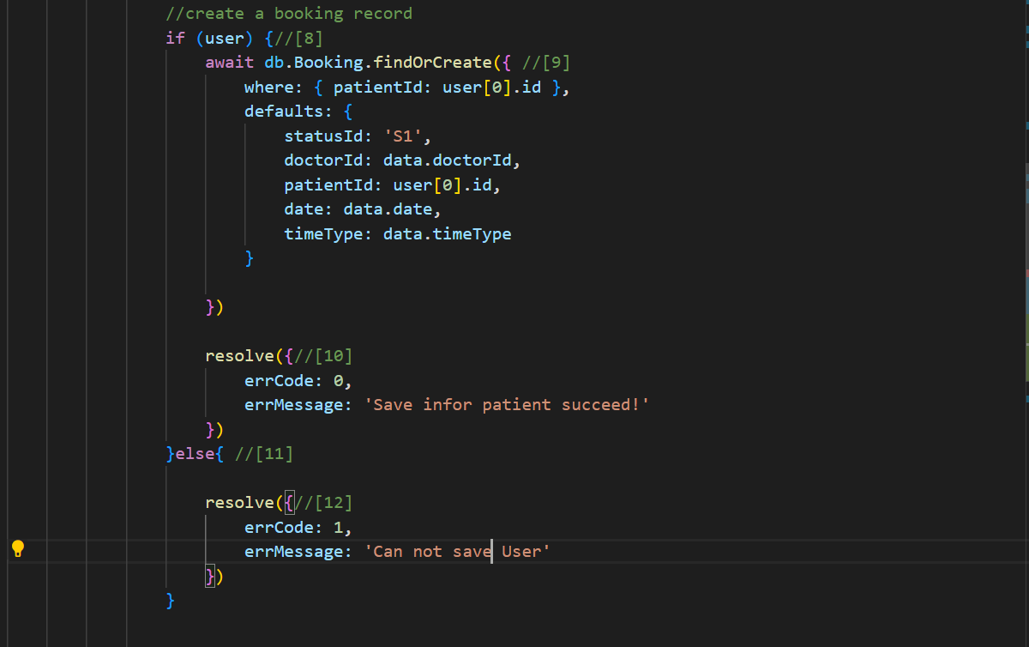

Fig. 87. Function postBookAppointment.

***Control flow graph:***

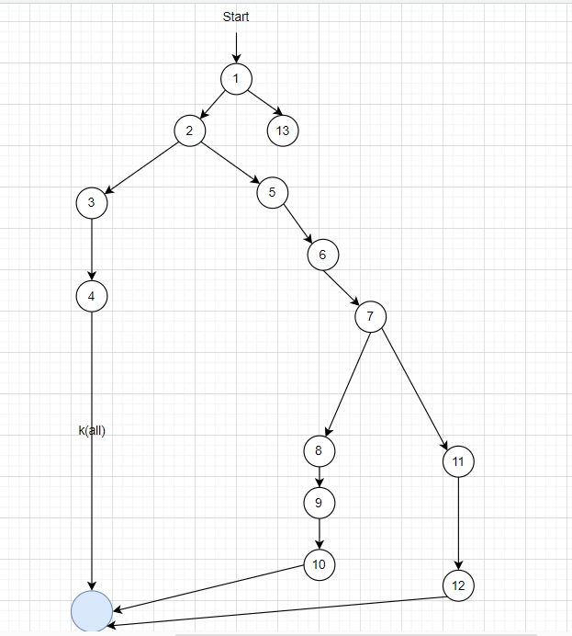

Fig. 88. Control flow graph of Function postBookAppointment.

V(G) = P +1 = 3+1 = 4

So, there are at least 4 test cases that can cover 100% of branches

1. 1 -> 13
2. 1 -> 2->3->4
3. 1 ->2 ->5 -> 6->7->8->9->10
4. 1 ->2 ->5 -> 6->7->11->12

Test Case for each part

Scrip 1: 1 ->13

=> Expect result: Error from server

Script 2: 1 -> 2->3->4

=> Expect result: Missing Parameter

Script 3: 1 ->2 ->5 -> 6->7->8->9->10

=> Expect result: Save information Patient Succes

Script 4: 1 ->2 ->5 -> 6->7->11->12

=> Expect result: Can not save user

***Data Flow Chart:***

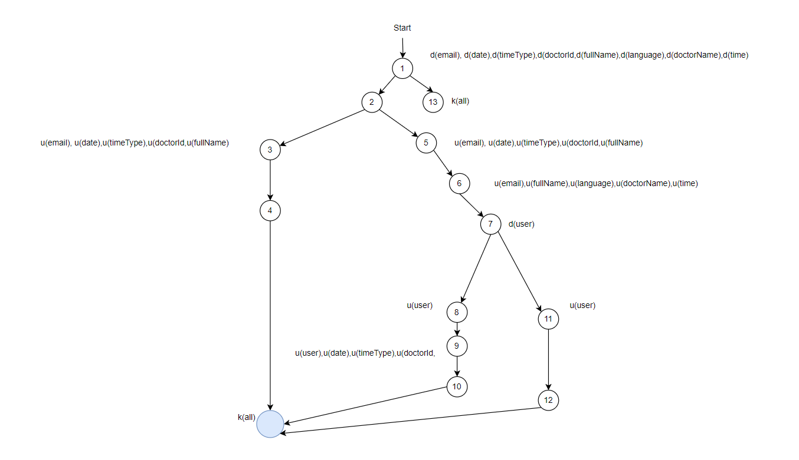

Fig. 89. Data Flow Chart of Function postBookAppointment.

Testing lifecycle for variable email:

Script 1: ~dk

Script 2: ~duk

Script 3: ~duuk

Script 4: ~duuk

Testing lifecycle for variable date:

Script 1: ~dk

Script 2: ~duk

Script 3: ~duuk

Script 4: ~duk

Testing lifecycle for variable TimeType:

Script 1: ~dk

Script 2: ~duk

Script 3: ~duuk

Script 4: ~duk

Testing lifecycle for variable doctorId:

Script 1: ~dk

Script 2: ~duk

Script 3: ~duuk

Script 4: ~duk

Testing lifecycle for variable fullName:

Script 1: ~dk

Script 2: ~duk

Script 3: ~duuk

Script 4: ~duuk

Testing lifecycle for variable language:

Script 1: ~dk

Script 2: ~duk

Script 3: ~duk

Script 4: ~duk

Testing lifecycle for variable doctorName:

Script 1: ~dk

Script 2: ~duk

Script 3: ~duk

Script 4: ~duk

Testing lifecycle for variable time:

Script 1 : ~dk

Script 2: ~duk

Script 3: ~duk

Script 4: ~duk

Testing lifecycle for variable user:

Script 1: k

Script 2: k

Script 3: ~duuk

Script 4: ~duuk

### 2.3. Function handleUserLogin

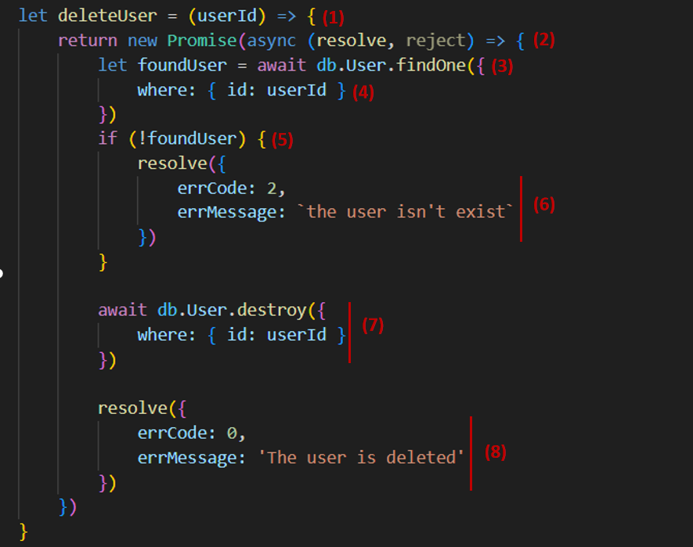

Fig. 90. Function handleUserLogin.

***Control flow graph:***

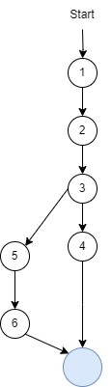

Fig. 91. Control flow graph of Function handleUserLogin.

***Cyclomatic complexity:***

V(G) = P + 1 = 1 + 1 =2

So, there are at least 1 test cases that can cover 100% of branches

1. 1 -> 2 -> 3 -> 4

2. 1 -> 2 -> 3 -> 5 -> 6

***Test case for each path:***

Script 1: 1 -> 2 -> 3 -> 4

=> Expect result: The user isn't existed.

Script 2: 1 -> 2 -> 3 -> 5 -> 6

=> Expected result: The user is deleted.

***General data flow graph:***

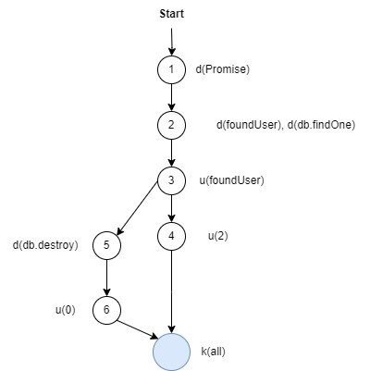

Fig. 92. General data flow graph of Function handleUserLogin.

1. 1 -> 2 -> 3 -> 4

2. 1 -> 2 -> 3 -> 5 -> 6

Testing lifecycle for Promise:

- Script1: ~dk

- Script2: ~dk

=> All 2 scenarios above don’t contain couples any unusual activity

Testing lifecycle for findOne:

- Script1: ~dk

- Script2: ~dk

=> All 2 scenarios above don’t contain couples any unusual activity

Testing lifecycle for variable destroy:

- Script1: ~dk

- Script2: ~dk

=> All 2 scenarios above don’t contain couples any unusual activity

Testing lifecycle for variable result:

- Script1: ~dk

- Script2: ~dk

=> All 2 scenarios above don’t contain couples any unusual activity

**2.4. Function createNewUser**

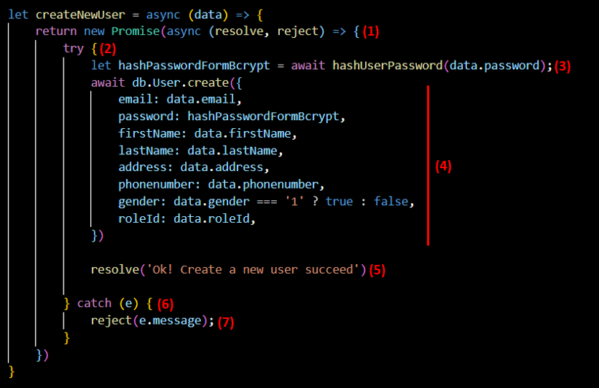

Fig. 93. Function createNewUser.

***Control flow graph:***

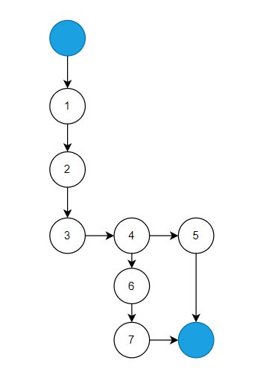

Fig. 94. Control flow graph of Function createNewUser.

***Cyclomatic complexity:***

- V(G) = P + 1 = 1 + 1 = 2

So, there are at least 2 test cases that can cover 100% of branches.

***Test cases for each path:***

Scrip 1: 1-2-3-4-5

User data is saved to the database

=> Expected result: Successfully creating a user and displaying the message "Ok! Create a new user succeed".

Scrip 2: 1-2-3-4-6-7

User data is not saved to the database.

=> Expected result: User creation failed with the error message obtained from the caught exception (e.message).

***General Data Flow Graph:***

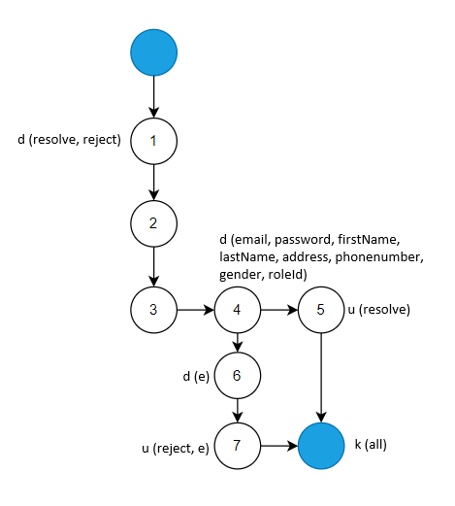

Fig. 95. General Data Flow Graph.

Testing the lifecycle for user creation:

Script 1: ~dduk

Scrip 2: ~ddduk

=> All 2 scenarios above don’t contain couples any unusual activity.

**2.5. Function getAllDoctors**

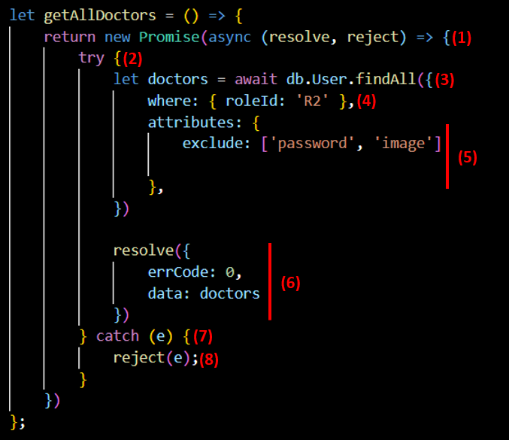

Fig. 96. Function getAllDoctors.

***Control flow graph:***

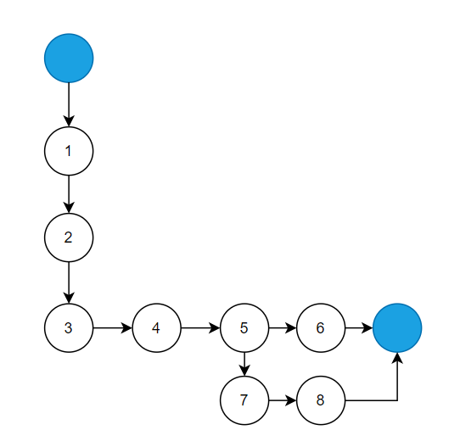

Fig. 97. Control flow graph of Function getAllDoctors.

***Cyclomatic complexity:***

- V(G) = P + 1 = 1 + 1 = 2

So, there are at least 2 test cases that can cover 100% of branches

***Test cases for each path:***

Scrip 1: 1-2-3-4-5-6

Get data of all doctors from database.

=> Expected result: A successful database query is indicated by the “errorCode” object.

Scrip 2: 1-2-3-4-5-7-8

Get data of all doctors from database.

=> Expected result: Database query failed with error.

***General Data Flow Graph:***

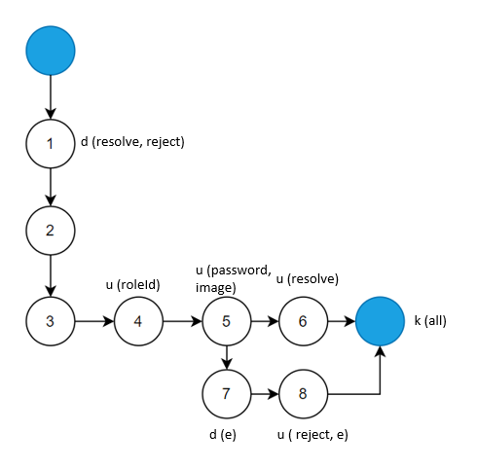

Fig. 98. General Data Flow Graph of Function getAllDoctors.

Lifecycle testing retrieves all physician data:

Script 1: ~duuuk

Scrip 2: ~duuduk

=> All 2 scenarios above don’t contain couples any unusual activity

**3. Black-box testing and bug report**

**\* Black-box testing**

Tab. 16. Black-box testing.

|  |  |  |
| --- | --- | --- |
| **No** | **Test case** | **Amount** |
| 1 | Test case pass | 40 |
| 2 | Test case fail | 8 |
| 3 | Total | 50 |

After going through the finalization of the Project, my team fixed some basic bugs so that the application could be used. Booking Appointments Website is still in the process of development and changes We have some Bug Reports here.

**\* Bug Report**

Tab. 17. Update Information for User can change email and password Bug Report.

|  |  |
| --- | --- |
| ID number | #1 |
| Name | When Update Information for User can change email and password |
| Reporter | Châu Quốc Thái |
| Submit Date | 20/10/2023 |
| Summary | When Admin Manage User, They can change Email, Password of User, Doctor |
| URL | http://localhost:3000/system/user-redux |
| Screenshot |  |
| Platform | Windows |
| Operating System | Window 11 |
| Browser | Chrome |
| Severity | Major |
| Assigned to | developer |
| Priority | High |

**Description**

When Admin Manage User, they can change Email, Password of User, Doctor.

**Steps to reproduce**

> Edit Email: test@gmail.com

> Edit Password: 123xyz

> Click save button

**Expected result**

Can not change email and password.

**Actual result**

Display Save information success.

**Note**

Fix Done we have disable Input data for email and password label, So we cannot edit them.

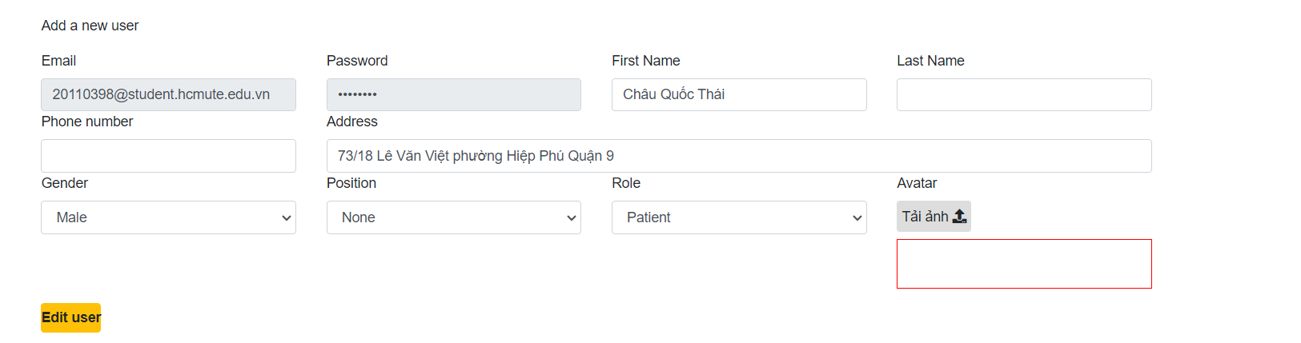

Fig. 99. Disabled Input data for email and password label.

Tab. 18. Create new schedule the data has been save duplicate Bug Report.

|  |  |
| --- | --- |
| ID number | #2 |
| Name | When create new schedule the data has been save duplicate |
| Reporter | Châu Quốc Thái |
| Submit Date | 05/11/2023 |
| Summary | When doctor create a new schedule, the data has been duplicated if they have chosen the time in one, they twice or more. |
| URL | http://localhost:3000/doctor/manage-schedule |
| Screenshot |  |
| Platform | Windows |
| Operating System | Window 11 |
| Browser | Chrome |
| Severity | Major |
| Assigned to | developer |
| Priority | High |

**Description**

When doctor create a new schedule, the data has been duplicated if they have chosen the time in one, they twice or more.

**Steps to reproduce**

> Choose Date: 05/11/2023 and Choose All time of this day

> Click save button

> Choose Date: 05/11/2023 and Choose All time of this day

> Click save button

**Expected result**

The system can filter time has been assigned yet and time not assign and save Data in the database.

**Actual result**

Save duplicate data in the data base.

**Note**

Fix Done We use if condition in the frontend part to filter and try to find the different time to save correctly.

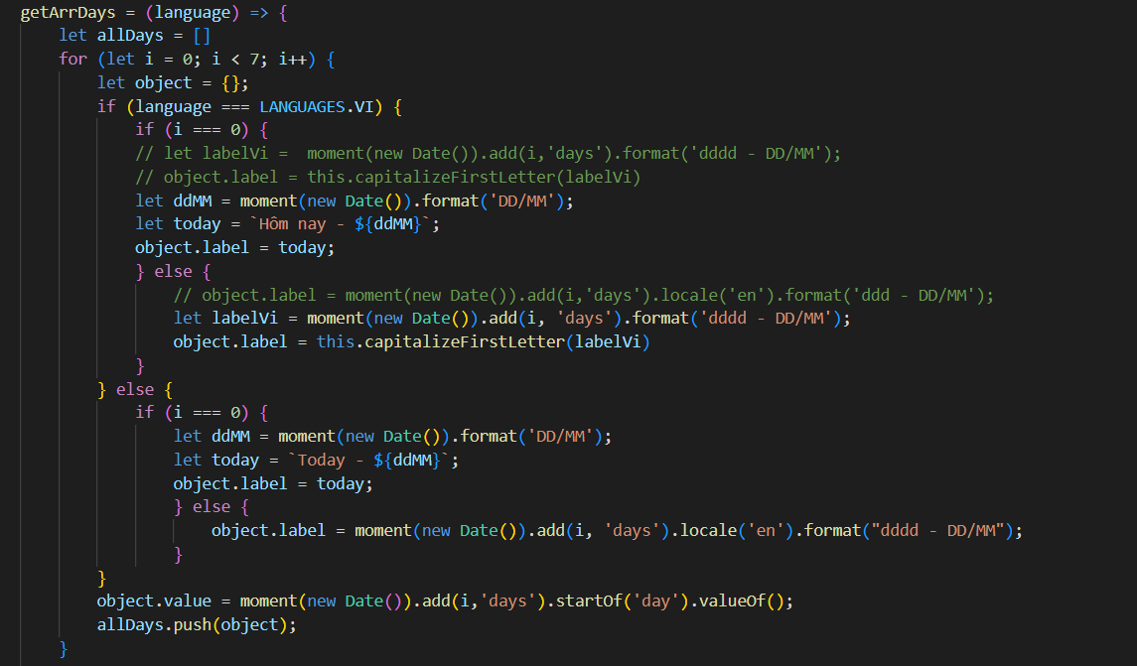

Fig. 100. Function getArrDays.

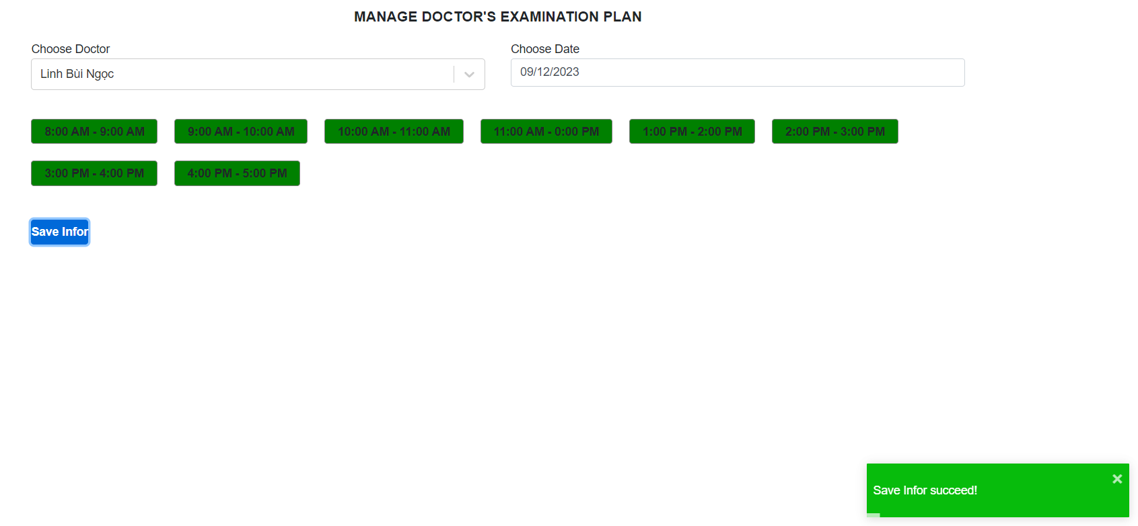

Fig. 101. The process of saving the doctor's medical examination plan was successful.

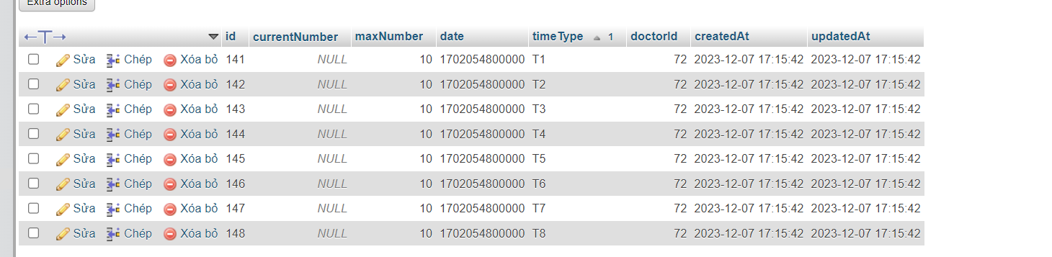

Fig. 102. Schedule table data.

Tab. 19. Edit a Doctor Information Bug Report.

|  |  |
| --- | --- |
| ID number | #3 |
| Name | When Edit a Doctor Information |
| Reporter | Châu Quốc Thái |
| Submit Date | 06/11/2023 |
| Summary | When Edit a Doctor Information we must fill all Information to Edit cannot edit a small part of this |
| URL | http://localhost:3000/system/manage-doctor |
| Screenshot |  |
| Platform | Windows |
| Operating System | Window 11 |
| Browser | Chrome |
| Severity | Major |
| Assigned to | developer |
| Priority | High |

**Description**

When Edit a Doctor Information we must fill all Information to Edit cannot edit a small part of this

**Steps to reproduce**

> Choose Doctor

> Edit name of him

> Click save button

**Expected result**



Fig. 103. Notification of successful saving of doctor information.

**Actual result**

Can not save

**Note**

Fix Done

Tab. 20. Formative Message in homepage Bug Report.

|  |  |
| --- | --- |
| ID number | #4 |
| Name | Formative Message in homepage |
| Reporter | Châu Quốc Thái |
| Submit Date | 10/11/2023 |
| Summary | When we choose the language English in homepage if we refresh website or come to another site of website the language will set again VN |
| URL | http://localhost:3000/home |
| Screenshot |  |
| Platform | Windows |
| Operating System | Window 11 |
| Browser | Chrome |
| Severity | Major |
| Assigned to | developer |
| Priority | High |

**Description**

When we choose the language English in homepage if we refresh website or come to another site of website the language will set again VN

**Steps to reproduce**

> Choose EN button

> Refresh Website

**Expected result**

Still in English Page

**Actual result**

Back to Vietnamese language

**Note**

Fix Done we have used the if condition in class compomentDidUpdate to save the language when user choose.

Tab. 21. When Create Schedule Bug Report.

|  |  |
| --- | --- |
| ID number | #5 |
| Name | When Create Schedule |
| Reporter | Châu Quốc Thái |
| Submit Date | 11/11/2023 |
| Summary | When doctor create a new schedule, they cannot create today schedule |
| URL | http://localhost:3000/doctor/manage-schedule |
| Screenshot |  |
| Platform | Windows |
| Operating System | Window 11 |
| Browser | Chrome |
| Severity | Major |
| Assigned to | developer |
| Priority | High |

**Description**

When doctor create a new schedule, they cannot create today schedule

**Steps to reproduce**

Select Date: 07/12/2023

Choose Time

Click Save button

**Expected result**

Save Succes

**Actual result**

Invalid date

**Note**

Fix Done we forget to set date value

Tab. 22. When Edit User Infor Bug Report.

|  |  |
| --- | --- |
| ID number | #6 |
| Name | When Edit User Infor |
| Reporter | Châu Quốc Thái |
| Submit Date | 11/11/2023 |
| Summary | When Admin edit user information cannot load data of image |
| URL | http://localhost:3000/system/user-redux |
| Screenshot |  |
| Platform | Windows |
| Operating System | Window 11 |
| Browser | Chrome |
| Severity | Major |
| Assigned to | developer |
| Priority | High |

**Description**

When doctor create a new schedule, they cannot create today schedule

**Steps to reproduce**

Select User and Edit button

**Expected result**

Load all Data of this user

**Actual result**

Cannot load data of image

**Note**

Fix Done

Tab. 23. When change the Province Specialty Bug Report.

|  |  |
| --- | --- |
| ID number | #7 |
| Name | When change the province Specialty |
| Reporter | Châu Quốc Thái |
| Submit Date | 11/11/2023 |
| Summary | When guest choose the Specialty and choose the province to get information of doctor by locate the name of the doctor not correct but the information of which they was correct |
| URL | http://localhost:3000/detail-specialty/2 |
| Screenshot |  |
| Platform | Windows |
| Operating System | Window 11 |
| Browser | Chrome |
| Severity | Major |
| Assigned to | developer |
| Priority | High |

**Description**

When guest choose the Specialty and choose the province to get information of doctor by locate the name of the doctor not correct but the information of which they was correct

**Steps to reproduce**

Select Specialty

Change the Province

**Expected result**

Correct information of doctor in Specialty

**Actual result**

The name of the doctor is not correct

**Note**

Fix Done set the condition in the componmentDidUpdate

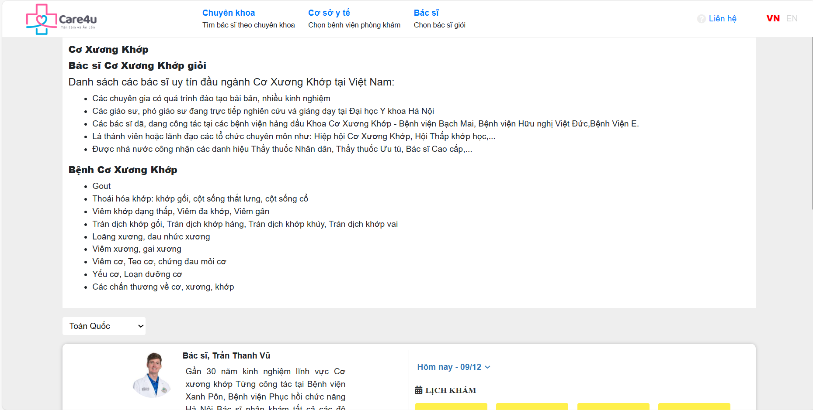.

Fig. 104. Specialty detail page interface.

Tab. 24. Cannot Load Image of Doctor in Specialty Bug Report.

|  |  |
| --- | --- |
| ID number | #8 |
| Name | Cannot Load Image of Doctor in Specialty |
| Reporter | Châu Quốc Thái |
| Submit Date | 11/11/2023 |
| Summary | When guest choose the specialty, they cannot see the image of doctor |
| URL | http://localhost:3000/detail-specialty/2 |
| Screenshot |  |
| Platform | Windows |
| Operating System | Window 11 |
| Browser | Chrome |
| Severity | Major |
| Assigned to | developer |
| Priority | Normal |

**Description**

When guest choose the Specialty, they can’t see the image of doctor

**Steps to reproduce**

Select Specialty

**Expected result**

Correct information of doctor in Specialty

**Actual result**

The name of the doctor is not correct

**Note**

Fix done

Tab. 25. Cannot Load Image of Doctor in Specialty Bug Report.

|  |  |
| --- | --- |
| ID number | #8 |
| Name | Cannot Load Image of Doctor in Specialty |
| Reporter | Châu Quốc Thái |
| Submit Date | 11/11/2023 |
| Summary | When guest choose the specialty, they cannot see the image of doctor |
| URL | http://localhost:3000/detail-specialty/2 |
| Screenshot |  |
| Platform | Windows |
| Operating System | Window 11 |
| Browser | Chrome |
| Severity | Major |
| Assigned to | developer |
| Priority | Normal |

**Description**

When guest choose the specialty, they can’t see the image of doctor

**Steps to reproduce**

Select Specialty

**Expected result**

Correct information of doctor in Specialty

**Actual result**

The name of the doctor is not correct

**Note**

Fix done

Tab. 26. Notification of successful saving of doctor information.

|  |  |
| --- | --- |
| ID number | #9 |
| Name | When send email to patient for confirm booking Appointment |
| Reporter | Châu Quốc Thái |
| Submit Date | 11/11/2023 |
| Summary | When Send email to patient if patient choose English language the email will use English else the email will use Vietnamese but all of email when we send is in English |
| URL |  |
| Screenshot |  |
| Platform | Windows |
| Operating System | Window 11 |
| Browser | Chrome |
| Severity | Major |
| Assigned to | developer |
| Priority | Normal |

**Description**

When Send email to patient if patient choose English language the email will use English else the email will use Vietnamese but all of email when we send is in English.

**Expected result**

Correct information of doctor in Specialty.

**Actual result**

The name of the doctor is not correct.

**Note**

Fix done.

**CHAPTER VI: CONCLUSION**

**1. Result**

Our project has successfully achieved its objectives in creating a user-centric and effective medical appointment booking website. The system significantly enhances the experience of patients and healthcare professionals alike, while also improving the operational dynamics of doctors.

We have developed a user-friendly interface that simplifies the process of finding healthcare providers and booking appointments. This has significantly improved the accessibility and convenience for patients seeking medical services. The system caters to the needs of doctors and other healthcare personnel. We have streamlined the process of managing patient appointments, ensuring a more efficient and easily workflow.

**2. Advantages and disadvantages of the system**

**2.1. Advantages of the system**

- The website offers a simple, intuitive interface that makes it easy for patients to find healthcare providers, view available appointment slots, and book appointments without any hassle. This user-centric design enhances patient experience and accessibility.

- Patients can book appointments from the comfort of their home at any time, reducing the need for phone calls or in-person visits just for appointment scheduling.

- The website provides a streamlined process for doctors to manage their appointments. Features like a real-time calendar, send an automatic email confirming scheduling information to the patient a then the doctor can email the results to the patient easily. Furthermore, doctors can manage patient’s medical history easily and quickly through the website.

- The website is built to be scalable, catering to the growing needs of doctors, healthcare facilities, and adaptable, allowing for updates and improvements based on user feedback and technological advancements.

**2.2. Disadvantages of the system**

- The system has not been implemented and developed on the server.

- Login and account registration for patients have not been optimized, so the website has not developed those features.

- While the platform can help reduce no-shows, it cannot eliminate this issue. Patients may still miss appointments or cancel at the last minute, causing scheduling disruptions.

- When switching between two Vietnamese English languages, it is restricted.

- The system does not have capabilities that allow users to reply, assess the quality, or manage items that are shown for the doctor to see.

**3. Development**

**-** Effectively deploy and develop the website on the server.

- Developing features for users to evaluate and respond to the quality of service when examining at the clinic or doctor.

- Developing chatbot so users can ask questions for it and from there it can answer user questions quickly.

- Developing login and register for patients effectively and optimally for the system.

- The system needs to develop user information collection features, which can analyze these data. It will help the system's intimate users have suggestions and diagnosis of their illness.

**REFERENCES**

[1] Sequelize - Getting Started. Link: https://sequelize.org/docs/v6/getting-started/

[2] React - React-router-dom. Link: <https://www.npmjs.com/package/react-router-dom>

[3] Npm - npm package. Link: https://www.npmjs.com/

[4] ReactJS - ReactJS guide. Link: https://legacy.reactjs.org/docs/getting-started.html

[5] NodeJS - NodeJS guide. Link: https://nodejs.org/en/guides

[6] SQL - SQL guide. Link: https://www.w3schools.com/sql/